**Snowflake SnowPro Advanced Data Engineer | Solved Questions | Examtopics**

<https://www.youtube.com/watch?v=op8_WxMaFY4>

**Snowflake SnowPro Advanced Data Engineer Exam Dumps & Questions 2025**

<https://www.youtube.com/watch?v=CWW-oIRTDr0>

<https://medium.com/@somen.swain/snowpro-advanced-data-engineer-cerification-preparation-tips-d6c658761427>

<https://learn.snowflake.com/en/certifications/snowpro-advanced-dataengineer/>

<https://docs.snowflake.com/en/sql-reference/transactions.html>

<https://docs.snowflake.com/en/sql-reference/external-functions-introduction.html>

<https://docs.snowflake.com/en/user-guide/tables-clustering-micropartitions.html>

<https://docs.snowflake.com/en/user-guide/views-materialized.html>

# Explore Semi‐structured Data

SELECT * FROM isd_2019_total LIMIT 10

|  |  |
| --- | --- |
| V | T |
| {  "data": {  "observations": [  {  "air": {  "dew-point": -0.2,  "dew-point-quality-code": "1",  "temp": 2.9,  "temp-quality-code": "1"  },  "atmospheric": {  "pressure": 10198,  "pressure-quality-code": "1"  },  "dt": "2019-04-17T14:00:00",  "sky": {  "ceiling": 99999,  "ceiling-quality-code": "9"  },  "visibility": {  "distance": 999999,  "distance-quality-code": "9"  },  "wind": {  "direction-angle": 220,  "direction-quality-code": "1",  "speed-quality-code": "1",  "speed-rate": 50  }  }  ]  },  "station": {  "ICAO": "ENSB",  "USAF": "010080",  "WBAN": 99999,  "coord": {  "lat": 78.246,  "lon": 15.466  },  "country": "SV",  "elev": 26.8,  "id": "01008099999",  "name": "LONGYEAR"  }  } | 2019-04-17 14:00:00.000 |
| {  "data": {  "observations": [  {  "air": {  "dew-point": 18,  "dew-point-quality-code": "1",  "temp": 20,  "temp-quality-code": "1"  },  "atmospheric": {  "pressure": 99999,  "pressure-quality-code": "9"  },  "dt": "2019-04-17T14:00:00",  "sky": {  "ceiling": 1067,  "ceiling-quality-code": "1"  },  "visibility": {  "distance": 9999,  "distance-quality-code": "1"  },  "wind": {  "direction-angle": 120,  "direction-quality-code": "1",  "speed-quality-code": "1",  "speed-rate": 31  }  }  ]  },  "station": {  "ICAO": "FVRG",  "USAF": "677750",  "WBAN": 99999,  "coord": {  "lat": -17.93,  "lon": 31.094  },  "country": "ZI",  "elev": 1489.6,  "id": "67775099999",  "name": "ROBERT GABRIEL MUGABE INTL / HARARE"  }  } | 2019-04-17 14:00:00.000 |

SELECT v, key, value FROM isd_2019_total, LATERAL FLATTEN (input => v) LIMIT 10;

|  |  |  |
| --- | --- | --- |
| V | KEY | VALUE |
| {  "data": {  "observations": [  {  "air": {  "dew-point": -0.1,  "dew-point-quality-code": "1",  "temp": 6.5,  "temp-quality-code": "1"  },  "atmospheric": {  "pressure": 10228,  "pressure-quality-code": "1"  },  "dt": "2019-05-14T09:00:00",  "sky": {  "ceiling": 99999,  "ceiling-quality-code": "9"  },  "visibility": {  "distance": 20000,  "distance-quality-code": "1"  },  "wind": {  "direction-angle": 260,  "direction-quality-code": "1",  "speed-quality-code": "1",  "speed-rate": 20  }  },  {  "air": {  "dew-point": -2,  "dew-point-quality-code": "1",  "temp": 8,  "temp-quality-code": "1"  },  "atmospheric": {  "pressure": 99999,  "pressure-quality-code": "9"  },  "dt": "2019-05-14T09:00:00",  "sky": {  "ceiling": 99999,  "ceiling-quality-code": "9"  },  "visibility": {  "distance": 9999,  "distance-quality-code": "1"  },  "wind": {  "direction-angle": 250,  "direction-quality-code": "1",  "speed-quality-code": "1",  "speed-rate": 40  }  }  ]  },  "station": {  "ICAO": "ULMM",  "USAF": "221130",  "WBAN": 99999,  "coord": {  "lat": 68.782,  "lon": 32.751  },  "country": "RS",  "elev": 81.1,  "id": "22113099999",  "name": "MURMANSK"  }  } | **data** | {  "observations": [  {  "air": {  "dew-point": -0.1,  "dew-point-quality-code": "1",  "temp": 6.5,  "temp-quality-code": "1"  },  "atmospheric": {  "pressure": 10228,  "pressure-quality-code": "1"  },  "dt": "2019-05-14T09:00:00",  "sky": {  "ceiling": 99999,  "ceiling-quality-code": "9"  },  "visibility": {  "distance": 20000,  "distance-quality-code": "1"  },  "wind": {  "direction-angle": 260,  "direction-quality-code": "1",  "speed-quality-code": "1",  "speed-rate": 20  }  },  {  "air": {  "dew-point": -2,  "dew-point-quality-code": "1",  "temp": 8,  "temp-quality-code": "1"  },  "atmospheric": {  "pressure": 99999,  "pressure-quality-code": "9"  },  "dt": "2019-05-14T09:00:00",  "sky": {  "ceiling": 99999,  "ceiling-quality-code": "9"  },  "visibility": {  "distance": 9999,  "distance-quality-code": "1"  },  "wind": {  "direction-angle": 250,  "direction-quality-code": "1",  "speed-quality-code": "1",  "speed-rate": 40  }  }  ]  } |
| {  "data": {  "observations": [  {  "air": {  "dew-point": -0.1,  "dew-point-quality-code": "1",  "temp": 6.5,  "temp-quality-code": "1"  },  "atmospheric": {  "pressure": 10228,  "pressure-quality-code": "1"  },  "dt": "2019-05-14T09:00:00",  "sky": {  "ceiling": 99999,  "ceiling-quality-code": "9"  },  "visibility": {  "distance": 20000,  "distance-quality-code": "1"  },  "wind": {  "direction-angle": 260,  "direction-quality-code": "1",  "speed-quality-code": "1",  "speed-rate": 20  }  },  {  "air": {  "dew-point": -2,  "dew-point-quality-code": "1",  "temp": 8,  "temp-quality-code": "1"  },  "atmospheric": {  "pressure": 99999,  "pressure-quality-code": "9"  },  "dt": "2019-05-14T09:00:00",  "sky": {  "ceiling": 99999,  "ceiling-quality-code": "9"  },  "visibility": {  "distance": 9999,  "distance-quality-code": "1"  },  "wind": {  "direction-angle": 250,  "direction-quality-code": "1",  "speed-quality-code": "1",  "speed-rate": 40  }  }  ]  },  "station": {  "ICAO": "ULMM",  "USAF": "221130",  "WBAN": 99999,  "coord": {  "lat": 68.782,  "lon": 32.751  },  "country": "RS",  "elev": 81.1,  "id": "22113099999",  "name": "MURMANSK"  }  } | **station** | {  "ICAO": "ULMM",  "USAF": "221130",  "WBAN": 99999,  "coord": {  "lat": 68.782,  "lon": 32.751  },  "country": "RS",  "elev": 81.1,  "id": "22113099999",  "name": "MURMANSK"  } |

SELECT

v:data.observations[0].dt AS time,

v:station.name AS station,

v:station.country AS country,

v:station.elev AS elevation,

v:data.observations[0].air.temp AS temp_celsius,

v:data.observations[0].air."dew-point" AS dew_point,

v:data.observations[0].wind."speed-rate" AS wind_speed

FROM weather.isd_2019_total

LIMIT 10;

|  |  |  |  |  |  |  |
| --- | --- | --- | --- | --- | --- | --- |
| TIME | STATION | COUNTRY | ELEVATION | TEMP_CELSIUS | DEW_POINT | WIND_SPEED |
| "2019-04-17T14:00:00" | "LONGYEAR" | "SV" | 26.8 | 2.9 | -0.2 | 50 |
| "2019-04-17T14:00:00" | "ROBERT GABRIEL MUGABE INTL / HARARE" | "ZI" | 1489.6 | 20 | 18 | 31 |
| "2019-04-17T14:00:00" | "SOLVAER III" | "NO" | 10 | 12.9 | -1.8 | 20 |
| "2019-04-17T14:00:00" | "SELDOVIA" | "US" | 0 | 999.9 | 999.9 | 0 |
| "2019-04-17T14:00:00" | "MATSUE" | "JA" | 22.4 | 11.8 | 5.9 | 10 |
| "2019-04-17T14:00:00" | "BRADSHAW" | "AS" | 76 | 29 | 19.3 | 31 |
| "2019-04-17T14:00:00" | "CLARESHOLM" | "CA" | 1009 | 3.8 | -3.7 | 26 |
| "2019-04-17T14:00:00" | "VAL D OR" | "CA" | 337.4 | 7 | -7 | 36 |
| "2019-04-17T14:00:00" | "KITSISSUT (CAREY OEER)" | "GL" | 11 | -16.5 | -20.6 | 31 |
| "2019-04-17T14:00:00" | "KATSUURA" | "JA" | 13.5 | 14.5 | 10.7 | 21 |

Run the following to display the types of columns from the last run query:

DESCRIBE RESULT LAST_QUERY_ID();

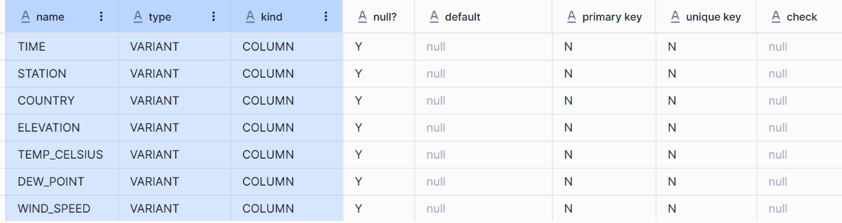

Remove the double quotes around the values by casting each value as a data type other than VARIANT:

SELECT

v:data:observations[0].dt::DATETIME AS time,

v:station.name::VARCHAR AS station,

v:station.country::VARCHAR AS country,

v:station.elev::NUMBER(8,4) AS elevation,

v:data.observations[0].air.temp::NUMBER(8,4) AS temp_celsius,

v:data.observations[0].air."dew-point"::NUMBER(8,4) AS dew_point,

v:data.observations[0].wind."speed-rate"::NUMBER AS wind_speed

FROM weather.isd_2019_total

LIMIT 10;

|  |  |  |  |  |  |  |
| --- | --- | --- | --- | --- | --- | --- |
| TIME | STATION | COUNTRY | ELEVATION | TEMP_CELSIUS | DEW_POINT | WIND_SPEED |
| 2019-04-17 14:00:00.000 | LONGYEAR | SV | 26.8000 | 2.9000 | -0.2000 | 50 |
| 2019-04-17 14:00:00.000 | ROBERT GABRIEL MUGABE INTL / HARARE | ZI | 1489.6000 | 20.0000 | 18.0000 | 31 |
| 2019-04-17 14:00:00.000 | SOLVAER III | NO | 10.0000 | 12.9000 | -1.8000 | 20 |
| 2019-04-17 14:00:00.000 | SELDOVIA | US | 0.0000 | 999.9000 | 999.9000 | 0 |
| 2019-04-17 14:00:00.000 | MATSUE | JA | 22.4000 | 11.8000 | 5.9000 | 10 |
| 2019-04-17 14:00:00.000 | BRADSHAW | AS | 76.0000 | 29.0000 | 19.3000 | 31 |
| 2019-04-17 14:00:00.000 | CLARESHOLM | CA | 1009.0000 | 3.8000 | -3.7000 | 26 |
| 2019-04-17 14:00:00.000 | VAL D OR | CA | 337.4000 | 7.0000 | -7.0000 | 36 |
| 2019-04-17 14:00:00.000 | KITSISSUT (CAREY OEER) | GL | 11.0000 | -16.5000 | -20.6000 | 31 |
| 2019-04-17 14:00:00.000 | KATSUURA | JA | 13.5000 | 14.5000 | 10.7000 | 21 |

DESCRIBE RESULT LAST_QUERY_ID();

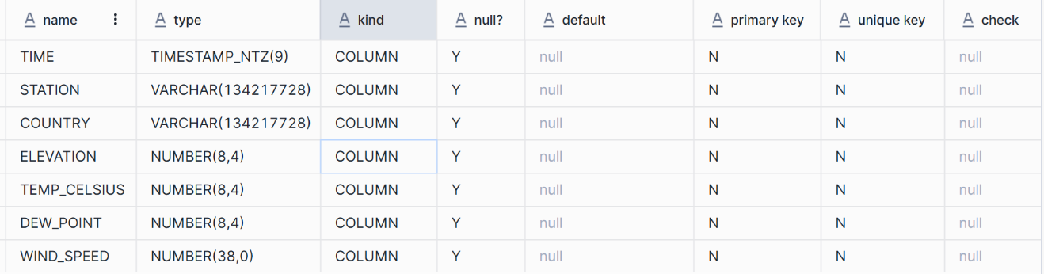

Extract the weather station-reported air temperature data that has passed all quality control checks. Rename the column to temp_celsius and include only temperature data with a temp-quality-code equal to 1.

SELECT

v:station.name::VARCHAR AS station,

v:station.country::VARCHAR AS country,

v:data.observations[0].air.temp::NUMBER(38,1) AS temp_celsius

FROM weather.isd_2019_total

WHERE country = 'FR'

AND v:data.observations[0].air."temp-quality-code" = '1';

|  |  |  |
| --- | --- | --- |
| **STATION** | **COUNTRY** | **TEMP_CELSIUS** |
| VATRY | FR | 22.0 |
| GOURDON | FR | 26.1 |
| LHERM | FR | 26.0 |
| BOURGES | FR | 25.0 |
| CHARNAY | FR | 25.2 |

# Apache Iceberg Tables

In this lab, external storage has already been configured for your use. We will be utilizing an AWS S3 storage location with pre-configured external storage volumes and stages. These pre-configured objects were created by the ACCOUNTADMIN role. Let's start by reviewing these predefined objects.

Reviewing the external volume

This command will display the details of the external volume, including whether it has write permissions.

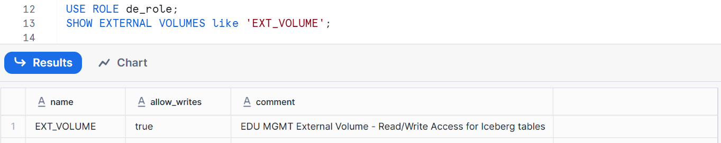

An External Volume is a named, account-level object in Snowflake that connects to your external cloud storage, such as S3, for Apache Iceberg tables. It stores the identity and access management (IAM) credentials necessary for secure access to your storage, allowing Snowflake to manage table data, Apache Iceberg metadata, and manifest files that include the table schema, partitions, and other essential metadata.

Describing the external volume: To gain further details about the external volume, you can use the DESCRIBE command:

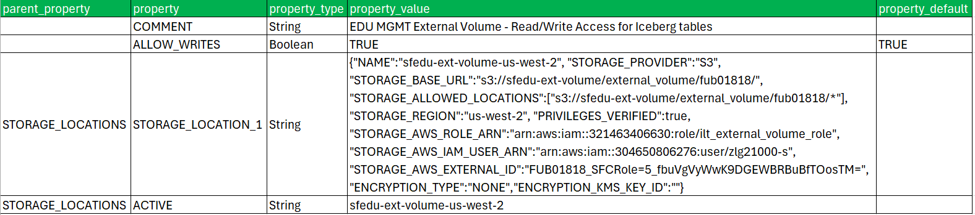

**Verify no existing files.**

Before creating Apache Iceberg tables, we need to ensure that the stage (used for storing data externally) is empty. This step ensures that any subsequent operations are performed on a clean slate.

A Stage in Snowflake refers to a location where data files are stored, either in the cloud (external) or within Snowflake(internal).

Although stages are not mandatory for Apache Iceberg tables, we use them to inspect the files created by these tables.

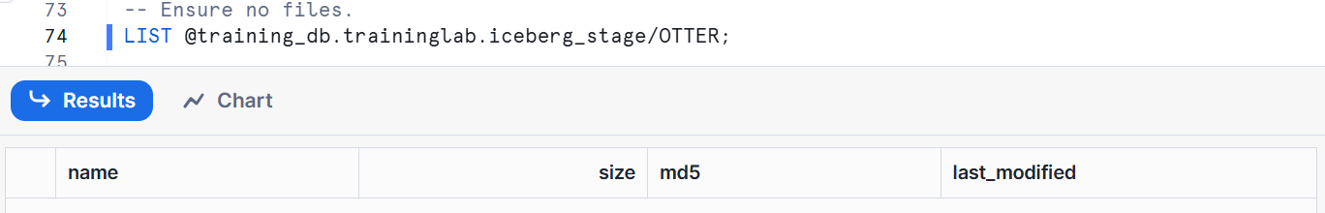

Set the path location for the Apache Iceberg™ table. Using the following command, we enable a schema-level path to store our Iceberg tables.

ALTER SCHEMA OTTER_de_db.ib_schema SET BASE_LOCATION_PREFIX = 'OTTER/ib_schema';

**Create an Apache Iceberg table.**

Let us create our first Apache Iceberg table. This table will be managed by Snowflake’s internal catalog, and the data will be stored in an external volume.

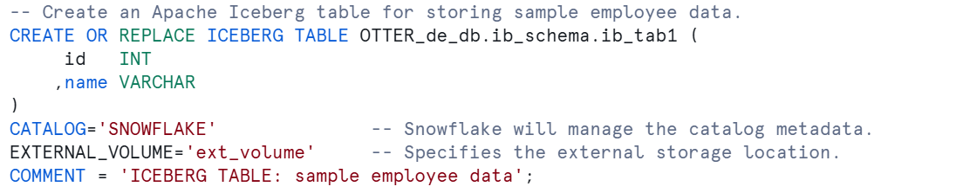

CATALOG=SNOWFLAKE: Specifies that Snowflake will manage the metadata.

EXTERNAL_VOLUME=ext_volume: Indicates where the table data will be physically stored.

**Review the metadata file.**

After creating the Apache Iceberg table, Snowflake generates a metadata file. This file stores information such as the name of the external volume, file size, last modified date, and more required for managing the table.



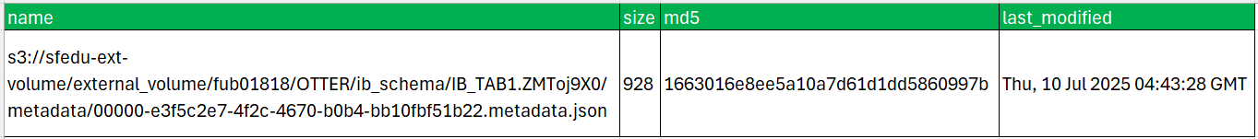

You should see a file in the metadata subfolder. This file is managed by Snowflake and is crucial for the functioning of the Apache Iceberg table. Note the **base_location_prefix** in the image that will group iceberg tables in the same schema into the folder, **OTTER/ib_schema**.

Insert data into the Apache Iceberg table. Now, let's insert some sample data into the Apache Iceberg table. This action will generate additional data files in the external storage.

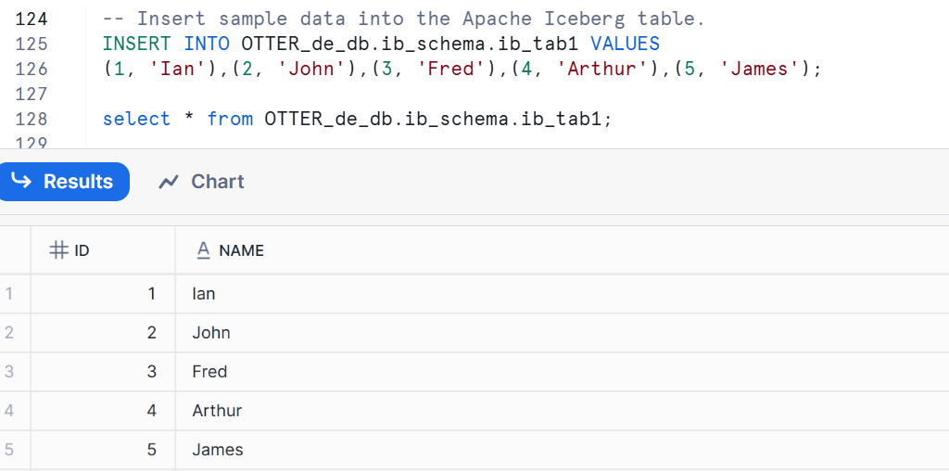

Review the files after data insertion.

After inserting data, Snowflake generates new files in the external storage, including metadata files(in JSON format) & data files (in Parquet format).



You should now see additional files in the data subfolder, including a Parquet file that contains the rows you inserted. In this output, you should see the following types of files.

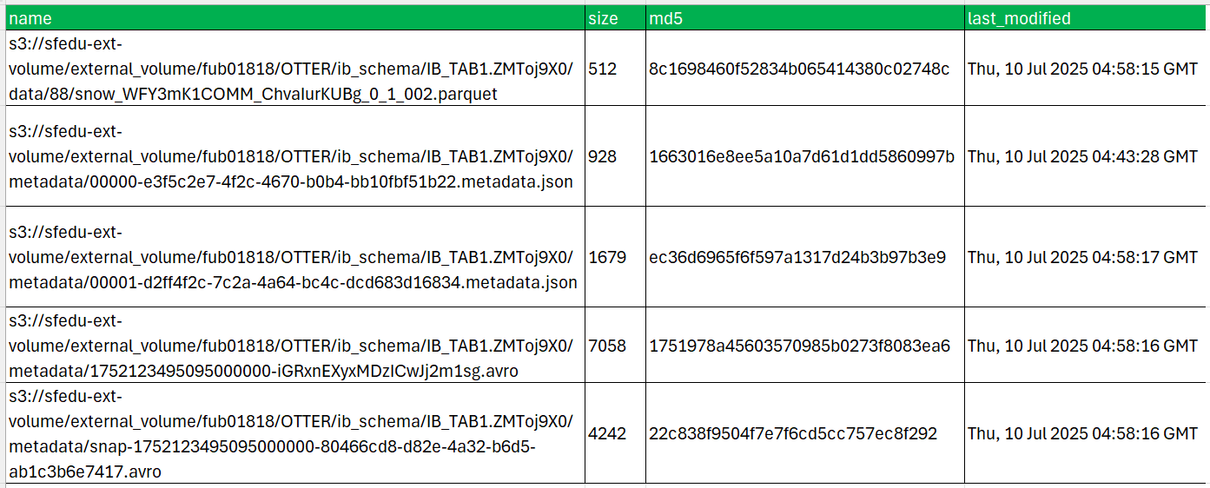

Insert more data and review the files. To further demonstrate the behaviour of Apache Iceberg tables, we will insert additional rows and observe the changes in the file structure.

-- Insert more rows into the Apache Iceberg table.

INSERT INTO OTTER_de_db.ib_schema.ib_tab1 VALUES

(6, 'Debbie'),(7, 'Bella') ,(8, 'Sam'),(9, 'Julie'),(10, 'Jane');

As you insert more data, Apache Iceberg continues to generate new files. The PATTERN option filters to show only the Parquet data files, which now represent both batches of inserted records.



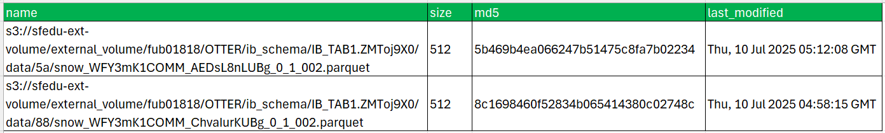

**Time Travel and Apache Iceberg™ Tables**

Apache Iceberg tables support time travel, allowing you to query historical versions of your data.

Create a second Apache Iceberg™ table with time travel.

The first Apache Iceberg table we created had the default 1 day of time travel data retention.

In this step, we show how to modify this time by adjusting the value assigned to the

DATA_RETENTION_TIME_IN_DAYS and setting it to 3 days.

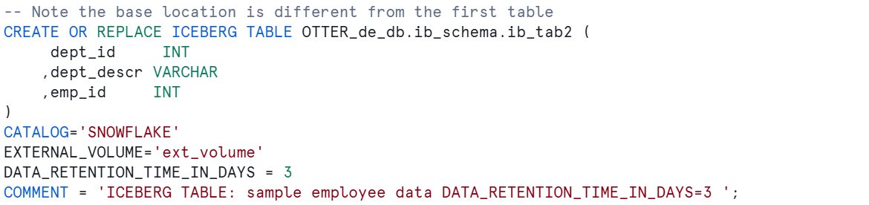

INSERT INTO OTTER_de_db.ib_schema.ib_tab2 VALUES

(1, 'MARKETING', 1),(1, 'MARKETING', 2)

,(2, 'ENGINEERING', 3),(2, 'ENGINEERING', 4),(2, 'ENGINEERING', 5)

,(3, 'SALES', 6),(3, 'SALES', 7),(3, 'SALES', 8)

,(4, 'ADMIN', 9),(4, 'ADMIN', 10);

Verify time travel on an iceberg table by deleting 3 rows.

DELETE FROM OTTER_de_db.ib_schema.ib_tab2 WHERE dept_descr = 'ENGINEERING';

-- capture the query_id into a variable

SET post_delete_query_id = last_query_id();

Now see the current row set after deletion.

-- There should be 7 rows

SELECT * FROM OTTER_de_db.ib_schema.ib_tab2;

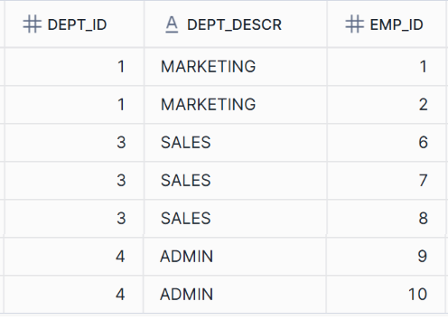

Now look at the contents of the table before the delete command was issued.

-- Data before deletion: 10 rows

SELECT * FROM OTTER_de_db.ib_schema.ib_tab2

BEFORE (statement => $post_delete_query_id);

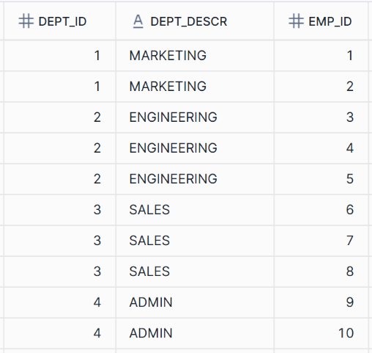

By stepping through the above steps, you should see that time travel works with Apache Iceberg tables as well as regular Snowflake tables. Snowflake does not support fail-safe for Apache Iceberg tables because the table data is in external cloud storage managed outside of Snowflake. To protect Apache Iceberg table data, configure the data protection and recovery with the cloud provider.

Re-insert the deleted rows. You can restore deleted data using time travel.

INSERT INTO OTTER_de_db.ib_schema.ib_tab2

SELECT * FROM OTTER_de_db.ib_schema.ib_tab2

BEFORE (statement => $post_delete_query_id)

WHERE dept_descr = 'ENGINEERING';

Verify rows were re-inserted.

-- There should be 10 rows

SELECT * FROM OTTER_de_db.ib_schema.ib_tab2;

**Joining Apache Iceberg™ Tables with Standard Tables**

Create and populate a standard table.

Finally, you'll join an Apache Iceberg table with a standard Snowflake table to demonstrate compatibility between the two.

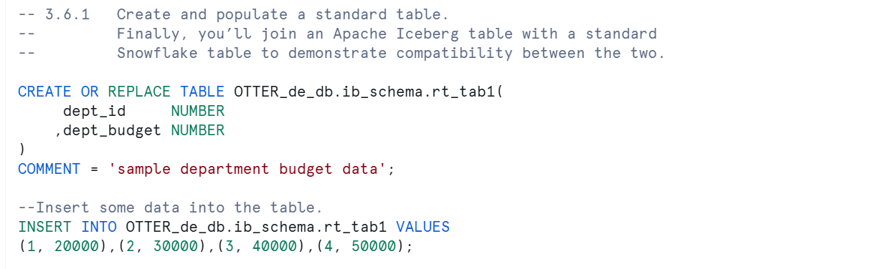

This step prepares a standard table with department budgets, which will be joined with the Apache Iceberg table data. Now, join the standard table with the Apache Iceberg table to combine the data.

This query joins the two tables on the dept_id.

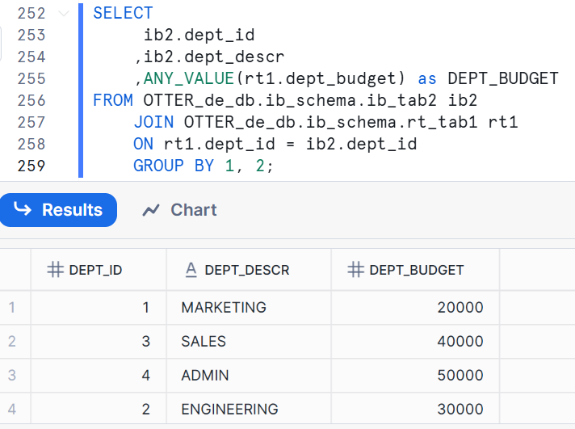

Review the data files from both tables.

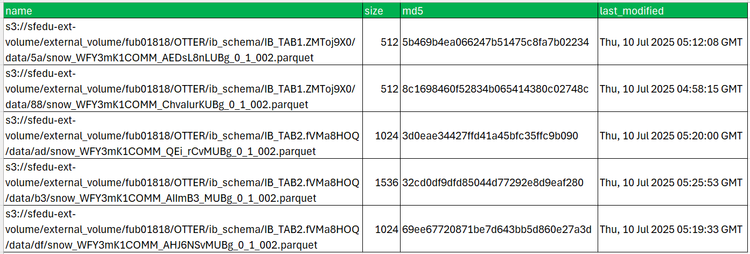

To see data files from just a single table such as ib_tab1, you can filter these results using the following commands:

SELECT *

FROM TABLE(RESULT_SCAN(LAST_QUERY_ID()))

WHERE "name" ILIKE '%IB_TAB1%';

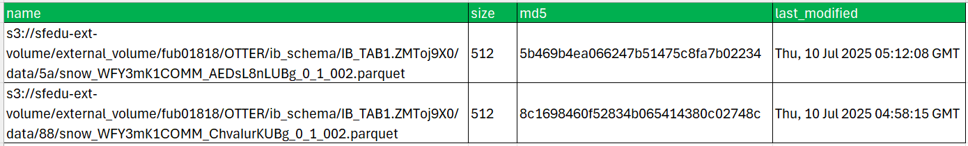

Suspend and resize your warehouse.

Finally, let's clean up by suspending and resizing the warehouse to conserve resources.

ALTER WAREHOUSE OTTER_de_wh SUSPEND;

ALTER WAREHOUSE OTTER_de_wh SET WAREHOUSE_SIZE = XSMALL;

**Key Takeaways**

* Apache Iceberg tables store their data and metadata files in an external cloud storage location (Amazon S3, Google Cloud Storage, or Azure Storage).
* Snowflake connects to your storage location using an external volume.
* Use the DATA_RETENTION_TIME_IN_DAYS table property to set how long to retain table metadata to support time travel and undropping the table.
* Apache Iceberg tables can be joined to regular tables making them easy to use.

# Scenario-data-lake

Ownership of “OTTER_de_db.raw.DATALAKE_STAGE” granted to “de_role” successfully, with all dependent grants revoked.

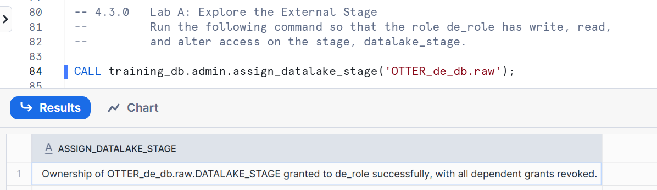

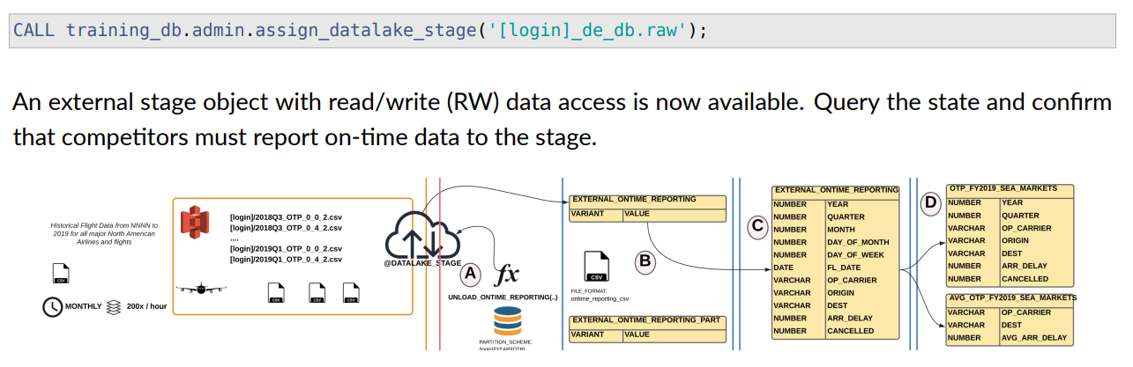

SHOW STAGES

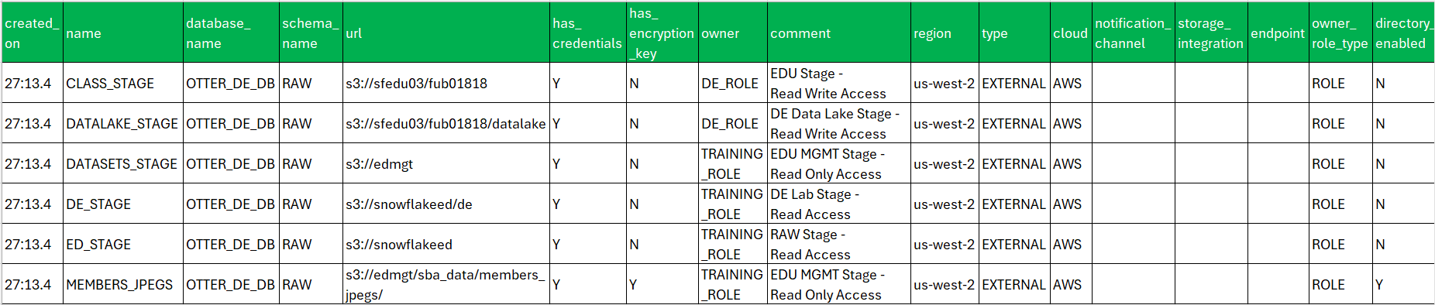

LIST @raw.datalake_stage/OTTER;

Initially Empty

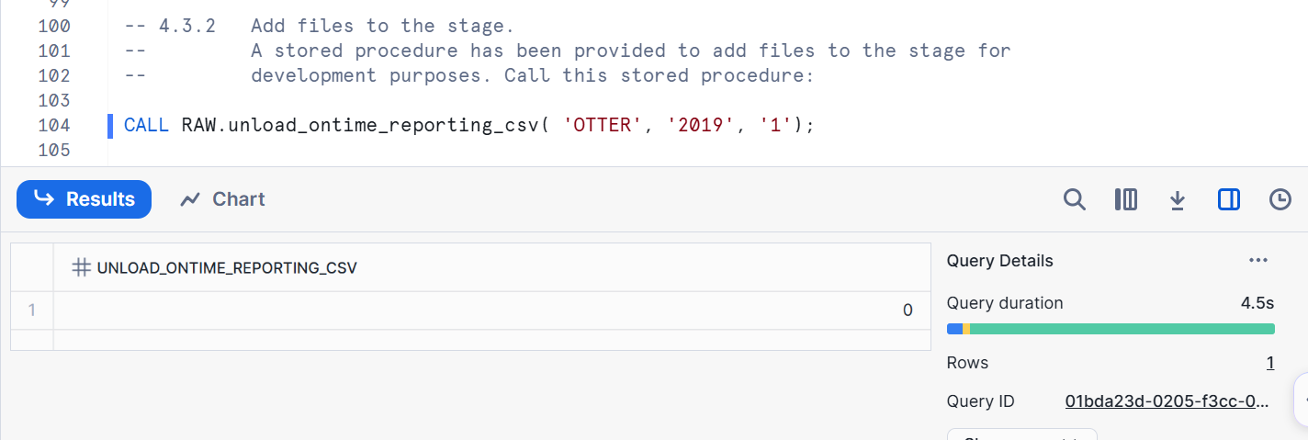

|  |
| --- |
| CREATE OR REPLACE PROCEDURE OTTER_DE_DB.RAW.UNLOAD_ONTIME_REPORTING_CSV("FOLDER" VARCHAR, "YEAR" VARCHAR, "QUARTER" VARCHAR)  RETURNS FLOAT  LANGUAGE JAVASCRIPT  STRICT  EXECUTE AS OWNER  AS '  var counter = 0;  var unload_qry = snowflake.execute({ sqlText: "copy into @raw.datalake_stage/" + FOLDER + "/" + YEAR +"Q" + QUARTER +"_OTP from (" +  " select * from raw.ONTIME_REPORTING WHERE YEAR = ''"+ YEAR +"'' AND QUARTER = ''"+ QUARTER +"'') " +  " OVERWRITE=TRUE file_format = (type = ''CSV'' COMPRESSION = NONE FIELD_DELIMITER = '','' " +  " skip_header = 1 NULL_IF = () FIELD_OPTIONALLY_ENCLOSED_BY=''\\"'');" });  return counter;  '; |

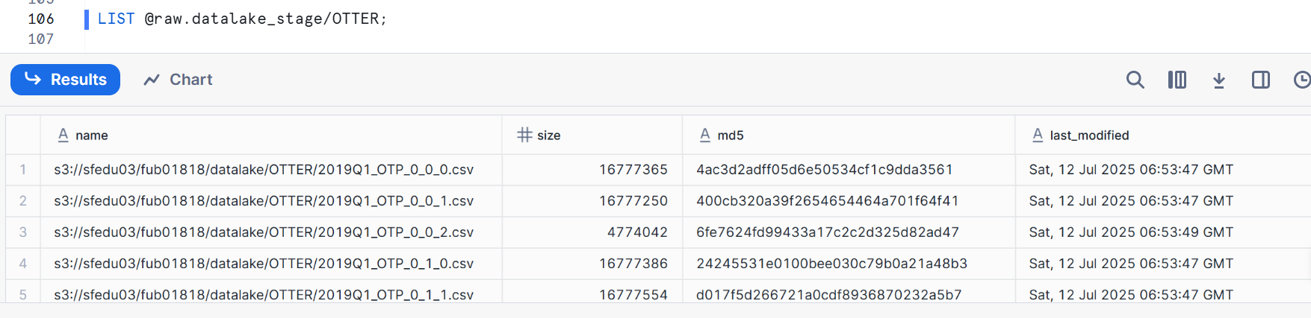

|  |  |  |  |
| --- | --- | --- | --- |
| NAME | SIZE | MD5 | LAST_MODIFIED |
| s3://sfedu03/fub01818/datalake/OTTER/2019Q1_OTP_0_0_0.csv | 16777365 | 4ac3d2adff05d6e50534cf1c9dda3561 | Sat, 12 Jul 2025 06:53:47 GMT |
| s3://sfedu03/fub01818/datalake/OTTER/2019Q1_OTP_0_0_1.csv | 16777250 | 400cb320a39f2654654464a701f64f41 | Sat, 12 Jul 2025 06:53:47 GMT |
| s3://sfedu03/fub01818/datalake/OTTER/2019Q1_OTP_0_0_2.csv | 4774042 | 6fe7624fd99433a17c2c2d325d82ad47 | Sat, 12 Jul 2025 06:53:49 GMT |
| s3://sfedu03/fub01818/datalake/OTTER/2019Q1_OTP_0_1_0.csv | 16777386 | 24245531e0100bee030c79b0a21a48b3 | Sat, 12 Jul 2025 06:53:47 GMT |
| s3://sfedu03/fub01818/datalake/OTTER/2019Q1_OTP_0_1_1.csv | 16777554 | d017f5d266721a0cdf8936870232a5b7 | Sat, 12 Jul 2025 06:53:47 GMT |
| s3://sfedu03/fub01818/datalake/OTTER/2019Q1_OTP_0_1_10.csv | 16777237 | c95168ceb5e945ea54f2b1a69f1e82a5 | Sat, 12 Jul 2025 06:53:49 GMT |
| s3://sfedu03/fub01818/datalake/OTTER/2019Q1_OTP_0_1_11.csv | 1394448 | 1a41c79c360431d55b65697c6330cc67 | Sat, 12 Jul 2025 06:53:49 GMT |
| s3://sfedu03/fub01818/datalake/OTTER/2019Q1_OTP_0_1_2.csv | 16777341 | 738b90494b11e1e3161ff0be70163a61 | Sat, 12 Jul 2025 06:53:47 GMT |
| s3://sfedu03/fub01818/datalake/OTTER/2019Q1_OTP_0_1_3.csv | 16777644 | 548cc3338cc800157d00b942eb4e60dc | Sat, 12 Jul 2025 06:53:48 GMT |
| s3://sfedu03/fub01818/datalake/OTTER/2019Q1_OTP_0_1_4.csv | 16777491 | 980d09777de627cc43fb4bec8cbd0e85 | Sat, 12 Jul 2025 06:53:48 GMT |
| s3://sfedu03/fub01818/datalake/OTTER/2019Q1_OTP_0_1_5.csv | 16777274 | b5dd02140c6d22cb42226d1d93dd8a13 | Sat, 12 Jul 2025 06:53:48 GMT |
| s3://sfedu03/fub01818/datalake/OTTER/2019Q1_OTP_0_1_6.csv | 16777228 | 23c614befc1e07625d4e92bcb8bf659f | Sat, 12 Jul 2025 06:53:48 GMT |
| s3://sfedu03/fub01818/datalake/OTTER/2019Q1_OTP_0_1_7.csv | 16777270 | 460a5d7d87c8382188f7fd8ced1116b4 | Sat, 12 Jul 2025 06:53:49 GMT |
| s3://sfedu03/fub01818/datalake/OTTER/2019Q1_OTP_0_1_8.csv | 16777573 | 88a3d50a19bca642e58f8ce0011bce2b | Sat, 12 Jul 2025 06:53:49 GMT |
| s3://sfedu03/fub01818/datalake/OTTER/2019Q1_OTP_0_1_9.csv | 16777311 | cf9c3f354557e19c733cad6aff50cc8b | Sat, 12 Jul 2025 06:53:49 GMT |
| s3://sfedu03/fub01818/datalake/OTTER/2019Q1_OTP_0_3_0.csv | 16777427 | dba1f9e06e9be17f9e8467a00d4ab4b8 | Sat, 12 Jul 2025 06:53:47 GMT |
| s3://sfedu03/fub01818/datalake/OTTER/2019Q1_OTP_0_3_1.csv | 16777429 | 3f2c4dbc9f4829a8e3e0acd0a9147d27 | Sat, 12 Jul 2025 06:53:47 GMT |
| s3://sfedu03/fub01818/datalake/OTTER/2019Q1_OTP_0_3_10.csv | 16632247 | 6d3f47167ca4b4f4a8b4231fa6e14d18 | Sat, 12 Jul 2025 06:53:49 GMT |
| s3://sfedu03/fub01818/datalake/OTTER/2019Q1_OTP_0_3_2.csv | 16777561 | 9f072f6b2ec4a790810c74786c0288ea | Sat, 12 Jul 2025 06:53:47 GMT |
| s3://sfedu03/fub01818/datalake/OTTER/2019Q1_OTP_0_3_3.csv | 16777356 | 407958a487b5e0f5172aad71e2eedb11 | Sat, 12 Jul 2025 06:53:47 GMT |
| s3://sfedu03/fub01818/datalake/OTTER/2019Q1_OTP_0_3_4.csv | 16777463 | ee9bdfc42af60ca622915b199d0f46d5 | Sat, 12 Jul 2025 06:53:48 GMT |
| s3://sfedu03/fub01818/datalake/OTTER/2019Q1_OTP_0_3_5.csv | 16777434 | 66d4db5437182f215ce3026be9edd3a6 | Sat, 12 Jul 2025 06:53:48 GMT |
| s3://sfedu03/fub01818/datalake/OTTER/2019Q1_OTP_0_3_6.csv | 16777495 | ede2b568f426c6ec4ddd8b14e2c25e0c | Sat, 12 Jul 2025 06:53:48 GMT |
| s3://sfedu03/fub01818/datalake/OTTER/2019Q1_OTP_0_3_7.csv | 16777566 | 18e4c8a00d545f15058990a9041bfc38 | Sat, 12 Jul 2025 06:53:49 GMT |
| s3://sfedu03/fub01818/datalake/OTTER/2019Q1_OTP_0_3_8.csv | 16777572 | ee8d4068765113fedc48dc62e6d388b2 | Sat, 12 Jul 2025 06:53:49 GMT |
| s3://sfedu03/fub01818/datalake/OTTER/2019Q1_OTP_0_3_9.csv | 16777240 | 7437bbdf209ef687f081a7952bc58877 | Sat, 12 Jul 2025 06:53:49 GMT |
| s3://sfedu03/fub01818/datalake/OTTER/2019Q1_OTP_0_4_0.csv | 16777417 | fee1fb14aa550f9e017ff63faff45dfc | Sat, 12 Jul 2025 06:53:47 GMT |
| s3://sfedu03/fub01818/datalake/OTTER/2019Q1_OTP_0_4_1.csv | 16777354 | 7ea2e16d9250852131550515fb0df4b7 | Sat, 12 Jul 2025 06:53:47 GMT |
| s3://sfedu03/fub01818/datalake/OTTER/2019Q1_OTP_0_4_2.csv | 16777332 | 7a9caee89ccf282dbbf75139bb77e263 | Sat, 12 Jul 2025 06:53:47 GMT |
| s3://sfedu03/fub01818/datalake/OTTER/2019Q1_OTP_0_4_3.csv | 9221356 | 88fb059ccd6f7b965bf648e3d0d033c5 | Sat, 12 Jul 2025 06:53:49 GMT |
| s3://sfedu03/fub01818/datalake/OTTER/2019Q1_OTP_0_6_0.csv | 16777570 | 17755651c3a04a68f5b988a1c122bf1d | Sat, 12 Jul 2025 06:53:47 GMT |
| s3://sfedu03/fub01818/datalake/OTTER/2019Q1_OTP_0_6_1.csv | 16777316 | f905b6e3d3a9e5bb71fd387d29149ea8 | Sat, 12 Jul 2025 06:53:47 GMT |
| s3://sfedu03/fub01818/datalake/OTTER/2019Q1_OTP_0_6_2.csv | 16777314 | cf85b64ee241e297005e69d351304a8b | Sat, 12 Jul 2025 06:53:47 GMT |
| s3://sfedu03/fub01818/datalake/OTTER/2019Q1_OTP_0_6_3.csv | 16777495 | e9e908fb54690e02b3dfe543bb0df950 | Sat, 12 Jul 2025 06:53:47 GMT |
| s3://sfedu03/fub01818/datalake/OTTER/2019Q1_OTP_0_6_4.csv | 14392462 | 9dba142f2921e1e3eb7e04020fac3323 | Sat, 12 Jul 2025 06:53:49 GMT |
| s3://sfedu03/fub01818/datalake/OTTER/2019Q1_OTP_0_7_0.csv | 16777276 | 5434c524e619d7073368d23a8c114307 | Sat, 12 Jul 2025 06:53:47 GMT |
| s3://sfedu03/fub01818/datalake/OTTER/2019Q1_OTP_0_7_1.csv | 16777660 | 85e085e6af45eece79840b5f82c26ac7 | Sat, 12 Jul 2025 06:53:47 GMT |
| s3://sfedu03/fub01818/datalake/OTTER/2019Q1_OTP_0_7_10.csv | 16777610 | 4cd49a2ff2b14f53efa9b6efe228ec18 | Sat, 12 Jul 2025 06:53:49 GMT |
| s3://sfedu03/fub01818/datalake/OTTER/2019Q1_OTP_0_7_11.csv | 1982704 | 67cbc8b5257bda473036fe4f3752bf55 | Sat, 12 Jul 2025 06:53:49 GMT |
| s3://sfedu03/fub01818/datalake/OTTER/2019Q1_OTP_0_7_2.csv | 16777448 | ef4d65ab8c0c1fca89550a46ec279258 | Sat, 12 Jul 2025 06:53:47 GMT |
| s3://sfedu03/fub01818/datalake/OTTER/2019Q1_OTP_0_7_3.csv | 16777259 | 4c38943f2ef81cd1f41fd106f3dab279 | Sat, 12 Jul 2025 06:53:48 GMT |
| s3://sfedu03/fub01818/datalake/OTTER/2019Q1_OTP_0_7_4.csv | 16777352 | cf2aaef79147b6064d57f6f0215dfe56 | Sat, 12 Jul 2025 06:53:48 GMT |
| s3://sfedu03/fub01818/datalake/OTTER/2019Q1_OTP_0_7_5.csv | 16777450 | df1c4028cd65c81d1e3b0c9b15e58943 | Sat, 12 Jul 2025 06:53:48 GMT |
| s3://sfedu03/fub01818/datalake/OTTER/2019Q1_OTP_0_7_6.csv | 16777439 | 94988eaf1dff920004f154a875b91817 | Sat, 12 Jul 2025 06:53:48 GMT |
| s3://sfedu03/fub01818/datalake/OTTER/2019Q1_OTP_0_7_7.csv | 16777567 | 0c6273bf0d929b72979af738b626cda9 | Sat, 12 Jul 2025 06:53:49 GMT |
| s3://sfedu03/fub01818/datalake/OTTER/2019Q1_OTP_0_7_8.csv | 16777256 | 3ca04402b94b51733d4582a8922d2ced | Sat, 12 Jul 2025 06:53:49 GMT |
| s3://sfedu03/fub01818/datalake/OTTER/2019Q1_OTP_0_7_9.csv | 16777542 | 305432e2c3865a2fe0e88f31eaddd6c4 | Sat, 12 Jul 2025 06:53:49 GMT |

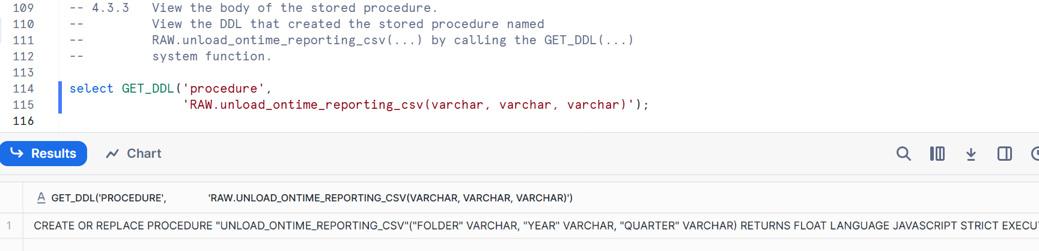

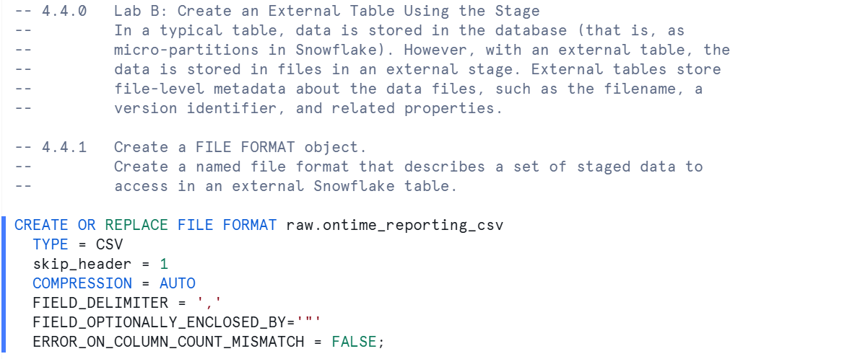

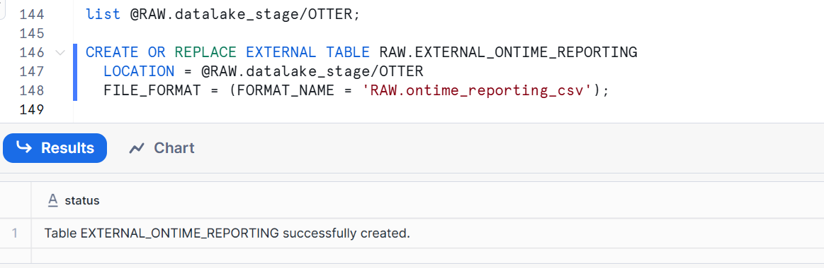

SHOW TABLES

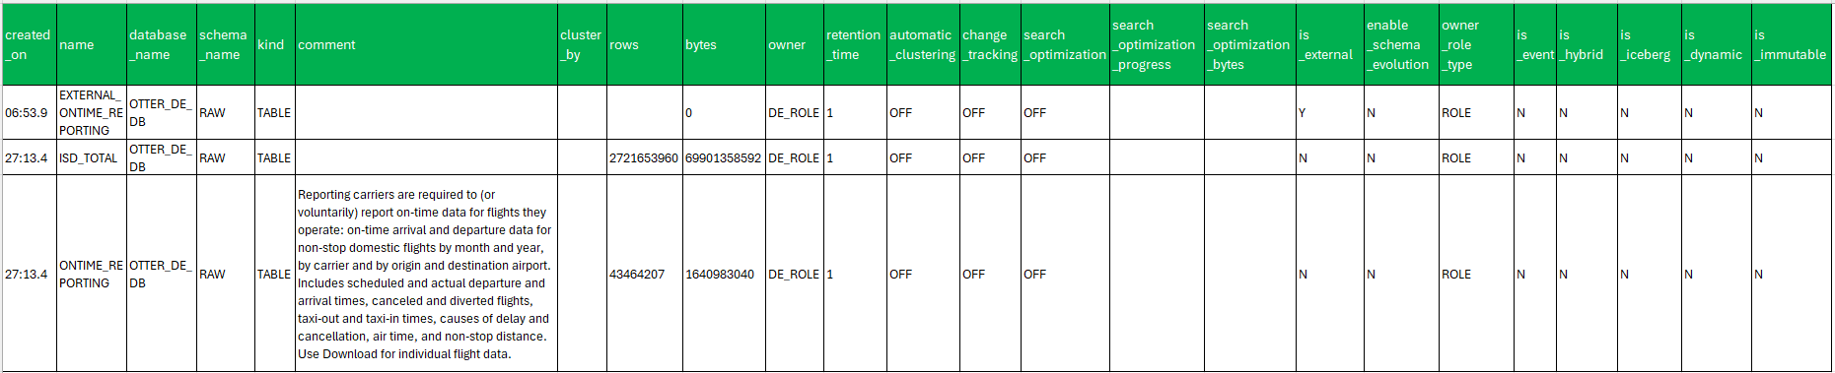

SHOW EXTERNAL TABLES

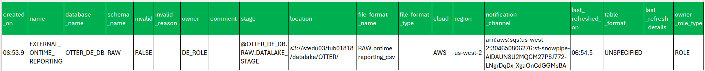

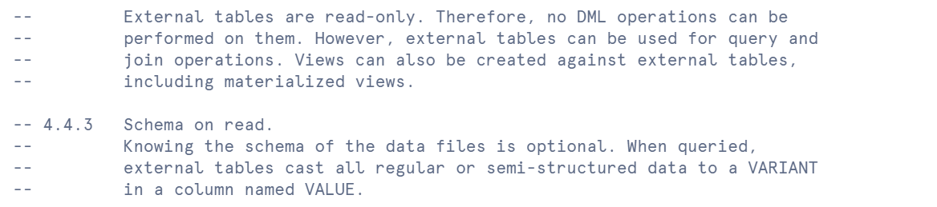

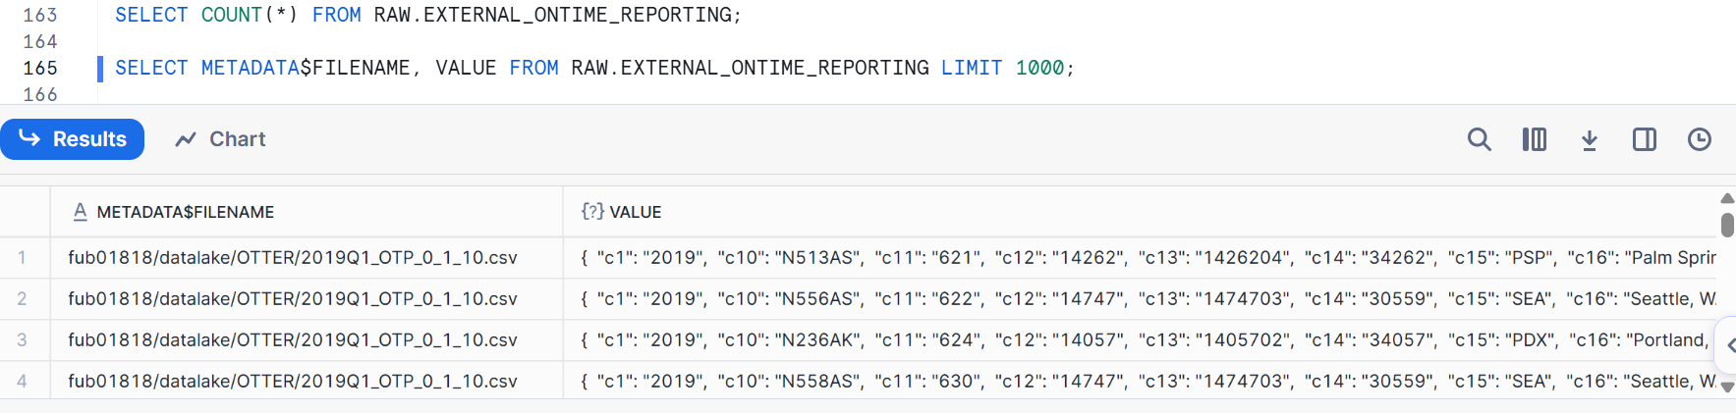

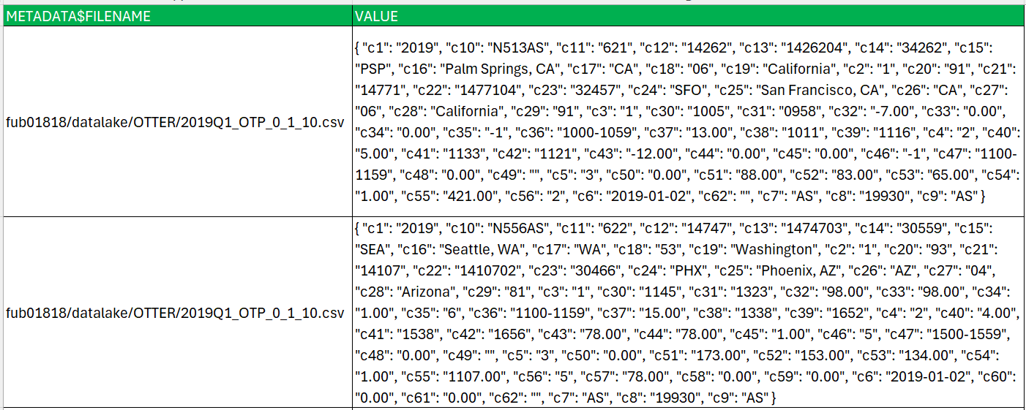

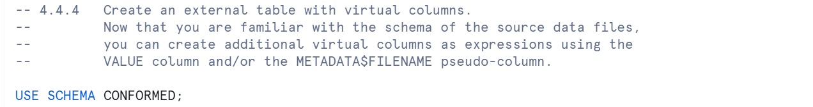

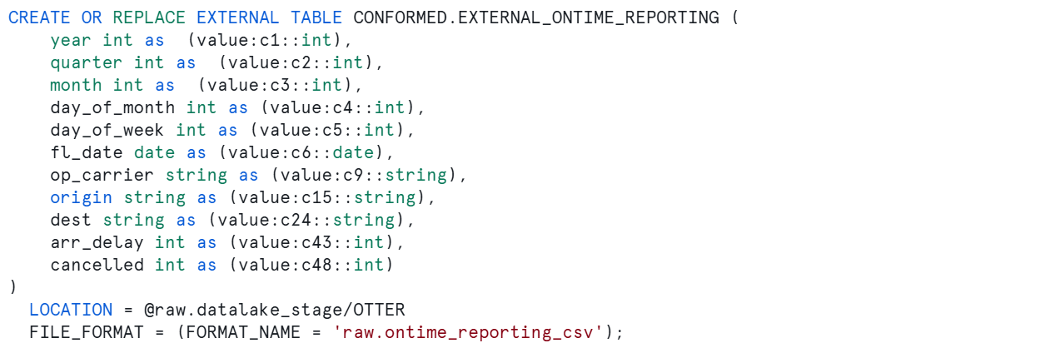

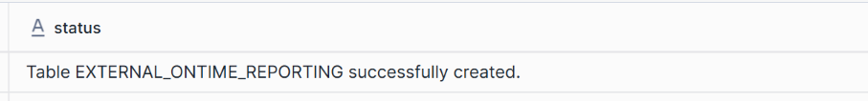

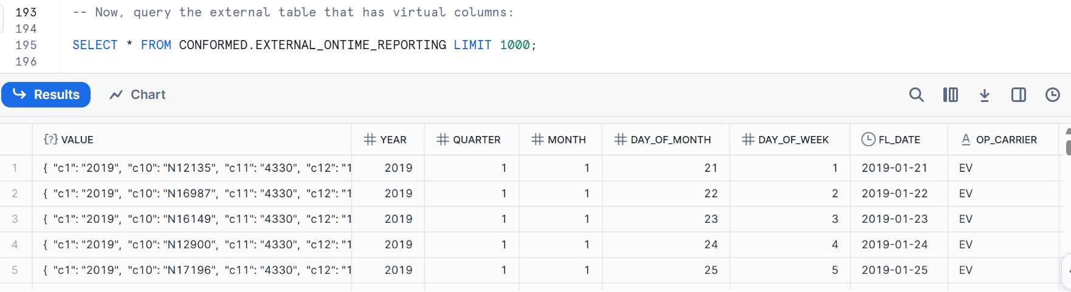

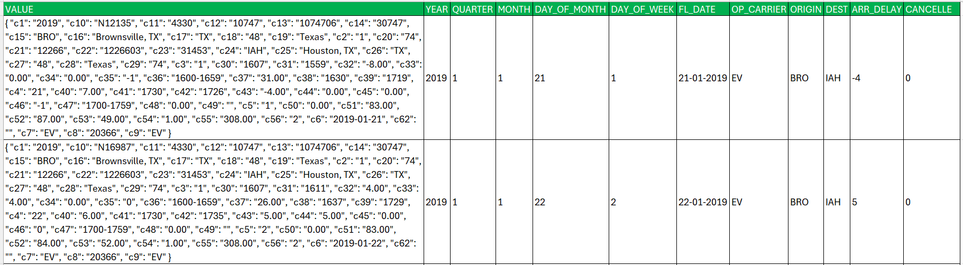

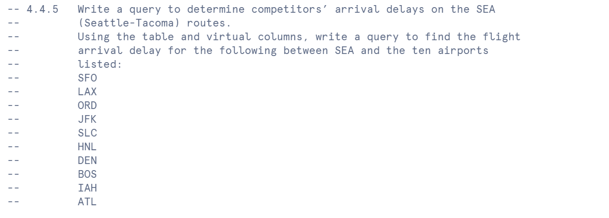

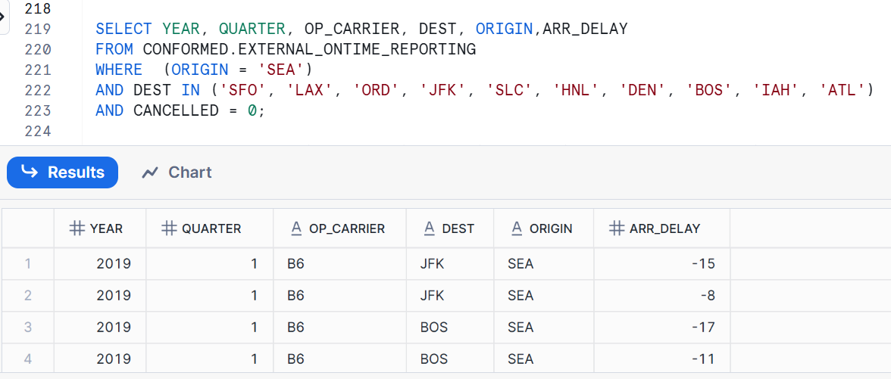

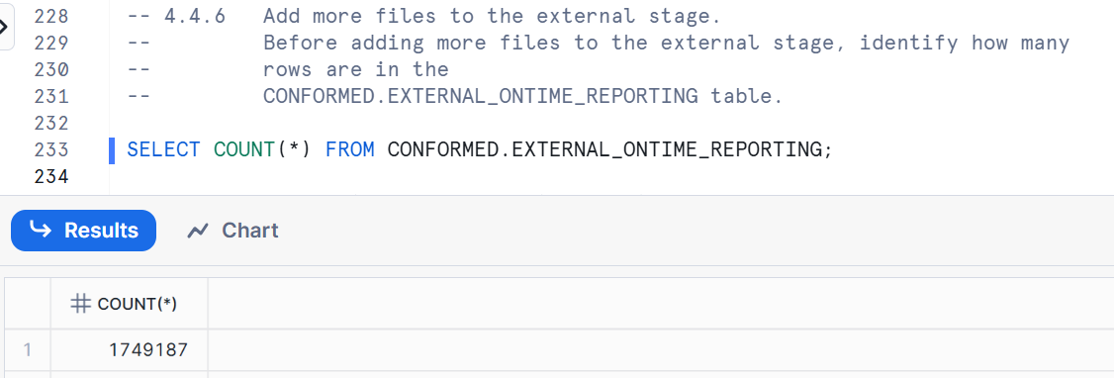

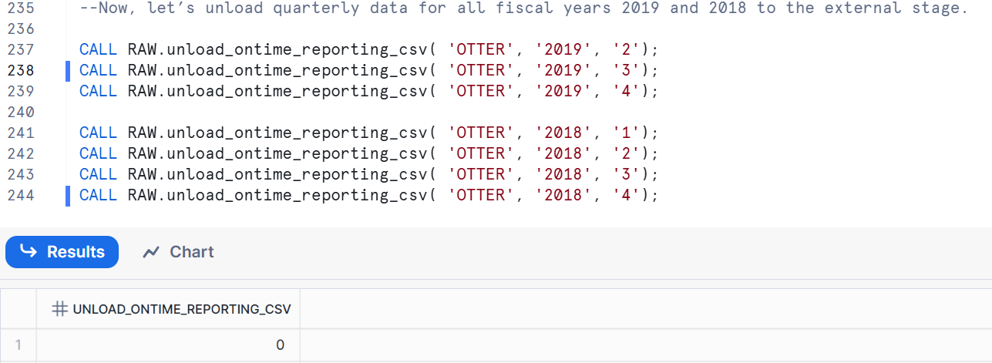

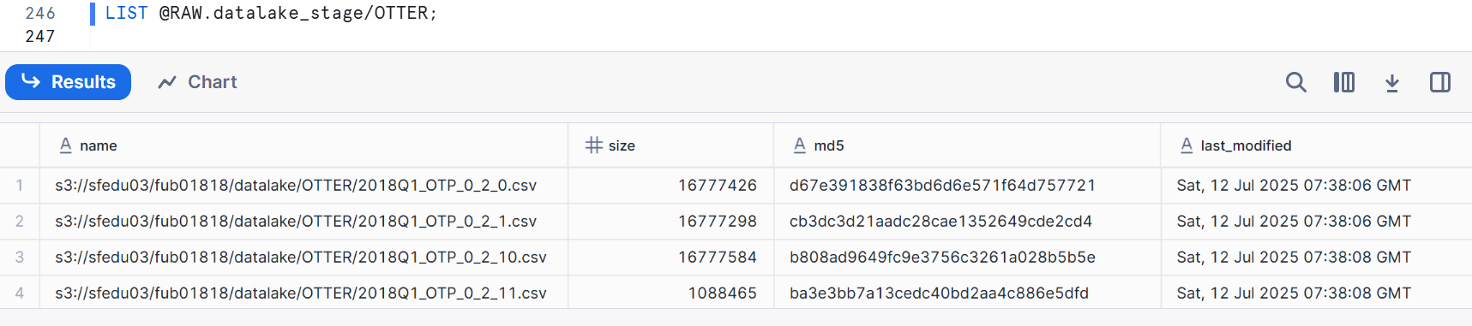

|  |  |  |  |
| --- | --- | --- | --- |
| NAME | SIZE | MD5 | LAST_MODIFIED |
| s3://sfedu03/fub01818/datalake/OTTER/2018Q1_OTP_0_2_0.csv | 16777426 | d67e391838f63bd6d6e571f64d757721 | Sat, 12 Jul 2025 07:38:06 GMT |
| s3://sfedu03/fub01818/datalake/OTTER/2018Q1_OTP_0_2_1.csv | 16777298 | cb3dc3d21aadc28cae1352649cde2cd4 | Sat, 12 Jul 2025 07:38:06 GMT |
| s3://sfedu03/fub01818/datalake/OTTER/2018Q1_OTP_0_2_10.csv | 16777584 | b808ad9649fc9e3756c3261a028b5b5e | Sat, 12 Jul 2025 07:38:08 GMT |
| s3://sfedu03/fub01818/datalake/OTTER/2018Q1_OTP_0_2_11.csv | 1088465 | ba3e3bb7a13cedc40bd2aa4c886e5dfd | Sat, 12 Jul 2025 07:38:08 GMT |
| s3://sfedu03/fub01818/datalake/OTTER/2018Q1_OTP_0_2_2.csv | 16777571 | 3de2e31416e5228a24c25c6b5630d59d | Sat, 12 Jul 2025 07:38:06 GMT |
| s3://sfedu03/fub01818/datalake/OTTER/2018Q1_OTP_0_2_3.csv | 16777447 | e5c11ed15695d478b47faeacaa5f31c3 | Sat, 12 Jul 2025 07:38:07 GMT |
| s3://sfedu03/fub01818/datalake/OTTER/2018Q1_OTP_0_2_4.csv | 16777219 | 00598440d6123f50961f7c8c6bcc3364 | Sat, 12 Jul 2025 07:38:07 GMT |
| s3://sfedu03/fub01818/datalake/OTTER/2018Q1_OTP_0_2_5.csv | 16777288 | 8a8838c69245887941c029bb80040091 | Sat, 12 Jul 2025 07:38:07 GMT |
| s3://sfedu03/fub01818/datalake/OTTER/2018Q1_OTP_0_2_6.csv | 16777315 | 329333cdef6f7b0bbb39a3036f84ff34 | Sat, 12 Jul 2025 07:38:07 GMT |
| s3://sfedu03/fub01818/datalake/OTTER/2018Q1_OTP_0_2_7.csv | 16777357 | 72ead8e9c612715871c052b2977d7849 | Sat, 12 Jul 2025 07:38:08 GMT |
| s3://sfedu03/fub01818/datalake/OTTER/2018Q1_OTP_0_2_8.csv | 16777500 | 3e5c0ac42de97f9008e6e1d9d31878d9 | Sat, 12 Jul 2025 07:38:08 GMT |
| s3://sfedu03/fub01818/datalake/OTTER/2018Q1_OTP_0_2_9.csv | 16777368 | e39774da1b44831ac389cd7bcc25aeaa | Sat, 12 Jul 2025 07:38:08 GMT |
| s3://sfedu03/fub01818/datalake/OTTER/2018Q1_OTP_0_3_0.csv | 16777506 | 8fa2d59c9ad0836e14944e1b3ed4a9b4 | Sat, 12 Jul 2025 07:38:06 GMT |
| s3://sfedu03/fub01818/datalake/OTTER/2018Q1_OTP_0_3_1.csv | 16777419 | 76c209b84d2762034637ce974d9ba9ca | Sat, 12 Jul 2025 07:38:06 GMT |
| s3://sfedu03/fub01818/datalake/OTTER/2018Q1_OTP_0_3_10.csv | 16777577 | e72219fba2fed263a14821c1120b0033 | Sat, 12 Jul 2025 07:38:08 GMT |
| s3://sfedu03/fub01818/datalake/OTTER/2018Q1_OTP_0_3_11.csv | 1038234 | 1eb27cfc3a2f91a0b279546a1358a239 | Sat, 12 Jul 2025 07:38:08 GMT |
| s3://sfedu03/fub01818/datalake/OTTER/2018Q1_OTP_0_3_2.csv | 16777502 | bbcf366414770f3c7196736017790522 | Sat, 12 Jul 2025 07:38:06 GMT |
| s3://sfedu03/fub01818/datalake/OTTER/2018Q1_OTP_0_3_3.csv | 16777476 | a107049f3781728f15b0e23b475eb312 | Sat, 12 Jul 2025 07:38:07 GMT |
| s3://sfedu03/fub01818/datalake/OTTER/2018Q1_OTP_0_3_4.csv | 16777442 | a215590b8787cc1788f90c53be1fad5c | Sat, 12 Jul 2025 07:38:07 GMT |
| s3://sfedu03/fub01818/datalake/OTTER/2018Q1_OTP_0_3_5.csv | 16777339 | ab95679d9c6c2d8c6a53514751e0a951 | Sat, 12 Jul 2025 07:38:07 GMT |
| s3://sfedu03/fub01818/datalake/OTTER/2018Q1_OTP_0_3_6.csv | 16777277 | 1fd2478396dfd5ee3544eaafe47327a3 | Sat, 12 Jul 2025 07:38:07 GMT |
| s3://sfedu03/fub01818/datalake/OTTER/2018Q1_OTP_0_3_7.csv | 16777548 | aa6e485c9af27a66cbd50bffb1d0dbec | Sat, 12 Jul 2025 07:38:08 GMT |
| s3://sfedu03/fub01818/datalake/OTTER/2018Q1_OTP_0_3_8.csv | 16777226 | 7c7dbb4aa346a494c9ee60170f8ce5cc | Sat, 12 Jul 2025 07:38:08 GMT |
| s3://sfedu03/fub01818/datalake/OTTER/2018Q1_OTP_0_3_9.csv | 16777540 | 6f665df5168704a4400d443fa34eb9c7 | Sat, 12 Jul 2025 07:38:08 GMT |
| s3://sfedu03/fub01818/datalake/OTTER/2018Q1_OTP_0_4_0.csv | 16777278 | a2bbc7c12daaffb2d754272ea22183ca | Sat, 12 Jul 2025 07:38:06 GMT |
| s3://sfedu03/fub01818/datalake/OTTER/2018Q1_OTP_0_4_1.csv | 16777447 | 378e78dd25b2b8e3cb53aa2e82480654 | Sat, 12 Jul 2025 07:38:06 GMT |
| s3://sfedu03/fub01818/datalake/OTTER/2018Q1_OTP_0_4_10.csv | 16777282 | ec11dd6b656909aa09ca86af90c840e8 | Sat, 12 Jul 2025 07:38:08 GMT |
| s3://sfedu03/fub01818/datalake/OTTER/2018Q1_OTP_0_4_11.csv | 135391 | 56da285a265e57c342b7b9e0ac0f634f | Sat, 12 Jul 2025 07:38:08 GMT |
| s3://sfedu03/fub01818/datalake/OTTER/2018Q1_OTP_0_4_2.csv | 16777376 | 264353cadccf78f0f0fecf91de7b39b7 | Sat, 12 Jul 2025 07:38:06 GMT |
| s3://sfedu03/fub01818/datalake/OTTER/2018Q1_OTP_0_4_3.csv | 16777291 | c6c7464f71efbb844755cf536a1647ba | Sat, 12 Jul 2025 07:38:07 GMT |
| s3://sfedu03/fub01818/datalake/OTTER/2018Q1_OTP_0_4_4.csv | 16777426 | a6127b18d1d6732f1b0dfc169b7dc009 | Sat, 12 Jul 2025 07:38:07 GMT |
| s3://sfedu03/fub01818/datalake/OTTER/2018Q1_OTP_0_4_5.csv | 16777313 | d47f96e082c7c5b0a2e3b05e1e56f721 | Sat, 12 Jul 2025 07:38:07 GMT |
| s3://sfedu03/fub01818/datalake/OTTER/2018Q1_OTP_0_4_6.csv | 16777316 | a9aee9b57e2e6f6f1a16664258b55d07 | Sat, 12 Jul 2025 07:38:07 GMT |
| s3://sfedu03/fub01818/datalake/OTTER/2018Q1_OTP_0_4_7.csv | 16777266 | 9c5d2ae3f7be3d73cb58050d8a9c15d4 | Sat, 12 Jul 2025 07:38:08 GMT |
| s3://sfedu03/fub01818/datalake/OTTER/2018Q1_OTP_0_4_8.csv | 16777627 | 57a7749f9738f95df3ab8c15d96edd16 | Sat, 12 Jul 2025 07:38:08 GMT |
| s3://sfedu03/fub01818/datalake/OTTER/2018Q1_OTP_0_4_9.csv | 16777470 | ade7bbe6655c5abcb0b41a05b5ff3524 | Sat, 12 Jul 2025 07:38:08 GMT |
| s3://sfedu03/fub01818/datalake/OTTER/2018Q1_OTP_0_5_0.csv | 16777272 | 561407c7bcbf94409ff3374d5a48dc9d | Sat, 12 Jul 2025 07:38:06 GMT |
| s3://sfedu03/fub01818/datalake/OTTER/2018Q1_OTP_0_5_1.csv | 16777497 | 575a49a9cc29a82ca67b868f721bc9f2 | Sat, 12 Jul 2025 07:38:06 GMT |
| s3://sfedu03/fub01818/datalake/OTTER/2018Q1_OTP_0_5_2.csv | 16777503 | 405aa163982ca4b637d107543ffe17bd | Sat, 12 Jul 2025 07:38:06 GMT |
| s3://sfedu03/fub01818/datalake/OTTER/2018Q1_OTP_0_5_3.csv | 16777569 | 75981862eba969100aa0924ae622a4b9 | Sat, 12 Jul 2025 07:38:07 GMT |
| s3://sfedu03/fub01818/datalake/OTTER/2018Q1_OTP_0_5_4.csv | 4060023 | 547a822b0e63a9c6bd4cc5c6caa6b1db | Sat, 12 Jul 2025 07:38:08 GMT |
| s3://sfedu03/fub01818/datalake/OTTER/2018Q1_OTP_0_6_0.csv | 16777265 | e21b166b9da7cf7e51682efeeca12227 | Sat, 12 Jul 2025 07:38:06 GMT |
| s3://sfedu03/fub01818/datalake/OTTER/2018Q1_OTP_0_6_1.csv | 16777367 | b2fd0aecdd52f7d75c51dc8ac08cc832 | Sat, 12 Jul 2025 07:38:06 GMT |
| s3://sfedu03/fub01818/datalake/OTTER/2018Q1_OTP_0_6_2.csv | 1222056 | 7be06bcc7db17a1186a9b73de7b4486c | Sat, 12 Jul 2025 07:38:09 GMT |
| s3://sfedu03/fub01818/datalake/OTTER/2018Q1_OTP_0_7_0.csv | 16777421 | 0f782b41dd6a7839b4170c62e9d7a93e | Sat, 12 Jul 2025 07:38:06 GMT |
| s3://sfedu03/fub01818/datalake/OTTER/2018Q1_OTP_0_7_1.csv | 16777247 | f19af6e8c726c88d2ba605b8a0ba5624 | Sat, 12 Jul 2025 07:38:06 GMT |
| s3://sfedu03/fub01818/datalake/OTTER/2018Q1_OTP_0_7_2.csv | 16777318 | 8f927f3bdb56aac26acec2f29ea62957 | Sat, 12 Jul 2025 07:38:06 GMT |
| s3://sfedu03/fub01818/datalake/OTTER/2018Q1_OTP_0_7_3.csv | 3392017 | e36e3005479f78a53837dc2950277e9c | Sat, 12 Jul 2025 07:38:08 GMT |
| s3://sfedu03/fub01818/datalake/OTTER/2018Q2_OTP_0_0_0.csv | 16777617 | cadd0af44a938dbfc748fbf16fd0a27c | Sat, 12 Jul 2025 07:38:13 GMT |
| s3://sfedu03/fub01818/datalake/OTTER/2018Q2_OTP_0_0_1.csv | 16777333 | b293071bd03b38a9d35a08e69796aafc | Sat, 12 Jul 2025 07:38:13 GMT |
| s3://sfedu03/fub01818/datalake/OTTER/2018Q2_OTP_0_0_10.csv | 16777332 | d3108dd47adcfcc5e8d9684bf8834571 | Sat, 12 Jul 2025 07:38:16 GMT |
| s3://sfedu03/fub01818/datalake/OTTER/2018Q2_OTP_0_0_11.csv | 431699 | 8086fbaff7d7943f13f040bbe4ea8e0e | Sat, 12 Jul 2025 07:38:16 GMT |
| s3://sfedu03/fub01818/datalake/OTTER/2018Q2_OTP_0_0_2.csv | 16777619 | 09ab9e5667c763f263e56b8fa23d0e9d | Sat, 12 Jul 2025 07:38:13 GMT |
| s3://sfedu03/fub01818/datalake/OTTER/2018Q2_OTP_0_0_3.csv | 16777356 | bf44deb23de01d4c143d7f9d34033324 | Sat, 12 Jul 2025 07:38:14 GMT |
| s3://sfedu03/fub01818/datalake/OTTER/2018Q2_OTP_0_0_4.csv | 16777465 | d81a525d7d73694b796ed05fde231b06 | Sat, 12 Jul 2025 07:38:14 GMT |
| s3://sfedu03/fub01818/datalake/OTTER/2018Q2_OTP_0_0_5.csv | 16777454 | bbb7b161006c3521baaa3b6afbdcd606 | Sat, 12 Jul 2025 07:38:14 GMT |
| s3://sfedu03/fub01818/datalake/OTTER/2018Q2_OTP_0_0_6.csv | 16777393 | 90f37471da722b042a07fdc618356cb9 | Sat, 12 Jul 2025 07:38:14 GMT |
| s3://sfedu03/fub01818/datalake/OTTER/2018Q2_OTP_0_0_7.csv | 16777492 | 45c043b75e1fca74cb1f74b9ae383012 | Sat, 12 Jul 2025 07:38:15 GMT |
| s3://sfedu03/fub01818/datalake/OTTER/2018Q2_OTP_0_0_8.csv | 16777230 | b05a21d6017341990923668eae7a1a78 | Sat, 12 Jul 2025 07:38:15 GMT |
| s3://sfedu03/fub01818/datalake/OTTER/2018Q2_OTP_0_0_9.csv | 16777529 | 91440e172ef57e040b9cf40c4ebf7792 | Sat, 12 Jul 2025 07:38:15 GMT |
| s3://sfedu03/fub01818/datalake/OTTER/2018Q2_OTP_0_1_0.csv | 16777520 | 9fafcc42e38a7b80eb18d3bf64736377 | Sat, 12 Jul 2025 07:38:13 GMT |
| s3://sfedu03/fub01818/datalake/OTTER/2018Q2_OTP_0_1_1.csv | 16777493 | da2645cff2458c0e62f52007398ecaf0 | Sat, 12 Jul 2025 07:38:13 GMT |
| s3://sfedu03/fub01818/datalake/OTTER/2018Q2_OTP_0_1_10.csv | 16777475 | 3116056371230c7eacb360a18e7b9ad2 | Sat, 12 Jul 2025 07:38:15 GMT |
| s3://sfedu03/fub01818/datalake/OTTER/2018Q2_OTP_0_1_11.csv | 479879 | f7a43df18c540fd67d6bc040f4fa6284 | Sat, 12 Jul 2025 07:38:16 GMT |
| s3://sfedu03/fub01818/datalake/OTTER/2018Q2_OTP_0_1_2.csv | 16777635 | 45371ace54b88aba73f2cc6b12767cca | Sat, 12 Jul 2025 07:38:13 GMT |
| s3://sfedu03/fub01818/datalake/OTTER/2018Q2_OTP_0_1_3.csv | 16777466 | 4cd1d9b787c966f491dac2ccae341fb6 | Sat, 12 Jul 2025 07:38:14 GMT |
| s3://sfedu03/fub01818/datalake/OTTER/2018Q2_OTP_0_1_4.csv | 16777388 | 79f914be41680d94fabc1945962c2798 | Sat, 12 Jul 2025 07:38:14 GMT |
| s3://sfedu03/fub01818/datalake/OTTER/2018Q2_OTP_0_1_5.csv | 16777575 | ac8e8930cfb45bb7fbcd9ee917ff4f98 | Sat, 12 Jul 2025 07:38:14 GMT |
| s3://sfedu03/fub01818/datalake/OTTER/2018Q2_OTP_0_1_6.csv | 16777218 | 233cba7dec3976b437dd2efba556aa74 | Sat, 12 Jul 2025 07:38:14 GMT |
| s3://sfedu03/fub01818/datalake/OTTER/2018Q2_OTP_0_1_7.csv | 16777535 | 00f425e0b8b10ee4ecd2e4655f4ce455 | Sat, 12 Jul 2025 07:38:15 GMT |
| s3://sfedu03/fub01818/datalake/OTTER/2018Q2_OTP_0_1_8.csv | 16777230 | 2cd95a9515a9c20b61e5dab2f9561f4d | Sat, 12 Jul 2025 07:38:15 GMT |
| s3://sfedu03/fub01818/datalake/OTTER/2018Q2_OTP_0_1_9.csv | 16777374 | df51c77ea112e5ffbed8a0da7567b588 | Sat, 12 Jul 2025 07:38:15 GMT |
| s3://sfedu03/fub01818/datalake/OTTER/2018Q2_OTP_0_4_0.csv | 16777444 | 2ac33c4562c3d4e203b2621e921988c1 | Sat, 12 Jul 2025 07:38:13 GMT |
| s3://sfedu03/fub01818/datalake/OTTER/2018Q2_OTP_0_4_1.csv | 16777264 | 1ca07dd597edca300c0276f5126bef11 | Sat, 12 Jul 2025 07:38:13 GMT |
| s3://sfedu03/fub01818/datalake/OTTER/2018Q2_OTP_0_4_2.csv | 16777235 | 1b9a71a062b0f4547c0f95d7915b8a0d | Sat, 12 Jul 2025 07:38:13 GMT |
| s3://sfedu03/fub01818/datalake/OTTER/2018Q2_OTP_0_4_3.csv | 16324544 | 3d8a149e87efb90418b5b093746c6ad6 | Sat, 12 Jul 2025 07:38:16 GMT |
| s3://sfedu03/fub01818/datalake/OTTER/2018Q2_OTP_0_5_0.csv | 16777486 | 44fae3cfd2df338d8f548a1c823a7b80 | Sat, 12 Jul 2025 07:38:13 GMT |
| s3://sfedu03/fub01818/datalake/OTTER/2018Q2_OTP_0_5_1.csv | 16777616 | 482a369fb87ca3c736e1781d2ae2d6b7 | Sat, 12 Jul 2025 07:38:13 GMT |
| s3://sfedu03/fub01818/datalake/OTTER/2018Q2_OTP_0_5_10.csv | 16777323 | ea0cb77b353808e7a047f1f7007fc688 | Sat, 12 Jul 2025 07:38:15 GMT |
| s3://sfedu03/fub01818/datalake/OTTER/2018Q2_OTP_0_5_11.csv | 114113 | a6f612f10304aea3de803e12c0640537 | Sat, 12 Jul 2025 07:38:16 GMT |
| s3://sfedu03/fub01818/datalake/OTTER/2018Q2_OTP_0_5_2.csv | 16777581 | 9c50662697666342855f83d6566754ff | Sat, 12 Jul 2025 07:38:13 GMT |
| s3://sfedu03/fub01818/datalake/OTTER/2018Q2_OTP_0_5_3.csv | 16777452 | c2043d50ebd7d915056d72dcbec0f8d2 | Sat, 12 Jul 2025 07:38:14 GMT |
| s3://sfedu03/fub01818/datalake/OTTER/2018Q2_OTP_0_5_4.csv | 16777365 | b24daf48d7b071f1ea609334f303add6 | Sat, 12 Jul 2025 07:38:14 GMT |
| s3://sfedu03/fub01818/datalake/OTTER/2018Q2_OTP_0_5_5.csv | 16777394 | 3d304fa8397c5f5ee9df2dbbf6b40297 | Sat, 12 Jul 2025 07:38:14 GMT |
| s3://sfedu03/fub01818/datalake/OTTER/2018Q2_OTP_0_5_6.csv | 16777403 | 915846e6f870115952297c1824240a08 | Sat, 12 Jul 2025 07:38:14 GMT |
| s3://sfedu03/fub01818/datalake/OTTER/2018Q2_OTP_0_5_7.csv | 16777622 | 4ec2a6a55ecca55eae50e9b2d887c662 | Sat, 12 Jul 2025 07:38:15 GMT |
| s3://sfedu03/fub01818/datalake/OTTER/2018Q2_OTP_0_5_8.csv | 16777552 | 4bc552e46508447df58947a9eabd818c | Sat, 12 Jul 2025 07:38:15 GMT |
| s3://sfedu03/fub01818/datalake/OTTER/2018Q2_OTP_0_5_9.csv | 16777414 | 6d2b8b392dd7505afbc6184b47eee780 | Sat, 12 Jul 2025 07:38:15 GMT |
| s3://sfedu03/fub01818/datalake/OTTER/2018Q2_OTP_0_6_0.csv | 16777528 | 1cbba2d19682b5cbf99806fa0ca8e7b1 | Sat, 12 Jul 2025 07:38:13 GMT |
| s3://sfedu03/fub01818/datalake/OTTER/2018Q2_OTP_0_6_1.csv | 16777435 | 8ebeaca1a3602cb24b0fc2946de58a76 | Sat, 12 Jul 2025 07:38:13 GMT |
| s3://sfedu03/fub01818/datalake/OTTER/2018Q2_OTP_0_6_2.csv | 16777247 | 59e676e37b1d063899df82a1dbd560f8 | Sat, 12 Jul 2025 07:38:14 GMT |
| s3://sfedu03/fub01818/datalake/OTTER/2018Q2_OTP_0_6_3.csv | 16777454 | aafc38dcd04a15a47343f2a6f6212b01 | Sat, 12 Jul 2025 07:38:14 GMT |
| s3://sfedu03/fub01818/datalake/OTTER/2018Q2_OTP_0_6_4.csv | 8161697 | 575e0261955a9990bb706cfdd41f1d4e | Sat, 12 Jul 2025 07:38:16 GMT |
| s3://sfedu03/fub01818/datalake/OTTER/2018Q2_OTP_0_7_0.csv | 16777507 | f35b9a6351fd10edfe6d09cb8d185cbd | Sat, 12 Jul 2025 07:38:13 GMT |
| s3://sfedu03/fub01818/datalake/OTTER/2018Q2_OTP_0_7_1.csv | 16777492 | 1f63681193a2f5ec82737e92c9ddaf57 | Sat, 12 Jul 2025 07:38:13 GMT |
| s3://sfedu03/fub01818/datalake/OTTER/2018Q2_OTP_0_7_2.csv | 16777332 | 5555f13b74c8b71f62beaa6b6f1f5219 | Sat, 12 Jul 2025 07:38:13 GMT |
| s3://sfedu03/fub01818/datalake/OTTER/2018Q2_OTP_0_7_3.csv | 16777582 | b9e81297754d3ca52fa4cf8dc9737c83 | Sat, 12 Jul 2025 07:38:14 GMT |
| s3://sfedu03/fub01818/datalake/OTTER/2018Q2_OTP_0_7_4.csv | 12325591 | d3a3b4c81ca95666b503138504d95370 | Sat, 12 Jul 2025 07:38:16 GMT |
| s3://sfedu03/fub01818/datalake/OTTER/2018Q3_OTP_0_0_0.csv | 16777312 | 54411f604f0e0608a56c407b53d9d972 | Sat, 12 Jul 2025 07:38:20 GMT |
| s3://sfedu03/fub01818/datalake/OTTER/2018Q3_OTP_0_0_1.csv | 16777354 | 6edbfbdfe1ad6485d430ce1b8df2ba55 | Sat, 12 Jul 2025 07:38:20 GMT |
| s3://sfedu03/fub01818/datalake/OTTER/2018Q3_OTP_0_0_10.csv | 16777317 | a861618b6850fca2d1e09f4079b9c360 | Sat, 12 Jul 2025 07:38:23 GMT |
| s3://sfedu03/fub01818/datalake/OTTER/2018Q3_OTP_0_0_11.csv | 661775 | d3c287f9fa4b00c5686f4bd5bfa0fda3 | Sat, 12 Jul 2025 07:38:23 GMT |
| s3://sfedu03/fub01818/datalake/OTTER/2018Q3_OTP_0_0_2.csv | 16777360 | 3f89e27515f0075a99724a256d6c5185 | Sat, 12 Jul 2025 07:38:21 GMT |
| s3://sfedu03/fub01818/datalake/OTTER/2018Q3_OTP_0_0_3.csv | 16777266 | afa56c6e86c639d3d80d644442527fb9 | Sat, 12 Jul 2025 07:38:21 GMT |
| s3://sfedu03/fub01818/datalake/OTTER/2018Q3_OTP_0_0_4.csv | 16777398 | 7a4d85cdefa00b70954579e54d03f7a0 | Sat, 12 Jul 2025 07:38:21 GMT |
| s3://sfedu03/fub01818/datalake/OTTER/2018Q3_OTP_0_0_5.csv | 16777605 | bda4cfe9312dca1c95e8d0106e49adc9 | Sat, 12 Jul 2025 07:38:21 GMT |
| s3://sfedu03/fub01818/datalake/OTTER/2018Q3_OTP_0_0_6.csv | 16777347 | 69804bbe16baeea59c651252ffcc180f | Sat, 12 Jul 2025 07:38:22 GMT |
| s3://sfedu03/fub01818/datalake/OTTER/2018Q3_OTP_0_0_7.csv | 16777387 | 8d08370cc62d2a24cfffdf45d80a5137 | Sat, 12 Jul 2025 07:38:22 GMT |
| s3://sfedu03/fub01818/datalake/OTTER/2018Q3_OTP_0_0_8.csv | 16777435 | f312f9ab5944a1007d4eec916c0aac71 | Sat, 12 Jul 2025 07:38:22 GMT |
| s3://sfedu03/fub01818/datalake/OTTER/2018Q3_OTP_0_0_9.csv | 16777459 | 18e8e66fb1473706637bf2e2a84cc716 | Sat, 12 Jul 2025 07:38:22 GMT |
| s3://sfedu03/fub01818/datalake/OTTER/2018Q3_OTP_0_1_0.csv | 16777416 | a5887b6202ab25f3ae4ecc0bb5fcaf2b | Sat, 12 Jul 2025 07:38:20 GMT |
| s3://sfedu03/fub01818/datalake/OTTER/2018Q3_OTP_0_1_1.csv | 16777247 | 8f22c5822d2681f373cec3460f11be29 | Sat, 12 Jul 2025 07:38:20 GMT |
| s3://sfedu03/fub01818/datalake/OTTER/2018Q3_OTP_0_1_10.csv | 16777418 | 2b1d6adeedec54f52ea2afd050bae4f6 | Sat, 12 Jul 2025 07:38:23 GMT |
| s3://sfedu03/fub01818/datalake/OTTER/2018Q3_OTP_0_1_11.csv | 109179 | 13757abcf9bc6e4200bacf5ef979bd38 | Sat, 12 Jul 2025 07:38:23 GMT |
| s3://sfedu03/fub01818/datalake/OTTER/2018Q3_OTP_0_1_2.csv | 16777327 | d12af3de151308630bab8cdccc0d3113 | Sat, 12 Jul 2025 07:38:21 GMT |
| s3://sfedu03/fub01818/datalake/OTTER/2018Q3_OTP_0_1_3.csv | 16777521 | 2c65399d5f94fef0a2915e5aa4a1e888 | Sat, 12 Jul 2025 07:38:21 GMT |
| s3://sfedu03/fub01818/datalake/OTTER/2018Q3_OTP_0_1_4.csv | 16777599 | d5a8cb483ce33fe843a361a3482710f8 | Sat, 12 Jul 2025 07:38:21 GMT |
| s3://sfedu03/fub01818/datalake/OTTER/2018Q3_OTP_0_1_5.csv | 16777227 | e5564b265a5da50dce6de0308513124c | Sat, 12 Jul 2025 07:38:22 GMT |
| s3://sfedu03/fub01818/datalake/OTTER/2018Q3_OTP_0_1_6.csv | 16777463 | 8b27f992f7461e07821eff839ba44b33 | Sat, 12 Jul 2025 07:38:22 GMT |
| s3://sfedu03/fub01818/datalake/OTTER/2018Q3_OTP_0_1_7.csv | 16777419 | a7b83db84db45a6d2a63522208ea6ac3 | Sat, 12 Jul 2025 07:38:22 GMT |
| s3://sfedu03/fub01818/datalake/OTTER/2018Q3_OTP_0_1_8.csv | 16777217 | 51f8296ab63a8318489a690f1aaafbc1 | Sat, 12 Jul 2025 07:38:22 GMT |
| s3://sfedu03/fub01818/datalake/OTTER/2018Q3_OTP_0_1_9.csv | 16777551 | 8366c09f886ee08ad84defe69fdcd0fc | Sat, 12 Jul 2025 07:38:23 GMT |
| s3://sfedu03/fub01818/datalake/OTTER/2018Q3_OTP_0_2_0.csv | 16777375 | 01d238e308288520238b8ee3fb64a701 | Sat, 12 Jul 2025 07:38:20 GMT |
| s3://sfedu03/fub01818/datalake/OTTER/2018Q3_OTP_0_2_1.csv | 16777327 | 0aa19f4639cb888442af8186f3a15d7f | Sat, 12 Jul 2025 07:38:20 GMT |
| s3://sfedu03/fub01818/datalake/OTTER/2018Q3_OTP_0_2_2.csv | 16777618 | 97a11c0338d3b621228461d76faf2163 | Sat, 12 Jul 2025 07:38:21 GMT |
| s3://sfedu03/fub01818/datalake/OTTER/2018Q3_OTP_0_2_3.csv | 16777497 | c4caaf12ca374741f71285fa7a49a8ea | Sat, 12 Jul 2025 07:38:21 GMT |
| s3://sfedu03/fub01818/datalake/OTTER/2018Q3_OTP_0_2_4.csv | 16777468 | 57701833609d63b75c2c34cae4b0ea71 | Sat, 12 Jul 2025 07:38:21 GMT |
| s3://sfedu03/fub01818/datalake/OTTER/2018Q3_OTP_0_2_5.csv | 3197293 | 5d152a94f78ec4a10a09d4b15ddeccfb | Sat, 12 Jul 2025 07:38:23 GMT |
| s3://sfedu03/fub01818/datalake/OTTER/2018Q3_OTP_0_4_0.csv | 16777405 | 072d5f100c7a1ea8a40c6f065df21a5f | Sat, 12 Jul 2025 07:38:20 GMT |
| s3://sfedu03/fub01818/datalake/OTTER/2018Q3_OTP_0_4_1.csv | 16777381 | 658ec8e38d1322dad3b6bbdd84439f07 | Sat, 12 Jul 2025 07:38:20 GMT |
| s3://sfedu03/fub01818/datalake/OTTER/2018Q3_OTP_0_4_10.csv | 16777366 | b9462cd80c8de7f9034b9ddb0a2ee27b | Sat, 12 Jul 2025 07:38:23 GMT |
| s3://sfedu03/fub01818/datalake/OTTER/2018Q3_OTP_0_4_11.csv | 722501 | e8e4d3e0bae07f09790fc80515110ba4 | Sat, 12 Jul 2025 07:38:23 GMT |
| s3://sfedu03/fub01818/datalake/OTTER/2018Q3_OTP_0_4_2.csv | 16777457 | 6cbfaf6e928441b7778e8f0dbe85472f | Sat, 12 Jul 2025 07:38:21 GMT |
| s3://sfedu03/fub01818/datalake/OTTER/2018Q3_OTP_0_4_3.csv | 16777394 | 981173a1434d765017dca92c45812e3f | Sat, 12 Jul 2025 07:38:21 GMT |
| s3://sfedu03/fub01818/datalake/OTTER/2018Q3_OTP_0_4_4.csv | 16777502 | ac482a82c6a33fd430cfa32d4823b89e | Sat, 12 Jul 2025 07:38:21 GMT |
| s3://sfedu03/fub01818/datalake/OTTER/2018Q3_OTP_0_4_5.csv | 16777524 | f8eb84e5d644599d357d1b88cdaa6fc2 | Sat, 12 Jul 2025 07:38:21 GMT |
| s3://sfedu03/fub01818/datalake/OTTER/2018Q3_OTP_0_4_6.csv | 16777442 | b139bcbb3cf7e5d4189241815d218dc9 | Sat, 12 Jul 2025 07:38:22 GMT |
| s3://sfedu03/fub01818/datalake/OTTER/2018Q3_OTP_0_4_7.csv | 16777222 | 496e836ffe08e4897607d6547880f2c0 | Sat, 12 Jul 2025 07:38:22 GMT |
| s3://sfedu03/fub01818/datalake/OTTER/2018Q3_OTP_0_4_8.csv | 16777416 | 7fee2ff80c60d99ae79de42d451fb8d8 | Sat, 12 Jul 2025 07:38:22 GMT |
| s3://sfedu03/fub01818/datalake/OTTER/2018Q3_OTP_0_4_9.csv | 16777450 | 94e58e9ac05151f1db12aa3ecbbb7d1b | Sat, 12 Jul 2025 07:38:23 GMT |
| s3://sfedu03/fub01818/datalake/OTTER/2018Q3_OTP_0_5_0.csv | 16777335 | fb7c89cf1e0fc36d303ebf6ac48b9abf | Sat, 12 Jul 2025 07:38:20 GMT |
| s3://sfedu03/fub01818/datalake/OTTER/2018Q3_OTP_0_5_1.csv | 16777454 | c98637dfff2ea6e39703a164a2cbf067 | Sat, 12 Jul 2025 07:38:20 GMT |
| s3://sfedu03/fub01818/datalake/OTTER/2018Q3_OTP_0_5_2.csv | 16777287 | c65ceaec074d86e0a47ffeaae73bca6a | Sat, 12 Jul 2025 07:38:21 GMT |
| s3://sfedu03/fub01818/datalake/OTTER/2018Q3_OTP_0_5_3.csv | 16777463 | 91e9f127d981c6afe2f8db2bbccaf90e | Sat, 12 Jul 2025 07:38:21 GMT |
| s3://sfedu03/fub01818/datalake/OTTER/2018Q3_OTP_0_5_4.csv | 16777399 | 321dfa59488b60f08a38b105edb89045 | Sat, 12 Jul 2025 07:38:21 GMT |
| s3://sfedu03/fub01818/datalake/OTTER/2018Q3_OTP_0_5_5.csv | 3615233 | 4cc47878a9e0fbd11ed3cd3b43e752a0 | Sat, 12 Jul 2025 07:38:23 GMT |
| s3://sfedu03/fub01818/datalake/OTTER/2018Q3_OTP_0_6_0.csv | 16777300 | 8bf91231ecaaf19505e28339499b0a1b | Sat, 12 Jul 2025 07:38:20 GMT |
| s3://sfedu03/fub01818/datalake/OTTER/2018Q3_OTP_0_6_1.csv | 16777282 | 092d1d703d76b69f2fc5c5bf48fa340e | Sat, 12 Jul 2025 07:38:20 GMT |
| s3://sfedu03/fub01818/datalake/OTTER/2018Q3_OTP_0_6_2.csv | 16777243 | 8740e74fb3e0de2e65a943ae76d8a7a5 | Sat, 12 Jul 2025 07:38:21 GMT |
| s3://sfedu03/fub01818/datalake/OTTER/2018Q3_OTP_0_6_3.csv | 11661873 | 00d7e498a1c3c2d2f8f533220c72fefb | Sat, 12 Jul 2025 07:38:23 GMT |
| s3://sfedu03/fub01818/datalake/OTTER/2018Q4_OTP_0_0_0.csv | 16777598 | e69678e14966e0789c65e3db84663626 | Sat, 12 Jul 2025 07:38:26 GMT |
| s3://sfedu03/fub01818/datalake/OTTER/2018Q4_OTP_0_0_1.csv | 16777498 | c324e0a41263e6d403a34d2e63d8ad8d | Sat, 12 Jul 2025 07:38:27 GMT |
| s3://sfedu03/fub01818/datalake/OTTER/2018Q4_OTP_0_0_2.csv | 16777570 | 65b50a3557440c2f8e61deda77f8b89d | Sat, 12 Jul 2025 07:38:27 GMT |
| s3://sfedu03/fub01818/datalake/OTTER/2018Q4_OTP_0_0_3.csv | 16777487 | 33541583fa7eb015fd0ce6684125c17a | Sat, 12 Jul 2025 07:38:27 GMT |
| s3://sfedu03/fub01818/datalake/OTTER/2018Q4_OTP_0_0_4.csv | 16777601 | 9b6daa4f5955f250ffb82217d46656d7 | Sat, 12 Jul 2025 07:38:28 GMT |
| s3://sfedu03/fub01818/datalake/OTTER/2018Q4_OTP_0_0_5.csv | 7963597 | ae54f6b5a9940dd1e39f2bb0fb265970 | Sat, 12 Jul 2025 07:38:28 GMT |
| s3://sfedu03/fub01818/datalake/OTTER/2018Q4_OTP_0_1_0.csv | 16777562 | a682784f813e560f1be6ad63ddefec1d | Sat, 12 Jul 2025 07:38:27 GMT |
| s3://sfedu03/fub01818/datalake/OTTER/2018Q4_OTP_0_1_1.csv | 16777380 | 396f2b69d3c4b6036f1aaf674cf4cc2e | Sat, 12 Jul 2025 07:38:27 GMT |
| s3://sfedu03/fub01818/datalake/OTTER/2018Q4_OTP_0_1_2.csv | 16777506 | e515ad0a2af90ad20e6dfcd933b558a9 | Sat, 12 Jul 2025 07:38:27 GMT |
| s3://sfedu03/fub01818/datalake/OTTER/2018Q4_OTP_0_1_3.csv | 16777326 | b2a8a346f16fb6388b8042df25deef1f | Sat, 12 Jul 2025 07:38:28 GMT |
| s3://sfedu03/fub01818/datalake/OTTER/2018Q4_OTP_0_1_4.csv | 16777580 | 9b26b4fe18bf8037f72389d24f05d0d4 | Sat, 12 Jul 2025 07:38:28 GMT |
| s3://sfedu03/fub01818/datalake/OTTER/2018Q4_OTP_0_1_5.csv | 9568128 | 77efd6ba8ae2bebdb1cc9183bfa70e02 | Sat, 12 Jul 2025 07:38:28 GMT |
| s3://sfedu03/fub01818/datalake/OTTER/2018Q4_OTP_0_2_0.csv | 16777390 | 62eae2c4cb1c509ed27bf1820216ee2d | Sat, 12 Jul 2025 07:38:27 GMT |
| s3://sfedu03/fub01818/datalake/OTTER/2018Q4_OTP_0_2_1.csv | 16777554 | 6921963aa5bba82f73c84f5bd532236e | Sat, 12 Jul 2025 07:38:27 GMT |
| s3://sfedu03/fub01818/datalake/OTTER/2018Q4_OTP_0_2_2.csv | 16777447 | f365f25cf616685b90fbd57e4eb88c1b | Sat, 12 Jul 2025 07:38:27 GMT |
| s3://sfedu03/fub01818/datalake/OTTER/2018Q4_OTP_0_2_3.csv | 16777250 | 40991f0d110c9cb019154a1d30281764 | Sat, 12 Jul 2025 07:38:27 GMT |
| s3://sfedu03/fub01818/datalake/OTTER/2018Q4_OTP_0_2_4.csv | 8193997 | f25bf791103fcaaf8be286d6005e94fc | Sat, 12 Jul 2025 07:38:28 GMT |
| s3://sfedu03/fub01818/datalake/OTTER/2018Q4_OTP_0_3_0.csv | 16777386 | 416748435ff5738e2579e7b4b66d0a7e | Sat, 12 Jul 2025 07:38:27 GMT |
| s3://sfedu03/fub01818/datalake/OTTER/2018Q4_OTP_0_3_1.csv | 16777616 | a9f78639e3f382eae5c698a877192824 | Sat, 12 Jul 2025 07:38:27 GMT |
| s3://sfedu03/fub01818/datalake/OTTER/2018Q4_OTP_0_3_2.csv | 16777380 | 9955e9b01ec43c1e6ede854cb0ad58ce | Sat, 12 Jul 2025 07:38:27 GMT |
| s3://sfedu03/fub01818/datalake/OTTER/2018Q4_OTP_0_3_3.csv | 16777469 | 61a026e1f8ae3bff86041212fe1d4f76 | Sat, 12 Jul 2025 07:38:28 GMT |
| s3://sfedu03/fub01818/datalake/OTTER/2018Q4_OTP_0_3_4.csv | 16777466 | 3b032292524b8d258b7449bcb716c56f | Sat, 12 Jul 2025 07:38:28 GMT |
| s3://sfedu03/fub01818/datalake/OTTER/2018Q4_OTP_0_3_5.csv | 9566343 | b5c22cde01f7f100e15c28954271a620 | Sat, 12 Jul 2025 07:38:28 GMT |
| s3://sfedu03/fub01818/datalake/OTTER/2018Q4_OTP_0_4_0.csv | 16777474 | 50d8a97ef148370abf1d3c9a1cd5d736 | Sat, 12 Jul 2025 07:38:27 GMT |
| s3://sfedu03/fub01818/datalake/OTTER/2018Q4_OTP_0_4_1.csv | 16777350 | ced6eaa57ea99cb6202bb95ccb983ebf | Sat, 12 Jul 2025 07:38:27 GMT |
| s3://sfedu03/fub01818/datalake/OTTER/2018Q4_OTP_0_4_2.csv | 16777247 | 935fb19b9b619715af0d6e19eef1d0f5 | Sat, 12 Jul 2025 07:38:27 GMT |
| s3://sfedu03/fub01818/datalake/OTTER/2018Q4_OTP_0_4_3.csv | 16777505 | b12dfe3968fb0b5abd45991f6c3a18d5 | Sat, 12 Jul 2025 07:38:28 GMT |
| s3://sfedu03/fub01818/datalake/OTTER/2018Q4_OTP_0_4_4.csv | 16777486 | c056d64a8e1c77bd33edf8d166e55ac3 | Sat, 12 Jul 2025 07:38:28 GMT |
| s3://sfedu03/fub01818/datalake/OTTER/2018Q4_OTP_0_4_5.csv | 9588841 | 83e5ac6c345e351795cc3ce3a24ba9dc | Sat, 12 Jul 2025 07:38:28 GMT |
| s3://sfedu03/fub01818/datalake/OTTER/2018Q4_OTP_0_5_0.csv | 16777490 | 7cfb3bc8673ac0ca73e24a123b44e0ae | Sat, 12 Jul 2025 07:38:26 GMT |
| s3://sfedu03/fub01818/datalake/OTTER/2018Q4_OTP_0_5_1.csv | 16777315 | 2de3e59e3382f446982303127e2b910c | Sat, 12 Jul 2025 07:38:27 GMT |
| s3://sfedu03/fub01818/datalake/OTTER/2018Q4_OTP_0_5_2.csv | 16777626 | 741a85102a534f98415babc3a009c7b1 | Sat, 12 Jul 2025 07:38:27 GMT |
| s3://sfedu03/fub01818/datalake/OTTER/2018Q4_OTP_0_5_3.csv | 16777401 | c768978461bfdd138ed9d9a645288170 | Sat, 12 Jul 2025 07:38:27 GMT |
| s3://sfedu03/fub01818/datalake/OTTER/2018Q4_OTP_0_5_4.csv | 16777367 | c7fdee3c9d4f694b048cfa4124b3f062 | Sat, 12 Jul 2025 07:38:28 GMT |
| s3://sfedu03/fub01818/datalake/OTTER/2018Q4_OTP_0_5_5.csv | 16777566 | 494c7352362addb30c8221804d24919b | Sat, 12 Jul 2025 07:38:28 GMT |
| s3://sfedu03/fub01818/datalake/OTTER/2018Q4_OTP_0_5_6.csv | 8524992 | 68219419c2fe7027fd7e2d93fba2fa8b | Sat, 12 Jul 2025 07:38:28 GMT |
| s3://sfedu03/fub01818/datalake/OTTER/2018Q4_OTP_0_6_0.csv | 16777263 | 97da8158d8c1b52785c2f06a53ffbff3 | Sat, 12 Jul 2025 07:38:26 GMT |
| s3://sfedu03/fub01818/datalake/OTTER/2018Q4_OTP_0_6_1.csv | 16777216 | aaefaa9aa94625e83cafb754d9855fe7 | Sat, 12 Jul 2025 07:38:27 GMT |
| s3://sfedu03/fub01818/datalake/OTTER/2018Q4_OTP_0_6_2.csv | 16777233 | 374398c259db5db1bbd918a0ab6126de | Sat, 12 Jul 2025 07:38:27 GMT |
| s3://sfedu03/fub01818/datalake/OTTER/2018Q4_OTP_0_6_3.csv | 16777450 | 54d53b272e082ac598442c8591c7276d | Sat, 12 Jul 2025 07:38:27 GMT |
| s3://sfedu03/fub01818/datalake/OTTER/2018Q4_OTP_0_6_4.csv | 16777273 | 860e39bc517ad44bec95cb3759670e3a | Sat, 12 Jul 2025 07:38:28 GMT |
| s3://sfedu03/fub01818/datalake/OTTER/2018Q4_OTP_0_6_5.csv | 16777282 | d541b57aed2e209969e8768f40b52d84 | Sat, 12 Jul 2025 07:38:28 GMT |
| s3://sfedu03/fub01818/datalake/OTTER/2018Q4_OTP_0_6_6.csv | 10253555 | a1ec811e54abf0815e2306abffe84dda | Sat, 12 Jul 2025 07:38:28 GMT |
| s3://sfedu03/fub01818/datalake/OTTER/2018Q4_OTP_0_7_0.csv | 16777627 | 86743c463f9343a7a48d33fa59410b6a | Sat, 12 Jul 2025 07:38:27 GMT |
| s3://sfedu03/fub01818/datalake/OTTER/2018Q4_OTP_0_7_1.csv | 16777544 | bc32cb17afdae131e1963b5d94b99d7d | Sat, 12 Jul 2025 07:38:27 GMT |
| s3://sfedu03/fub01818/datalake/OTTER/2018Q4_OTP_0_7_2.csv | 16777315 | 30898c9b0c5017901b68be0f07168cb2 | Sat, 12 Jul 2025 07:38:27 GMT |
| s3://sfedu03/fub01818/datalake/OTTER/2018Q4_OTP_0_7_3.csv | 16777226 | d7cc658517a580dec2056fb74e52e988 | Sat, 12 Jul 2025 07:38:27 GMT |
| s3://sfedu03/fub01818/datalake/OTTER/2018Q4_OTP_0_7_4.csv | 16777257 | 5ba4deb07189022b03825d3a25c3a5f7 | Sat, 12 Jul 2025 07:38:28 GMT |
| s3://sfedu03/fub01818/datalake/OTTER/2018Q4_OTP_0_7_5.csv | 7986391 | 18fff8f507df9541e8b2e77d3ee0ec0f | Sat, 12 Jul 2025 07:38:28 GMT |
| s3://sfedu03/fub01818/datalake/OTTER/2019Q1_OTP_0_0_0.csv | 16777365 | 4ac3d2adff05d6e50534cf1c9dda3561 | Sat, 12 Jul 2025 06:53:47 GMT |
| s3://sfedu03/fub01818/datalake/OTTER/2019Q1_OTP_0_0_1.csv | 16777250 | 400cb320a39f2654654464a701f64f41 | Sat, 12 Jul 2025 06:53:47 GMT |
| s3://sfedu03/fub01818/datalake/OTTER/2019Q1_OTP_0_0_2.csv | 4774042 | 6fe7624fd99433a17c2c2d325d82ad47 | Sat, 12 Jul 2025 06:53:49 GMT |
| s3://sfedu03/fub01818/datalake/OTTER/2019Q1_OTP_0_1_0.csv | 16777386 | 24245531e0100bee030c79b0a21a48b3 | Sat, 12 Jul 2025 06:53:47 GMT |
| s3://sfedu03/fub01818/datalake/OTTER/2019Q1_OTP_0_1_1.csv | 16777554 | d017f5d266721a0cdf8936870232a5b7 | Sat, 12 Jul 2025 06:53:47 GMT |
| s3://sfedu03/fub01818/datalake/OTTER/2019Q1_OTP_0_1_10.csv | 16777237 | c95168ceb5e945ea54f2b1a69f1e82a5 | Sat, 12 Jul 2025 06:53:49 GMT |
| s3://sfedu03/fub01818/datalake/OTTER/2019Q1_OTP_0_1_11.csv | 1394448 | 1a41c79c360431d55b65697c6330cc67 | Sat, 12 Jul 2025 06:53:49 GMT |
| s3://sfedu03/fub01818/datalake/OTTER/2019Q1_OTP_0_1_2.csv | 16777341 | 738b90494b11e1e3161ff0be70163a61 | Sat, 12 Jul 2025 06:53:47 GMT |
| s3://sfedu03/fub01818/datalake/OTTER/2019Q1_OTP_0_1_3.csv | 16777644 | 548cc3338cc800157d00b942eb4e60dc | Sat, 12 Jul 2025 06:53:48 GMT |
| s3://sfedu03/fub01818/datalake/OTTER/2019Q1_OTP_0_1_4.csv | 16777491 | 980d09777de627cc43fb4bec8cbd0e85 | Sat, 12 Jul 2025 06:53:48 GMT |
| s3://sfedu03/fub01818/datalake/OTTER/2019Q1_OTP_0_1_5.csv | 16777274 | b5dd02140c6d22cb42226d1d93dd8a13 | Sat, 12 Jul 2025 06:53:48 GMT |
| s3://sfedu03/fub01818/datalake/OTTER/2019Q1_OTP_0_1_6.csv | 16777228 | 23c614befc1e07625d4e92bcb8bf659f | Sat, 12 Jul 2025 06:53:48 GMT |
| s3://sfedu03/fub01818/datalake/OTTER/2019Q1_OTP_0_1_7.csv | 16777270 | 460a5d7d87c8382188f7fd8ced1116b4 | Sat, 12 Jul 2025 06:53:49 GMT |
| s3://sfedu03/fub01818/datalake/OTTER/2019Q1_OTP_0_1_8.csv | 16777573 | 88a3d50a19bca642e58f8ce0011bce2b | Sat, 12 Jul 2025 06:53:49 GMT |
| s3://sfedu03/fub01818/datalake/OTTER/2019Q1_OTP_0_1_9.csv | 16777311 | cf9c3f354557e19c733cad6aff50cc8b | Sat, 12 Jul 2025 06:53:49 GMT |
| s3://sfedu03/fub01818/datalake/OTTER/2019Q1_OTP_0_3_0.csv | 16777427 | dba1f9e06e9be17f9e8467a00d4ab4b8 | Sat, 12 Jul 2025 06:53:47 GMT |
| s3://sfedu03/fub01818/datalake/OTTER/2019Q1_OTP_0_3_1.csv | 16777429 | 3f2c4dbc9f4829a8e3e0acd0a9147d27 | Sat, 12 Jul 2025 06:53:47 GMT |
| s3://sfedu03/fub01818/datalake/OTTER/2019Q1_OTP_0_3_10.csv | 16632247 | 6d3f47167ca4b4f4a8b4231fa6e14d18 | Sat, 12 Jul 2025 06:53:49 GMT |
| s3://sfedu03/fub01818/datalake/OTTER/2019Q1_OTP_0_3_2.csv | 16777561 | 9f072f6b2ec4a790810c74786c0288ea | Sat, 12 Jul 2025 06:53:47 GMT |
| s3://sfedu03/fub01818/datalake/OTTER/2019Q1_OTP_0_3_3.csv | 16777356 | 407958a487b5e0f5172aad71e2eedb11 | Sat, 12 Jul 2025 06:53:47 GMT |
| s3://sfedu03/fub01818/datalake/OTTER/2019Q1_OTP_0_3_4.csv | 16777463 | ee9bdfc42af60ca622915b199d0f46d5 | Sat, 12 Jul 2025 06:53:48 GMT |
| s3://sfedu03/fub01818/datalake/OTTER/2019Q1_OTP_0_3_5.csv | 16777434 | 66d4db5437182f215ce3026be9edd3a6 | Sat, 12 Jul 2025 06:53:48 GMT |
| s3://sfedu03/fub01818/datalake/OTTER/2019Q1_OTP_0_3_6.csv | 16777495 | ede2b568f426c6ec4ddd8b14e2c25e0c | Sat, 12 Jul 2025 06:53:48 GMT |
| s3://sfedu03/fub01818/datalake/OTTER/2019Q1_OTP_0_3_7.csv | 16777566 | 18e4c8a00d545f15058990a9041bfc38 | Sat, 12 Jul 2025 06:53:49 GMT |
| s3://sfedu03/fub01818/datalake/OTTER/2019Q1_OTP_0_3_8.csv | 16777572 | ee8d4068765113fedc48dc62e6d388b2 | Sat, 12 Jul 2025 06:53:49 GMT |
| s3://sfedu03/fub01818/datalake/OTTER/2019Q1_OTP_0_3_9.csv | 16777240 | 7437bbdf209ef687f081a7952bc58877 | Sat, 12 Jul 2025 06:53:49 GMT |
| s3://sfedu03/fub01818/datalake/OTTER/2019Q1_OTP_0_4_0.csv | 16777417 | fee1fb14aa550f9e017ff63faff45dfc | Sat, 12 Jul 2025 06:53:47 GMT |
| s3://sfedu03/fub01818/datalake/OTTER/2019Q1_OTP_0_4_1.csv | 16777354 | 7ea2e16d9250852131550515fb0df4b7 | Sat, 12 Jul 2025 06:53:47 GMT |
| s3://sfedu03/fub01818/datalake/OTTER/2019Q1_OTP_0_4_2.csv | 16777332 | 7a9caee89ccf282dbbf75139bb77e263 | Sat, 12 Jul 2025 06:53:47 GMT |
| s3://sfedu03/fub01818/datalake/OTTER/2019Q1_OTP_0_4_3.csv | 9221356 | 88fb059ccd6f7b965bf648e3d0d033c5 | Sat, 12 Jul 2025 06:53:49 GMT |
| s3://sfedu03/fub01818/datalake/OTTER/2019Q1_OTP_0_6_0.csv | 16777570 | 17755651c3a04a68f5b988a1c122bf1d | Sat, 12 Jul 2025 06:53:47 GMT |
| s3://sfedu03/fub01818/datalake/OTTER/2019Q1_OTP_0_6_1.csv | 16777316 | f905b6e3d3a9e5bb71fd387d29149ea8 | Sat, 12 Jul 2025 06:53:47 GMT |
| s3://sfedu03/fub01818/datalake/OTTER/2019Q1_OTP_0_6_2.csv | 16777314 | cf85b64ee241e297005e69d351304a8b | Sat, 12 Jul 2025 06:53:47 GMT |
| s3://sfedu03/fub01818/datalake/OTTER/2019Q1_OTP_0_6_3.csv | 16777495 | e9e908fb54690e02b3dfe543bb0df950 | Sat, 12 Jul 2025 06:53:47 GMT |
| s3://sfedu03/fub01818/datalake/OTTER/2019Q1_OTP_0_6_4.csv | 14392462 | 9dba142f2921e1e3eb7e04020fac3323 | Sat, 12 Jul 2025 06:53:49 GMT |
| s3://sfedu03/fub01818/datalake/OTTER/2019Q1_OTP_0_7_0.csv | 16777276 | 5434c524e619d7073368d23a8c114307 | Sat, 12 Jul 2025 06:53:47 GMT |
| s3://sfedu03/fub01818/datalake/OTTER/2019Q1_OTP_0_7_1.csv | 16777660 | 85e085e6af45eece79840b5f82c26ac7 | Sat, 12 Jul 2025 06:53:47 GMT |
| s3://sfedu03/fub01818/datalake/OTTER/2019Q1_OTP_0_7_10.csv | 16777610 | 4cd49a2ff2b14f53efa9b6efe228ec18 | Sat, 12 Jul 2025 06:53:49 GMT |
| s3://sfedu03/fub01818/datalake/OTTER/2019Q1_OTP_0_7_11.csv | 1982704 | 67cbc8b5257bda473036fe4f3752bf55 | Sat, 12 Jul 2025 06:53:49 GMT |
| s3://sfedu03/fub01818/datalake/OTTER/2019Q1_OTP_0_7_2.csv | 16777448 | ef4d65ab8c0c1fca89550a46ec279258 | Sat, 12 Jul 2025 06:53:47 GMT |
| s3://sfedu03/fub01818/datalake/OTTER/2019Q1_OTP_0_7_3.csv | 16777259 | 4c38943f2ef81cd1f41fd106f3dab279 | Sat, 12 Jul 2025 06:53:48 GMT |
| s3://sfedu03/fub01818/datalake/OTTER/2019Q1_OTP_0_7_4.csv | 16777352 | cf2aaef79147b6064d57f6f0215dfe56 | Sat, 12 Jul 2025 06:53:48 GMT |
| s3://sfedu03/fub01818/datalake/OTTER/2019Q1_OTP_0_7_5.csv | 16777450 | df1c4028cd65c81d1e3b0c9b15e58943 | Sat, 12 Jul 2025 06:53:48 GMT |
| s3://sfedu03/fub01818/datalake/OTTER/2019Q1_OTP_0_7_6.csv | 16777439 | 94988eaf1dff920004f154a875b91817 | Sat, 12 Jul 2025 06:53:48 GMT |
| s3://sfedu03/fub01818/datalake/OTTER/2019Q1_OTP_0_7_7.csv | 16777567 | 0c6273bf0d929b72979af738b626cda9 | Sat, 12 Jul 2025 06:53:49 GMT |
| s3://sfedu03/fub01818/datalake/OTTER/2019Q1_OTP_0_7_8.csv | 16777256 | 3ca04402b94b51733d4582a8922d2ced | Sat, 12 Jul 2025 06:53:49 GMT |
| s3://sfedu03/fub01818/datalake/OTTER/2019Q1_OTP_0_7_9.csv | 16777542 | 305432e2c3865a2fe0e88f31eaddd6c4 | Sat, 12 Jul 2025 06:53:49 GMT |
| s3://sfedu03/fub01818/datalake/OTTER/2019Q2_OTP_0_1_0.csv | 16777278 | 707a075eddeec3e088c25354034b10aa | Sat, 12 Jul 2025 07:36:12 GMT |
| s3://sfedu03/fub01818/datalake/OTTER/2019Q2_OTP_0_1_1.csv | 16777217 | 11d428fecbdce0c5ff4586388861406f | Sat, 12 Jul 2025 07:36:13 GMT |
| s3://sfedu03/fub01818/datalake/OTTER/2019Q2_OTP_0_1_10.csv | 16777281 | c35e12c16c17a0ff0735a002c82a139a | Sat, 12 Jul 2025 07:36:16 GMT |
| s3://sfedu03/fub01818/datalake/OTTER/2019Q2_OTP_0_1_11.csv | 1567043 | 8adfd638529bfd981978affda04b7a31 | Sat, 12 Jul 2025 07:36:16 GMT |
| s3://sfedu03/fub01818/datalake/OTTER/2019Q2_OTP_0_1_2.csv | 16777229 | 9dd18050b6aca7e49bcd5a64a2fa2940 | Sat, 12 Jul 2025 07:36:13 GMT |
| s3://sfedu03/fub01818/datalake/OTTER/2019Q2_OTP_0_1_3.csv | 16777268 | 2283aa35f4b638953216fdce9e6cdba7 | Sat, 12 Jul 2025 07:36:13 GMT |
| s3://sfedu03/fub01818/datalake/OTTER/2019Q2_OTP_0_1_4.csv | 16777572 | f0d97a5213de12a875e4ddc8ff11e338 | Sat, 12 Jul 2025 07:36:14 GMT |
| s3://sfedu03/fub01818/datalake/OTTER/2019Q2_OTP_0_1_5.csv | 16777493 | 7d88d5cdacfb05e9572fc19f9ddddd29 | Sat, 12 Jul 2025 07:36:14 GMT |
| s3://sfedu03/fub01818/datalake/OTTER/2019Q2_OTP_0_1_6.csv | 16777290 | 6bd91ef4d3f059e28ac819c3db243f0c | Sat, 12 Jul 2025 07:36:14 GMT |
| s3://sfedu03/fub01818/datalake/OTTER/2019Q2_OTP_0_1_7.csv | 16777254 | d8bf28001c70d4c9af4bf1837208810f | Sat, 12 Jul 2025 07:36:15 GMT |
| s3://sfedu03/fub01818/datalake/OTTER/2019Q2_OTP_0_1_8.csv | 16777578 | b045c213d89da0c0f339f345accce83c | Sat, 12 Jul 2025 07:36:15 GMT |
| s3://sfedu03/fub01818/datalake/OTTER/2019Q2_OTP_0_1_9.csv | 16777287 | a193f9beae1195b3f992bd3ce05942b4 | Sat, 12 Jul 2025 07:36:15 GMT |
| s3://sfedu03/fub01818/datalake/OTTER/2019Q2_OTP_0_2_0.csv | 16777386 | 72d597eba9d592c6359f87d3870ade9f | Sat, 12 Jul 2025 07:36:12 GMT |
| s3://sfedu03/fub01818/datalake/OTTER/2019Q2_OTP_0_2_1.csv | 16777537 | 495d87d79c356a27b27685bd2fcf760a | Sat, 12 Jul 2025 07:36:13 GMT |
| s3://sfedu03/fub01818/datalake/OTTER/2019Q2_OTP_0_2_2.csv | 16777225 | 9e6108962affcce80414566edf2b634f | Sat, 12 Jul 2025 07:36:13 GMT |
| s3://sfedu03/fub01818/datalake/OTTER/2019Q2_OTP_0_2_3.csv | 16777564 | f055379553c1d2676e653d241de0bcf1 | Sat, 12 Jul 2025 07:36:13 GMT |
| s3://sfedu03/fub01818/datalake/OTTER/2019Q2_OTP_0_2_4.csv | 16777266 | c5c90f04329e190e86bb54b750167443 | Sat, 12 Jul 2025 07:36:14 GMT |
| s3://sfedu03/fub01818/datalake/OTTER/2019Q2_OTP_0_2_5.csv | 5195684 | 20f7883337fd0a1b896e1819d00189c5 | Sat, 12 Jul 2025 07:36:16 GMT |
| s3://sfedu03/fub01818/datalake/OTTER/2019Q2_OTP_0_4_0.csv | 16777432 | 4a74e40b2e13f584498a7d57a108a970 | Sat, 12 Jul 2025 07:36:12 GMT |
| s3://sfedu03/fub01818/datalake/OTTER/2019Q2_OTP_0_4_1.csv | 16777421 | a0b84523798c1c23e99cb1269884af5a | Sat, 12 Jul 2025 07:36:13 GMT |
| s3://sfedu03/fub01818/datalake/OTTER/2019Q2_OTP_0_4_10.csv | 12445043 | 54b7395ae94fd756c96d12b015239152 | Sat, 12 Jul 2025 07:36:16 GMT |
| s3://sfedu03/fub01818/datalake/OTTER/2019Q2_OTP_0_4_2.csv | 16777589 | bfb9a4687980c82f7f4859304568133e | Sat, 12 Jul 2025 07:36:13 GMT |
| s3://sfedu03/fub01818/datalake/OTTER/2019Q2_OTP_0_4_3.csv | 16777260 | 8d5521c2362f3ce59bb9a99d9d373156 | Sat, 12 Jul 2025 07:36:13 GMT |
| s3://sfedu03/fub01818/datalake/OTTER/2019Q2_OTP_0_4_4.csv | 16777322 | 96827bcd79628c4f83cb3656b95e1550 | Sat, 12 Jul 2025 07:36:14 GMT |
| s3://sfedu03/fub01818/datalake/OTTER/2019Q2_OTP_0_4_5.csv | 16777343 | 5868b7c410490c9ac5327ccca2247004 | Sat, 12 Jul 2025 07:36:14 GMT |
| s3://sfedu03/fub01818/datalake/OTTER/2019Q2_OTP_0_4_6.csv | 16777350 | 427c15cdedfbf96bc553b0302e790276 | Sat, 12 Jul 2025 07:36:14 GMT |
| s3://sfedu03/fub01818/datalake/OTTER/2019Q2_OTP_0_4_7.csv | 16777667 | 6cf2a71d4ef7beee058882711dba1f43 | Sat, 12 Jul 2025 07:36:15 GMT |
| s3://sfedu03/fub01818/datalake/OTTER/2019Q2_OTP_0_4_8.csv | 16777595 | d0235ad1031692504dd82646b9577198 | Sat, 12 Jul 2025 07:36:15 GMT |
| s3://sfedu03/fub01818/datalake/OTTER/2019Q2_OTP_0_4_9.csv | 16777655 | 135d462dbc999a7f5a2e192fc068905c | Sat, 12 Jul 2025 07:36:15 GMT |
| s3://sfedu03/fub01818/datalake/OTTER/2019Q2_OTP_0_5_0.csv | 16777532 | 65a5ab3154b8cf2c0fa6c6efa5864e2b | Sat, 12 Jul 2025 07:36:12 GMT |
| s3://sfedu03/fub01818/datalake/OTTER/2019Q2_OTP_0_5_1.csv | 16777474 | 04620faf526ae93c637030364ce055d0 | Sat, 12 Jul 2025 07:36:13 GMT |
| s3://sfedu03/fub01818/datalake/OTTER/2019Q2_OTP_0_5_10.csv | 16777350 | 52c76e15e11c8fa91849c80afa164ff1 | Sat, 12 Jul 2025 07:36:15 GMT |
| s3://sfedu03/fub01818/datalake/OTTER/2019Q2_OTP_0_5_11.csv | 281967 | 8ffb89b420103eb0134b474f4b2cc94f | Sat, 12 Jul 2025 07:36:16 GMT |
| s3://sfedu03/fub01818/datalake/OTTER/2019Q2_OTP_0_5_2.csv | 16777358 | 72bc7265558aac096fae03a8cf33790c | Sat, 12 Jul 2025 07:36:13 GMT |
| s3://sfedu03/fub01818/datalake/OTTER/2019Q2_OTP_0_5_3.csv | 16777413 | bfec26316c23b10fcb27d35cd62d5f4b | Sat, 12 Jul 2025 07:36:13 GMT |
| s3://sfedu03/fub01818/datalake/OTTER/2019Q2_OTP_0_5_4.csv | 16777231 | 10bbcfaf445d2ae6c40f6e303b7474c2 | Sat, 12 Jul 2025 07:36:13 GMT |
| s3://sfedu03/fub01818/datalake/OTTER/2019Q2_OTP_0_5_5.csv | 16777293 | 927f43afcdc38cede672fc1227c1a014 | Sat, 12 Jul 2025 07:36:14 GMT |
| s3://sfedu03/fub01818/datalake/OTTER/2019Q2_OTP_0_5_6.csv | 16777221 | e60aa454857c937e6f38c7208ae292f9 | Sat, 12 Jul 2025 07:36:14 GMT |
| s3://sfedu03/fub01818/datalake/OTTER/2019Q2_OTP_0_5_7.csv | 16777229 | ed5324736d0f6662249054174421fa8e | Sat, 12 Jul 2025 07:36:14 GMT |
| s3://sfedu03/fub01818/datalake/OTTER/2019Q2_OTP_0_5_8.csv | 16777520 | 72f089444311273d4c6231580df1651e | Sat, 12 Jul 2025 07:36:14 GMT |
| s3://sfedu03/fub01818/datalake/OTTER/2019Q2_OTP_0_5_9.csv | 16777427 | 9e94bbdeb7e4c3cdfa3eab63a5316086 | Sat, 12 Jul 2025 07:36:15 GMT |
| s3://sfedu03/fub01818/datalake/OTTER/2019Q2_OTP_0_6_0.csv | 16777290 | 6ac34b5c0652ba32344e9e3d7d19e26d | Sat, 12 Jul 2025 07:36:12 GMT |
| s3://sfedu03/fub01818/datalake/OTTER/2019Q2_OTP_0_6_1.csv | 16777521 | ee75d25806dd93e2aa864cc637b1e58c | Sat, 12 Jul 2025 07:36:12 GMT |
| s3://sfedu03/fub01818/datalake/OTTER/2019Q2_OTP_0_6_2.csv | 16777509 | fae3cc04b011148d6309ce7da62bfa66 | Sat, 12 Jul 2025 07:36:13 GMT |
| s3://sfedu03/fub01818/datalake/OTTER/2019Q2_OTP_0_6_3.csv | 16777314 | 02054e9b7a0f435a92682bba49135f7d | Sat, 12 Jul 2025 07:36:13 GMT |
| s3://sfedu03/fub01818/datalake/OTTER/2019Q2_OTP_0_6_4.csv | 4284103 | 01a76e285ab346866f6ac76997e14c22 | Sat, 12 Jul 2025 07:36:16 GMT |
| s3://sfedu03/fub01818/datalake/OTTER/2019Q2_OTP_0_7_0.csv | 16777399 | f9ae6f70c59472a6124721e30d1be069 | Sat, 12 Jul 2025 07:36:12 GMT |
| s3://sfedu03/fub01818/datalake/OTTER/2019Q2_OTP_0_7_1.csv | 16777624 | e6bdfda00e38f07c87289e828ca51a88 | Sat, 12 Jul 2025 07:36:12 GMT |
| s3://sfedu03/fub01818/datalake/OTTER/2019Q2_OTP_0_7_2.csv | 16777229 | 1d8d2110f8812e4605d1e35a4dd77ee7 | Sat, 12 Jul 2025 07:36:13 GMT |
| s3://sfedu03/fub01818/datalake/OTTER/2019Q2_OTP_0_7_3.csv | 16777656 | 7ef67f9043a93bba995ef2a9f30b282f | Sat, 12 Jul 2025 07:36:13 GMT |
| s3://sfedu03/fub01818/datalake/OTTER/2019Q2_OTP_0_7_4.csv | 16405655 | f0a3db99585ee94166515189f65bc5a3 | Sat, 12 Jul 2025 07:36:16 GMT |
| s3://sfedu03/fub01818/datalake/OTTER/2019Q3_OTP_0_0_0.csv | 16777261 | 825794ff6828ac0d7ab01e312c462eaf | Sat, 12 Jul 2025 07:36:46 GMT |
| s3://sfedu03/fub01818/datalake/OTTER/2019Q3_OTP_0_0_1.csv | 16777298 | 528269b8026286edf7212701b9b2101c | Sat, 12 Jul 2025 07:36:46 GMT |
| s3://sfedu03/fub01818/datalake/OTTER/2019Q3_OTP_0_0_2.csv | 16777574 | 77db0c43d5adcb201b3fad89508ba653 | Sat, 12 Jul 2025 07:36:46 GMT |
| s3://sfedu03/fub01818/datalake/OTTER/2019Q3_OTP_0_0_3.csv | 16777278 | 4f28ae6dd7016be6bac29f26d23d9ec1 | Sat, 12 Jul 2025 07:36:47 GMT |
| s3://sfedu03/fub01818/datalake/OTTER/2019Q3_OTP_0_0_4.csv | 16777586 | 75fe4b5015501fcc6e3f0c9e4f67c6fb | Sat, 12 Jul 2025 07:36:47 GMT |
| s3://sfedu03/fub01818/datalake/OTTER/2019Q3_OTP_0_0_5.csv | 9364488 | 43d5e916d285d7eafbecf722fee72755 | Sat, 12 Jul 2025 07:36:49 GMT |
| s3://sfedu03/fub01818/datalake/OTTER/2019Q3_OTP_0_1_0.csv | 16777282 | bbbef848dc2da5cc071e73e20c09adcd | Sat, 12 Jul 2025 07:36:46 GMT |
| s3://sfedu03/fub01818/datalake/OTTER/2019Q3_OTP_0_1_1.csv | 16777217 | b67eb510dc68d58a9c9b164bed16e899 | Sat, 12 Jul 2025 07:36:46 GMT |
| s3://sfedu03/fub01818/datalake/OTTER/2019Q3_OTP_0_1_2.csv | 16777478 | 86228aa2ef26b79ca83cc00349bdc060 | Sat, 12 Jul 2025 07:36:46 GMT |
| s3://sfedu03/fub01818/datalake/OTTER/2019Q3_OTP_0_1_3.csv | 16777564 | 06f7f43b3a74d7daf74f137bb13ae671 | Sat, 12 Jul 2025 07:36:46 GMT |
| s3://sfedu03/fub01818/datalake/OTTER/2019Q3_OTP_0_1_4.csv | 1741945 | 954a613401ce0cd731ec34418a543f7f | Sat, 12 Jul 2025 07:36:49 GMT |
| s3://sfedu03/fub01818/datalake/OTTER/2019Q3_OTP_0_2_0.csv | 16777602 | 3154ccf2474e8fd25075d5b927a34f8b | Sat, 12 Jul 2025 07:36:46 GMT |
| s3://sfedu03/fub01818/datalake/OTTER/2019Q3_OTP_0_2_1.csv | 16777643 | d006da5b090acbe26bac48874439d52c | Sat, 12 Jul 2025 07:36:46 GMT |
| s3://sfedu03/fub01818/datalake/OTTER/2019Q3_OTP_0_2_10.csv | 16777554 | e26ee22aa4b0878ca81c8af38b850621 | Sat, 12 Jul 2025 07:36:49 GMT |
| s3://sfedu03/fub01818/datalake/OTTER/2019Q3_OTP_0_2_11.csv | 485920 | 8ad0d0c0425e5909887d6a129b983ecb | Sat, 12 Jul 2025 07:36:49 GMT |
| s3://sfedu03/fub01818/datalake/OTTER/2019Q3_OTP_0_2_2.csv | 16777465 | 78a1e56e9f0984b7dc41d795c1925ef5 | Sat, 12 Jul 2025 07:36:46 GMT |
| s3://sfedu03/fub01818/datalake/OTTER/2019Q3_OTP_0_2_3.csv | 16777484 | 98952481cc7881e30ee5a45e92a09693 | Sat, 12 Jul 2025 07:36:47 GMT |
| s3://sfedu03/fub01818/datalake/OTTER/2019Q3_OTP_0_2_4.csv | 16777294 | 2ba3f893efca527fd219b7d16ea336bf | Sat, 12 Jul 2025 07:36:47 GMT |
| s3://sfedu03/fub01818/datalake/OTTER/2019Q3_OTP_0_2_5.csv | 16777360 | 63897192aa9ba8e135aa2373b2f2b423 | Sat, 12 Jul 2025 07:36:47 GMT |
| s3://sfedu03/fub01818/datalake/OTTER/2019Q3_OTP_0_2_6.csv | 16777534 | e2f01152ef27b91568536c8ec2469e1d | Sat, 12 Jul 2025 07:36:47 GMT |
| s3://sfedu03/fub01818/datalake/OTTER/2019Q3_OTP_0_2_7.csv | 16777583 | 1bdaac3d6b89780d6aa194b26f69da99 | Sat, 12 Jul 2025 07:36:48 GMT |
| s3://sfedu03/fub01818/datalake/OTTER/2019Q3_OTP_0_2_8.csv | 16777612 | f20fb07dbad84a2102aa911aa67298da | Sat, 12 Jul 2025 07:36:48 GMT |
| s3://sfedu03/fub01818/datalake/OTTER/2019Q3_OTP_0_2_9.csv | 16777332 | b692ad7790442a201abd9b086d5dd4b4 | Sat, 12 Jul 2025 07:36:48 GMT |
| s3://sfedu03/fub01818/datalake/OTTER/2019Q3_OTP_0_3_0.csv | 16777471 | 02abde01cbeab7c0be5564369f58659c | Sat, 12 Jul 2025 07:36:46 GMT |
| s3://sfedu03/fub01818/datalake/OTTER/2019Q3_OTP_0_3_1.csv | 16777274 | b09b99f6e466cc76547367c6e0f6d7af | Sat, 12 Jul 2025 07:36:46 GMT |
| s3://sfedu03/fub01818/datalake/OTTER/2019Q3_OTP_0_3_10.csv | 16777501 | 780d7a06b1f91fdee81bfd05e24b40a9 | Sat, 12 Jul 2025 07:36:48 GMT |
| s3://sfedu03/fub01818/datalake/OTTER/2019Q3_OTP_0_3_11.csv | 354213 | fcd832cf21adf0dc34a9555cce89f02f | Sat, 12 Jul 2025 07:36:49 GMT |
| s3://sfedu03/fub01818/datalake/OTTER/2019Q3_OTP_0_3_2.csv | 16777460 | 2f1d00ac74876c4c5970a38678094fe9 | Sat, 12 Jul 2025 07:36:46 GMT |
| s3://sfedu03/fub01818/datalake/OTTER/2019Q3_OTP_0_3_3.csv | 16777381 | 81419bf28a97d9dc80e425eb0a12de21 | Sat, 12 Jul 2025 07:36:46 GMT |
| s3://sfedu03/fub01818/datalake/OTTER/2019Q3_OTP_0_3_4.csv | 16777612 | aad40ba985d4d297099c3faa85956e18 | Sat, 12 Jul 2025 07:36:47 GMT |
| s3://sfedu03/fub01818/datalake/OTTER/2019Q3_OTP_0_3_5.csv | 16777337 | d116a1f63926d9c4e612bb7eb6130ab7 | Sat, 12 Jul 2025 07:36:47 GMT |
| s3://sfedu03/fub01818/datalake/OTTER/2019Q3_OTP_0_3_6.csv | 16777527 | 8beb8cdcd3ef3f06d94a659393d5d113 | Sat, 12 Jul 2025 07:36:47 GMT |
| s3://sfedu03/fub01818/datalake/OTTER/2019Q3_OTP_0_3_7.csv | 16777589 | 46a312168f1e3aaa3dd175ce499b177c | Sat, 12 Jul 2025 07:36:47 GMT |
| s3://sfedu03/fub01818/datalake/OTTER/2019Q3_OTP_0_3_8.csv | 16777590 | b8b1913b7221a3cc34b9caeaf01d692a | Sat, 12 Jul 2025 07:36:48 GMT |
| s3://sfedu03/fub01818/datalake/OTTER/2019Q3_OTP_0_3_9.csv | 16777511 | 9e0dc7116c98c5bb0a60cb0dfda32d51 | Sat, 12 Jul 2025 07:36:48 GMT |
| s3://sfedu03/fub01818/datalake/OTTER/2019Q3_OTP_0_6_0.csv | 16777393 | 193b4763d694c69df5e7d3e99123d3c9 | Sat, 12 Jul 2025 07:36:46 GMT |
| s3://sfedu03/fub01818/datalake/OTTER/2019Q3_OTP_0_6_1.csv | 16777657 | f04fe9190843a4c29d400b179627129e | Sat, 12 Jul 2025 07:36:46 GMT |
| s3://sfedu03/fub01818/datalake/OTTER/2019Q3_OTP_0_6_2.csv | 16777602 | 044633c610576b2fdda680bb434e89fd | Sat, 12 Jul 2025 07:36:46 GMT |
| s3://sfedu03/fub01818/datalake/OTTER/2019Q3_OTP_0_6_3.csv | 16777540 | 71f0c91719a9846cd23c7dbaeb7932e5 | Sat, 12 Jul 2025 07:36:47 GMT |
| s3://sfedu03/fub01818/datalake/OTTER/2019Q3_OTP_0_6_4.csv | 16777275 | 2b06c0ce26403940ded793a2259b4764 | Sat, 12 Jul 2025 07:36:47 GMT |
| s3://sfedu03/fub01818/datalake/OTTER/2019Q3_OTP_0_6_5.csv | 9082028 | 58b75efd4346061ec8dad74c87eb551b | Sat, 12 Jul 2025 07:36:49 GMT |
| s3://sfedu03/fub01818/datalake/OTTER/2019Q3_OTP_0_7_0.csv | 16777418 | 036ce1412fac1617e9d552334e55af73 | Sat, 12 Jul 2025 07:36:46 GMT |
| s3://sfedu03/fub01818/datalake/OTTER/2019Q3_OTP_0_7_1.csv | 16777352 | 1fbed0830237e8c3a3f6fdc0d97c05ea | Sat, 12 Jul 2025 07:36:46 GMT |
| s3://sfedu03/fub01818/datalake/OTTER/2019Q3_OTP_0_7_10.csv | 16777442 | 7c7ca0da0918de3189afdc3023cfed47 | Sat, 12 Jul 2025 07:36:48 GMT |
| s3://sfedu03/fub01818/datalake/OTTER/2019Q3_OTP_0_7_11.csv | 1192754 | dec8fabb79f8e523cfd9802074c82d26 | Sat, 12 Jul 2025 07:36:49 GMT |
| s3://sfedu03/fub01818/datalake/OTTER/2019Q3_OTP_0_7_2.csv | 16777247 | aa3fa2045f967097a80cc9b6992ca11b | Sat, 12 Jul 2025 07:36:46 GMT |
| s3://sfedu03/fub01818/datalake/OTTER/2019Q3_OTP_0_7_3.csv | 16777334 | be5ec67dc2db39dce064a9d9fa343564 | Sat, 12 Jul 2025 07:36:47 GMT |
| s3://sfedu03/fub01818/datalake/OTTER/2019Q3_OTP_0_7_4.csv | 16777377 | fd05c67e95f6b4af7d20d2a6ab2cabd2 | Sat, 12 Jul 2025 07:36:47 GMT |
| s3://sfedu03/fub01818/datalake/OTTER/2019Q3_OTP_0_7_5.csv | 16777561 | 3d54faa8ffc07a9b6656567f2e9fa46e | Sat, 12 Jul 2025 07:36:47 GMT |
| s3://sfedu03/fub01818/datalake/OTTER/2019Q3_OTP_0_7_6.csv | 16777253 | 083ded4728c07948f92530a0f3026f1f | Sat, 12 Jul 2025 07:36:47 GMT |
| s3://sfedu03/fub01818/datalake/OTTER/2019Q3_OTP_0_7_7.csv | 16777412 | 9b010157e9669b2ab46de5fd1450026c | Sat, 12 Jul 2025 07:36:48 GMT |
| s3://sfedu03/fub01818/datalake/OTTER/2019Q3_OTP_0_7_8.csv | 16777233 | 273e9a8996d6c3525b8ad26c5736373f | Sat, 12 Jul 2025 07:36:48 GMT |
| s3://sfedu03/fub01818/datalake/OTTER/2019Q3_OTP_0_7_9.csv | 16777522 | c76165c55d73845452e03152074c447e | Sat, 12 Jul 2025 07:36:48 GMT |
| s3://sfedu03/fub01818/datalake/OTTER/2019Q4_OTP_0_0_0.csv | 16777302 | ab2a95a78c75277b4ff92c7cb2a93695 | Sat, 12 Jul 2025 07:37:46 GMT |
| s3://sfedu03/fub01818/datalake/OTTER/2019Q4_OTP_0_0_1.csv | 16777482 | 1fb36864e1b768fb308137f2a075ab79 | Sat, 12 Jul 2025 07:37:46 GMT |
| s3://sfedu03/fub01818/datalake/OTTER/2019Q4_OTP_0_0_2.csv | 16777280 | 017a6a30a90e62c123284948d9c4b570 | Sat, 12 Jul 2025 07:37:47 GMT |
| s3://sfedu03/fub01818/datalake/OTTER/2019Q4_OTP_0_0_3.csv | 16777531 | d8a81e8afce19d116c022115b5b1bf25 | Sat, 12 Jul 2025 07:37:47 GMT |
| s3://sfedu03/fub01818/datalake/OTTER/2019Q4_OTP_0_0_4.csv | 16777361 | ce1b6d725e3eedcfbc2c7f7de1b7b586 | Sat, 12 Jul 2025 07:37:48 GMT |
| s3://sfedu03/fub01818/datalake/OTTER/2019Q4_OTP_0_0_5.csv | 16777352 | 06f28242d95973fe2390e8c9f42cc78e | Sat, 12 Jul 2025 07:37:48 GMT |
| s3://sfedu03/fub01818/datalake/OTTER/2019Q4_OTP_0_0_6.csv | 15517231 | 30c7cc564c84b02f3989c39c8f6a20fa | Sat, 12 Jul 2025 07:37:48 GMT |
| s3://sfedu03/fub01818/datalake/OTTER/2019Q4_OTP_0_1_0.csv | 16777232 | 5d00c6f2b6d547aca84cd81902209d7e | Sat, 12 Jul 2025 07:37:46 GMT |
| s3://sfedu03/fub01818/datalake/OTTER/2019Q4_OTP_0_1_1.csv | 16777260 | 5210292ac19c077ae8db90c018060207 | Sat, 12 Jul 2025 07:37:47 GMT |
| s3://sfedu03/fub01818/datalake/OTTER/2019Q4_OTP_0_1_2.csv | 16777463 | b0b4017ecc2732d9b46490b8791a7430 | Sat, 12 Jul 2025 07:37:47 GMT |
| s3://sfedu03/fub01818/datalake/OTTER/2019Q4_OTP_0_1_3.csv | 16777511 | 6a2009636a5981d777a8d9e8cbb69227 | Sat, 12 Jul 2025 07:37:47 GMT |
| s3://sfedu03/fub01818/datalake/OTTER/2019Q4_OTP_0_1_4.csv | 16777310 | 8c501366cbac3ef38c020c65baa64dd7 | Sat, 12 Jul 2025 07:37:48 GMT |
| s3://sfedu03/fub01818/datalake/OTTER/2019Q4_OTP_0_1_5.csv | 9490918 | 4997d9a135baa03a9f6e80cde42435f0 | Sat, 12 Jul 2025 07:37:48 GMT |
| s3://sfedu03/fub01818/datalake/OTTER/2019Q4_OTP_0_2_0.csv | 16777648 | b0efffa9a19fe46ddeb35c208880d418 | Sat, 12 Jul 2025 07:37:46 GMT |
| s3://sfedu03/fub01818/datalake/OTTER/2019Q4_OTP_0_2_1.csv | 16777427 | 09eb429ce2e57052014a4f9e41d7c970 | Sat, 12 Jul 2025 07:37:46 GMT |
| s3://sfedu03/fub01818/datalake/OTTER/2019Q4_OTP_0_2_2.csv | 16777469 | 7f7379655e6be4353d2fc113a0961088 | Sat, 12 Jul 2025 07:37:47 GMT |
| s3://sfedu03/fub01818/datalake/OTTER/2019Q4_OTP_0_2_3.csv | 16777278 | e1c49426e8bd69299abfe6cac298d2c6 | Sat, 12 Jul 2025 07:37:47 GMT |
| s3://sfedu03/fub01818/datalake/OTTER/2019Q4_OTP_0_2_4.csv | 16777524 | 02d8ef85d6650a402fe5c08a9bb99604 | Sat, 12 Jul 2025 07:37:48 GMT |
| s3://sfedu03/fub01818/datalake/OTTER/2019Q4_OTP_0_2_5.csv | 9765828 | c457d7bf548798c2e10116f177095f52 | Sat, 12 Jul 2025 07:37:48 GMT |
| s3://sfedu03/fub01818/datalake/OTTER/2019Q4_OTP_0_3_0.csv | 16777411 | b8d6a31645c286eeef02ed2d70cd19ee | Sat, 12 Jul 2025 07:37:46 GMT |
| s3://sfedu03/fub01818/datalake/OTTER/2019Q4_OTP_0_3_1.csv | 16777519 | eef46f236b67f978b146e4eef9427113 | Sat, 12 Jul 2025 07:37:46 GMT |
| s3://sfedu03/fub01818/datalake/OTTER/2019Q4_OTP_0_3_2.csv | 16777459 | 5c8777e6fc93e8969a281b6066a09244 | Sat, 12 Jul 2025 07:37:47 GMT |
| s3://sfedu03/fub01818/datalake/OTTER/2019Q4_OTP_0_3_3.csv | 16777379 | 43d2d46659c65f47faa56039c0db7bd7 | Sat, 12 Jul 2025 07:37:47 GMT |
| s3://sfedu03/fub01818/datalake/OTTER/2019Q4_OTP_0_3_4.csv | 16777524 | 048df8b6549ae222e98226d26251b4b6 | Sat, 12 Jul 2025 07:37:47 GMT |
| s3://sfedu03/fub01818/datalake/OTTER/2019Q4_OTP_0_3_5.csv | 16777253 | 468a1be4f0f81acea85670965ad8a88a | Sat, 12 Jul 2025 07:37:48 GMT |
| s3://sfedu03/fub01818/datalake/OTTER/2019Q4_OTP_0_3_6.csv | 16777361 | 5d0823dd4a25e72029339593ff866fbc | Sat, 12 Jul 2025 07:37:48 GMT |
| s3://sfedu03/fub01818/datalake/OTTER/2019Q4_OTP_0_3_7.csv | 8459693 | 250bb7f6c80a58a54217a9bca4cf2f07 | Sat, 12 Jul 2025 07:37:48 GMT |
| s3://sfedu03/fub01818/datalake/OTTER/2019Q4_OTP_0_4_0.csv | 16777223 | 46c42388d468403ed3f58e35a98fe9f2 | Sat, 12 Jul 2025 07:37:46 GMT |
| s3://sfedu03/fub01818/datalake/OTTER/2019Q4_OTP_0_4_1.csv | 16777371 | 9790e89d86cea82ab72d425ee3db197b | Sat, 12 Jul 2025 07:37:47 GMT |
| s3://sfedu03/fub01818/datalake/OTTER/2019Q4_OTP_0_4_2.csv | 16777443 | 565e556e0f6c78ba1972e0f6adb00a24 | Sat, 12 Jul 2025 07:37:47 GMT |
| s3://sfedu03/fub01818/datalake/OTTER/2019Q4_OTP_0_4_3.csv | 16777226 | 21e95aca311b4a837c759eb07912d459 | Sat, 12 Jul 2025 07:37:47 GMT |
| s3://sfedu03/fub01818/datalake/OTTER/2019Q4_OTP_0_4_4.csv | 16777551 | 17fdd2164b997d7f24cb6572cedc5b7f | Sat, 12 Jul 2025 07:37:48 GMT |
| s3://sfedu03/fub01818/datalake/OTTER/2019Q4_OTP_0_4_5.csv | 6381240 | 2048ed13b7fb0ed97d9bd203262e07dd | Sat, 12 Jul 2025 07:37:48 GMT |
| s3://sfedu03/fub01818/datalake/OTTER/2019Q4_OTP_0_5_0.csv | 16777386 | 0910609a92c310f86cab836f29fce9df | Sat, 12 Jul 2025 07:37:46 GMT |
| s3://sfedu03/fub01818/datalake/OTTER/2019Q4_OTP_0_5_1.csv | 16777443 | 1393c74716d0b70a8404cd98bf9cfe06 | Sat, 12 Jul 2025 07:37:46 GMT |
| s3://sfedu03/fub01818/datalake/OTTER/2019Q4_OTP_0_5_2.csv | 16777559 | 7de7604e270f71bd9ea665bc3570c2b5 | Sat, 12 Jul 2025 07:37:47 GMT |
| s3://sfedu03/fub01818/datalake/OTTER/2019Q4_OTP_0_5_3.csv | 16777330 | 3392b4844ba51b64efc669bcd522dad5 | Sat, 12 Jul 2025 07:37:47 GMT |
| s3://sfedu03/fub01818/datalake/OTTER/2019Q4_OTP_0_5_4.csv | 16777235 | 6815436e5ab3e8a6f0073cc00f766e59 | Sat, 12 Jul 2025 07:37:47 GMT |
| s3://sfedu03/fub01818/datalake/OTTER/2019Q4_OTP_0_5_5.csv | 9582084 | 4d56c658befea24c2751dba0b350b55f | Sat, 12 Jul 2025 07:37:48 GMT |
| s3://sfedu03/fub01818/datalake/OTTER/2019Q4_OTP_0_6_0.csv | 16777366 | cf0222b8b8436740a175b1d1ef5ed20f | Sat, 12 Jul 2025 07:37:46 GMT |
| s3://sfedu03/fub01818/datalake/OTTER/2019Q4_OTP_0_6_1.csv | 16777502 | 2b7083c89745bfaae86be75c58a900b2 | Sat, 12 Jul 2025 07:37:47 GMT |
| s3://sfedu03/fub01818/datalake/OTTER/2019Q4_OTP_0_6_2.csv | 16777508 | 34d0a708527099476377c2f94e967ed1 | Sat, 12 Jul 2025 07:37:47 GMT |
| s3://sfedu03/fub01818/datalake/OTTER/2019Q4_OTP_0_6_3.csv | 16777480 | 384e7abe746c76b839184a9bd3b6bc07 | Sat, 12 Jul 2025 07:37:47 GMT |
| s3://sfedu03/fub01818/datalake/OTTER/2019Q4_OTP_0_6_4.csv | 14765607 | 36983f2c239885911f8e4693f9a4d96f | Sat, 12 Jul 2025 07:37:48 GMT |
| s3://sfedu03/fub01818/datalake/OTTER/2019Q4_OTP_0_7_0.csv | 16777585 | 229284c1a3f172bb6e3d30ffe419c49b | Sat, 12 Jul 2025 07:37:46 GMT |
| s3://sfedu03/fub01818/datalake/OTTER/2019Q4_OTP_0_7_1.csv | 16777324 | e9e9256f65b20ef102cf39ecff2c6f46 | Sat, 12 Jul 2025 07:37:46 GMT |
| s3://sfedu03/fub01818/datalake/OTTER/2019Q4_OTP_0_7_2.csv | 16777222 | 40e73379dac34eae830e129faff09779 | Sat, 12 Jul 2025 07:37:47 GMT |
| s3://sfedu03/fub01818/datalake/OTTER/2019Q4_OTP_0_7_3.csv | 16777568 | ed0567bb3fb57f884b6f743c6a0e07d2 | Sat, 12 Jul 2025 07:37:47 GMT |
| s3://sfedu03/fub01818/datalake/OTTER/2019Q4_OTP_0_7_4.csv | 16777384 | 128d6377fa4aa00f2359b4ddd3cae513 | Sat, 12 Jul 2025 07:37:48 GMT |
| s3://sfedu03/fub01818/datalake/OTTER/2019Q4_OTP_0_7_5.csv | 9763664 | d6e34c4324e1197192c5abc074cc5a10 | Sat, 12 Jul 2025 07:37:48 GMT |

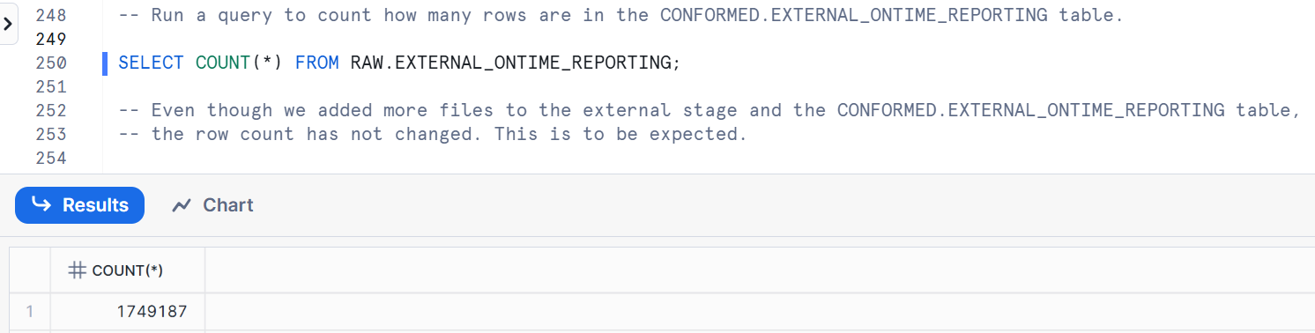

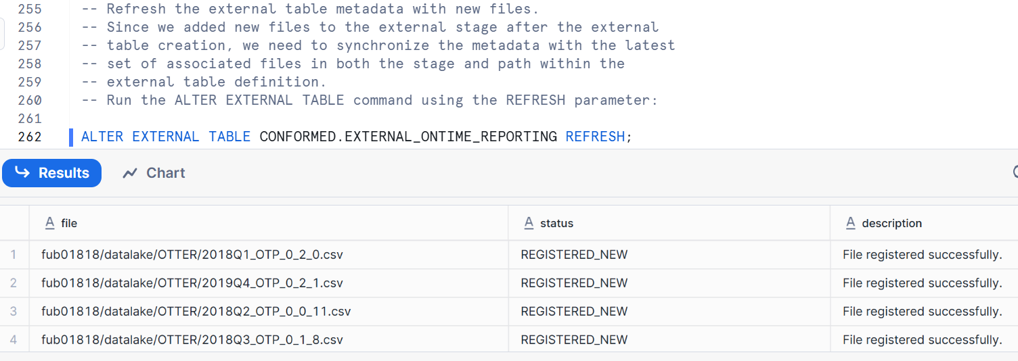

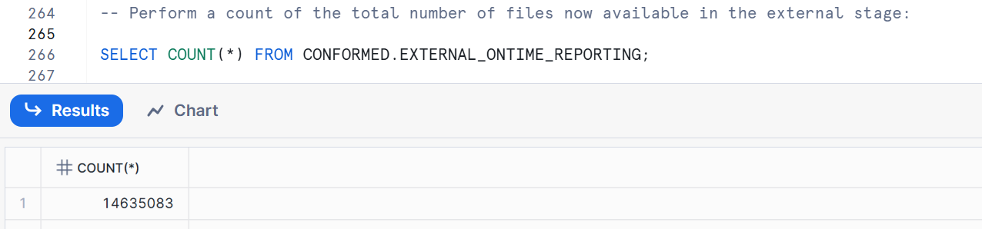

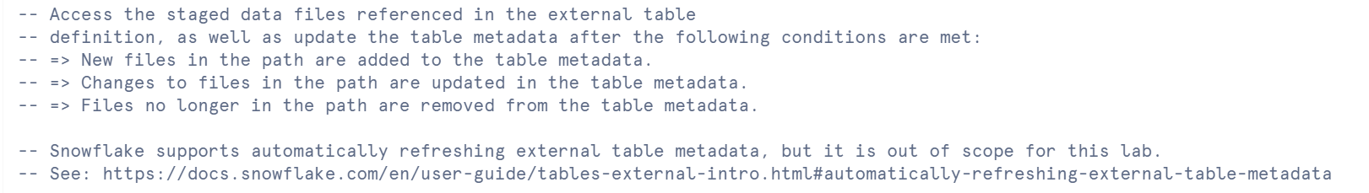

<https://docs.snowflake.com/en/user-guide/tables-external-intro#automatically-refreshing-external-table-metadata>

**Partitioned External Tables**



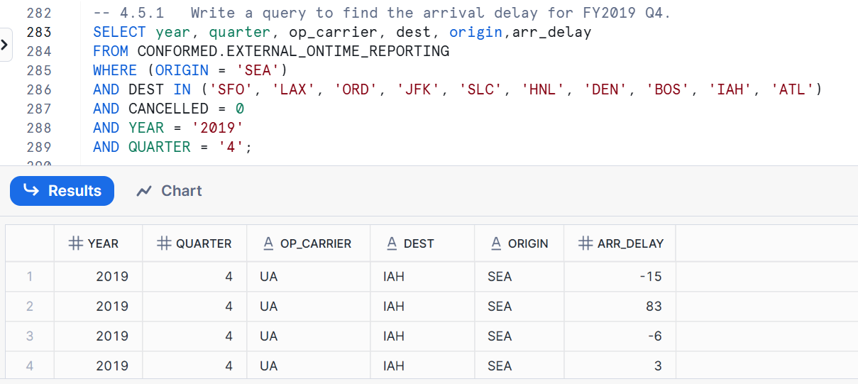

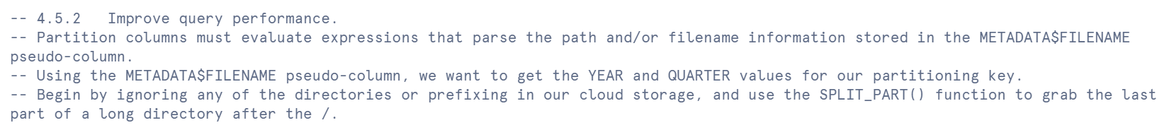

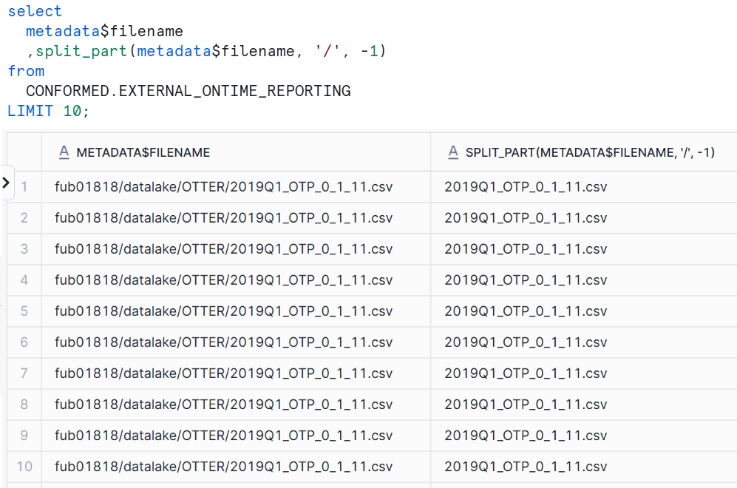

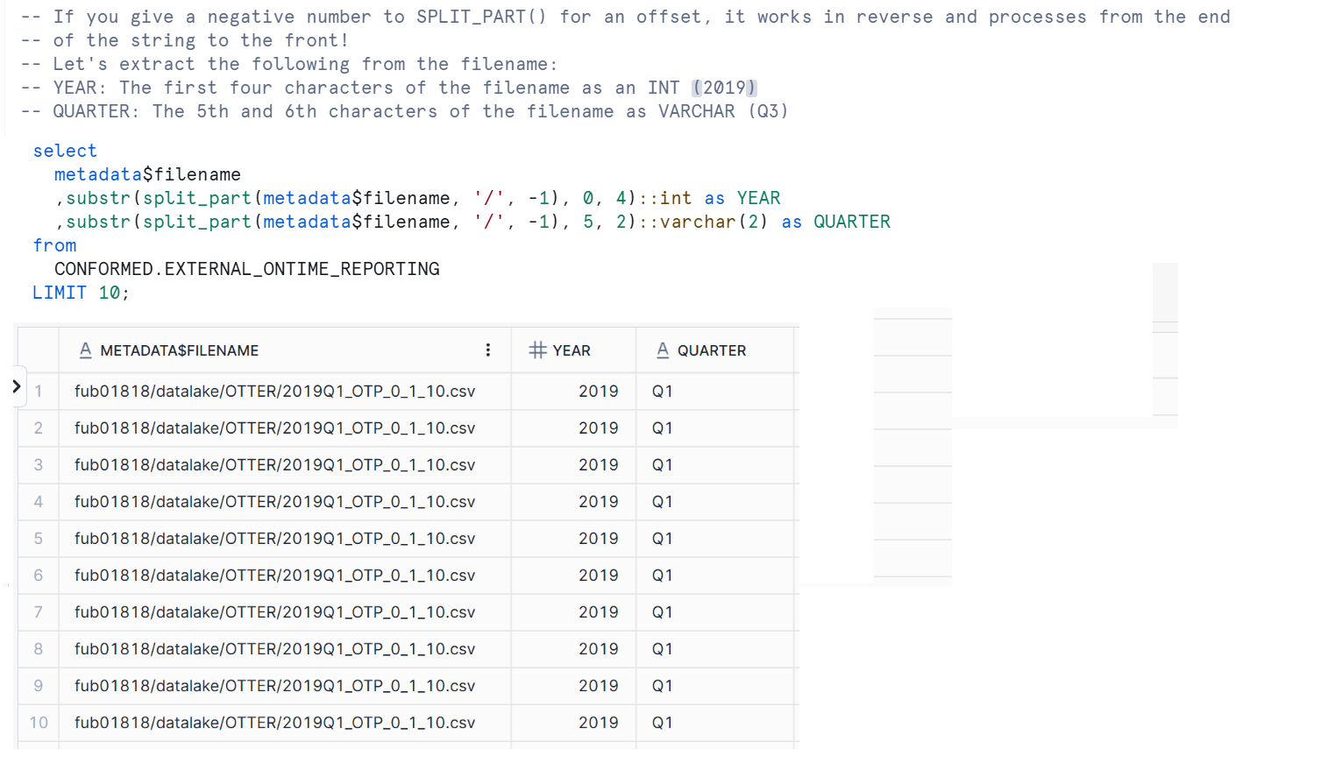

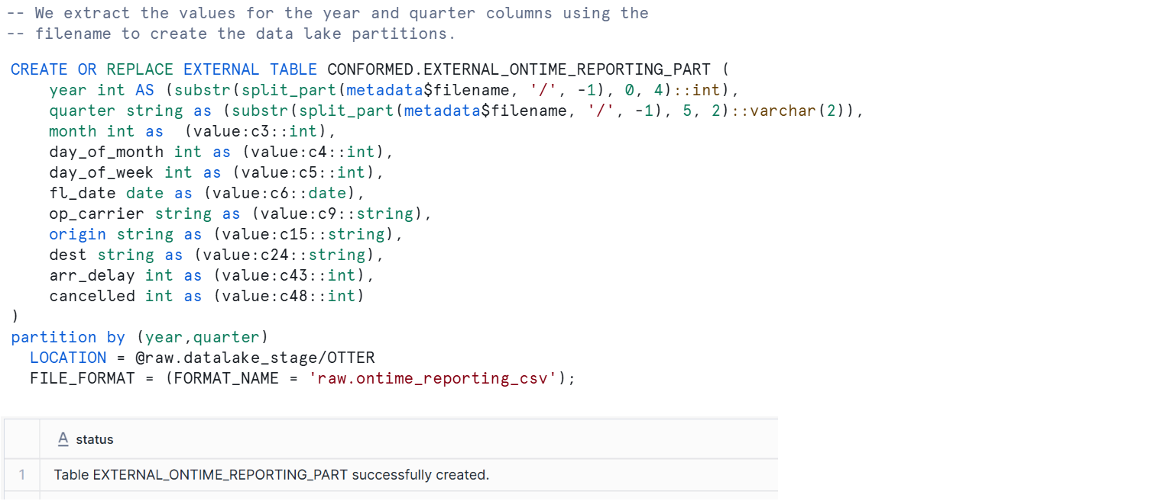

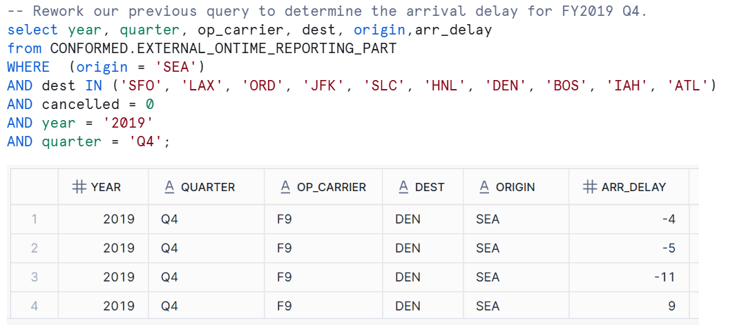

Examine Query Performance using the Query Profile. Not all partitions were scanned in this query.

**Creating Materialized View on External table**



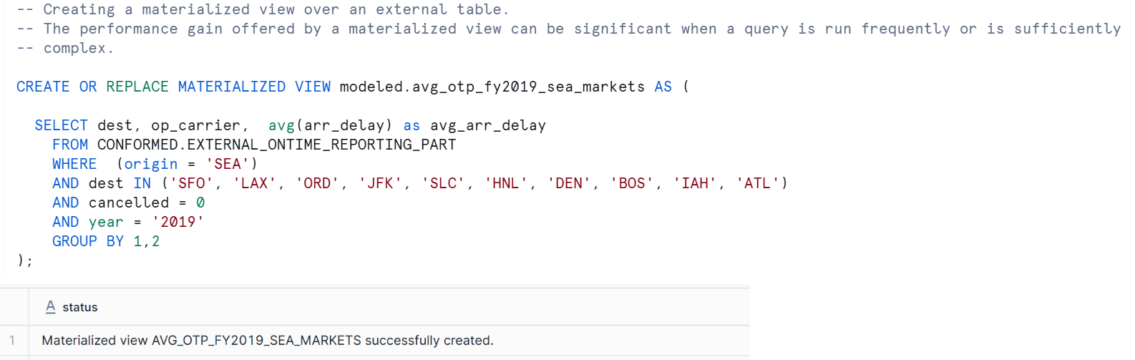

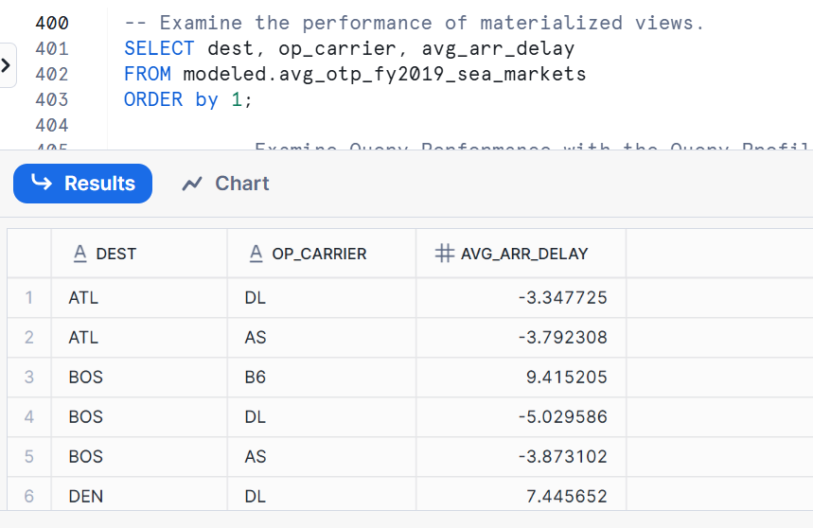



# Snowflake PIPE

In Snowflake, a **PIPE** (specifically, a **Snowpipe**) is a named, first-class Snowflake object that encapsulates a COPY INTO statement, used for **continuous and automated data ingestion** from external stages (like Amazon S3, Azure Blob Storage, or Google Cloud Storage) into Snowflake tables.

**Purpose of Snowflake Pipes (Snowpipe):**

The primary purpose of Snowpipe is to provide a **serverless, automated, and near real-time** solution for loading data into Snowflake. It contrasts with traditional bulk loading methods (like manually running COPY INTO commands on a schedule) by offering several key advantages:

1. **Continuous Data Loading (Micro-batches):** Snowpipe is designed to load data from files as soon as they become available in a stage. This means it can load data in small, frequent micro-batches, making the data available for querying within minutes (or even seconds for Snowpipe Streaming), rather than waiting for larger batch loads.
2. **Automation:** Snowpipe eliminates the need for manual intervention. Once configured, it continuously monitors your cloud storage for new data files. When a new file lands, Snowpipe is automatically triggered to ingest it.

There are two main mechanisms for this automation:

* **Cloud Messaging:** This is the most common and recommended approach. Event notifications (e.g., S3 Event Notifications, Azure Event Grid, Google Cloud Pub/Sub) are configured on your cloud storage bucket. When new files are created, these events notify Snowpipe, which then queues the files for loading.
* **Snowpipe REST Endpoints:** Your client application can call a public REST endpoint with the name of a pipe object and a list of data filenames. If new data files matching the list are found, they are queued for loading.

1. **Serverless Architecture:** Snowpipe is a serverless feature. You don't need to provision, manage, or resize a virtual warehouse for Snowpipe to operate. Snowflake automatically provides the necessary compute resources to load your data, scaling up and down as needed based on the ingestion load. You are billed based on the actual compute resources consumed by Snowpipe.
2. **Cost-Effectiveness for Streaming Data:** For high-volume, low-latency data feeds, Snowpipe can be more cost-effective than frequently running small COPY INTO operations on a dedicated warehouse, as its billing is optimized for streaming ingestion.
3. **Simplified Data Pipelines:** Snowpipe streamlines the process of continuous data pipelines, reducing the complexity of managing ETL (Extract, Transform, Load) processes and scheduling jobs.
4. **Duplicate Prevention:** Snowpipe uses file-loading metadata to prevent reloading the same files (and thus duplicating data) into a table. It tracks the path and name of each loaded file.

**How a Pipe Works:**

1. **Define a Pipe:** You create a pipe object in Snowflake using the CREATE PIPE SQL command. This command includes a COPY INTO statement that specifies the source stage, the target table, and any file format options or transformations.
2. **Stage Data:** New data files are placed into an external cloud storage location (e.g., an S3 bucket).
3. **Event Notification (or REST Call):**
   * **Automated (Cloud Messaging):** The cloud storage service sends an event notification when a new file is added. This notification is typically sent to a message queue (e.g., AWS SQS, Azure Storage Queue, Google Cloud Pub/Sub) that Snowpipe monitors.
   * **Manual (REST API):** Your application explicitly calls Snowpipe's REST API to tell it that new files are available.
4. **Queueing:** Snowpipe receives the notification (or REST call), detects the new files, and adds them to an internal queue.
5. **Data Ingestion:** Snowflake-provided compute resources then consume files from this queue and load the data into the target table according to the COPY INTO statement defined within the pipe.

**When to use Snowpipe:**

Snowpipe is ideal for scenarios where you need:

* **Near real-time data availability:** For live dashboards, real-time analytics, fraud detection, etc.
* **Continuous data streams:** From IoT devices, application logs, change data capture (CDC) feeds, message queues (like Kafka via Snowpipe Streaming).
* **Frequent, small file arrivals:** When data arrives incrementally rather than in large, infrequent batches.
* **Reduced operational overhead:** To avoid manual COPY INTO commands or complex scheduling.

In summary, Snowflake Pipes (Snowpipe) are a fundamental component for building robust, automated, and efficient continuous data ingestion pipelines in the Snowflake Data Cloud.

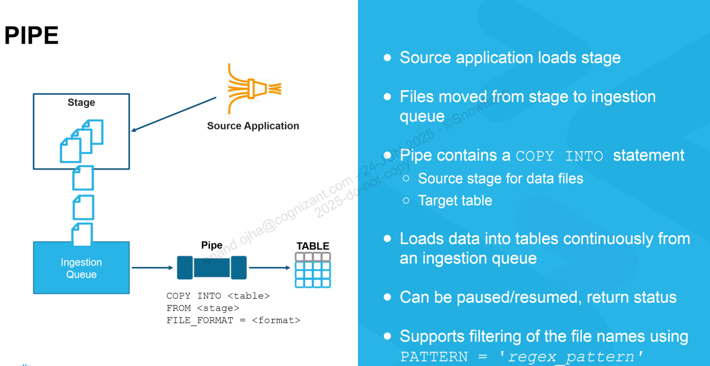

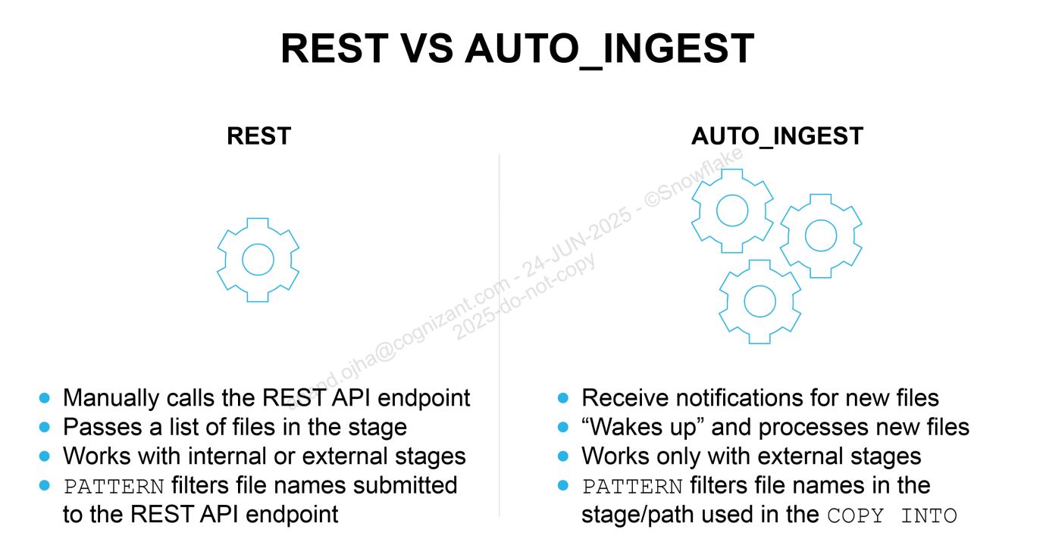

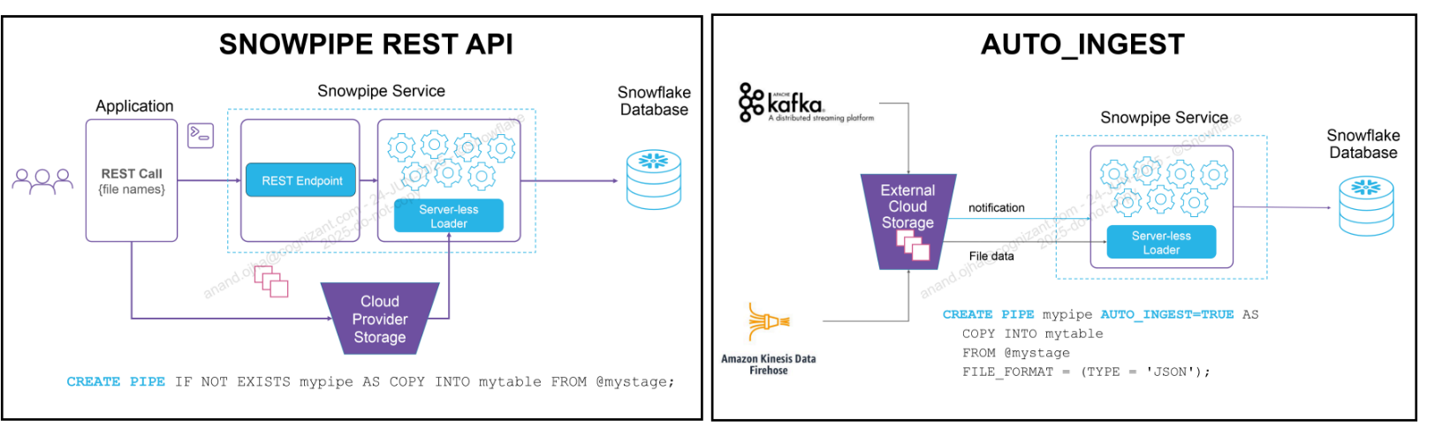

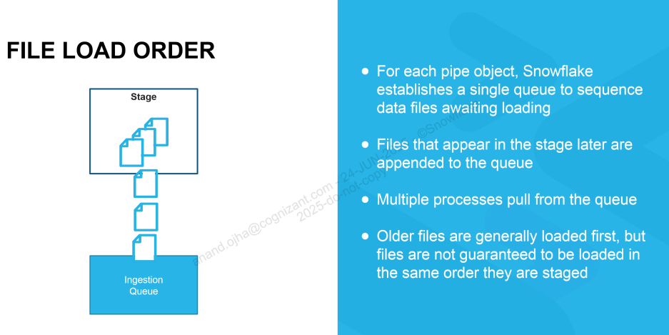

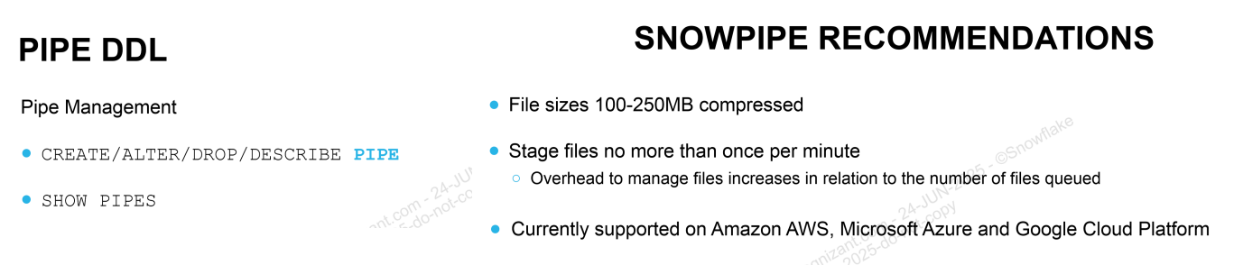

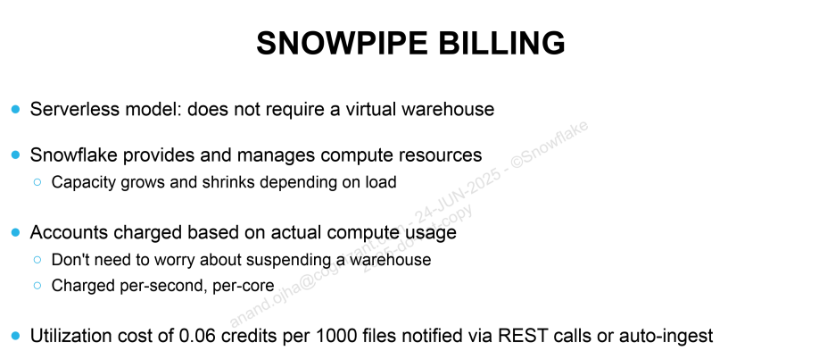

There are two types of Snowpipe: **basic pipes** and **continuous load pipes**. In this exercise, we will work with basic pipes.

Create the CITIBIKE.TRIPS table:

create or replace table trips (

tripduration integer

,starttime timestamp

,stoptime timestamp

,start_station_id integer

,start_station_name string

,start_station_latitude float

,start_station_longitude float

,end_station_id integer

,end_station_name string

,end_station_latitude float

,end_station_longitude float

,bikeid integer

,membership_type string

,usertype string

,birth_year integer

,gender integer);

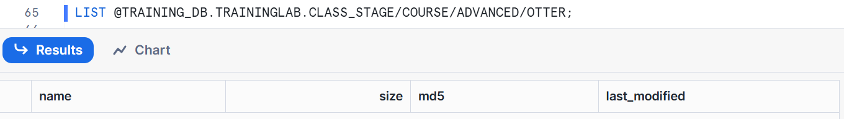

Create a pipe for the CITIBIKE.TRIPS table and verify that the pipe exists:

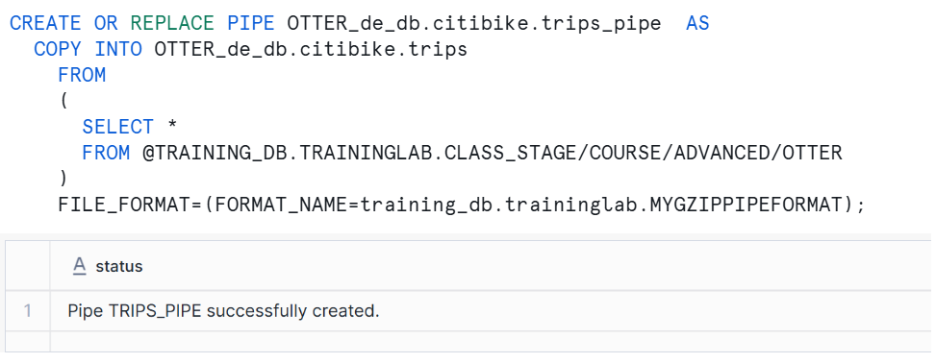

SHOW PIPES

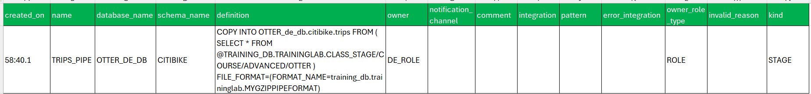

Unload data from the existing CITIBIKE database onto the stage referenced when creating the pipe:

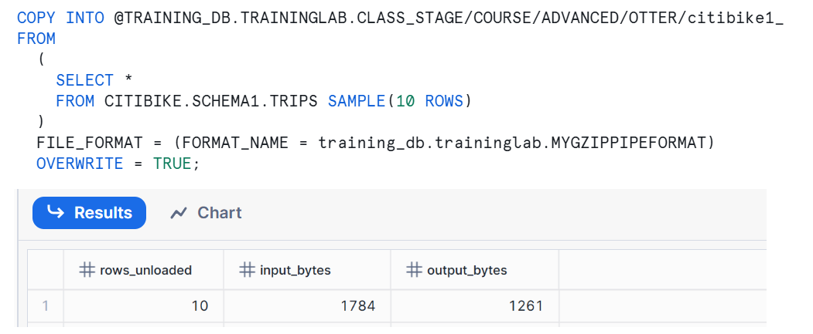

List the files on the cloud storage stage managed by Snowflake (a.k.a. internal stage).

Note that you can use list or its abbreviated form **ls** to show the files in a stage. You should see new files loaded into the stage location specified in the copy statement above.

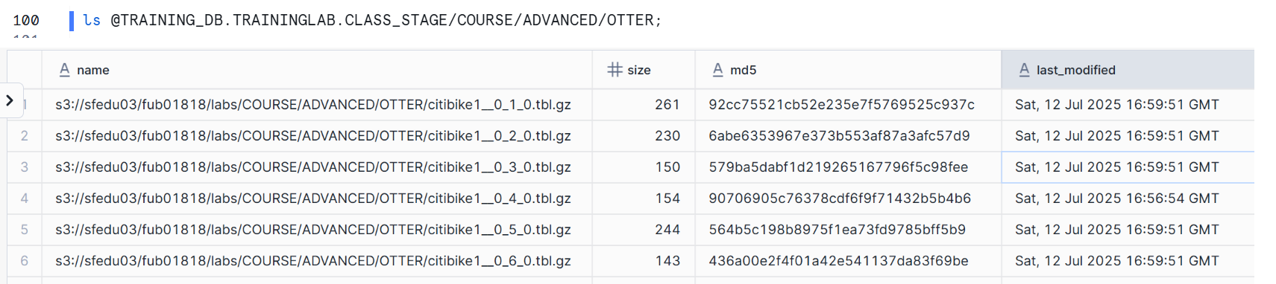

Refresh the stage with new files and list the stage contents before and after loading it:

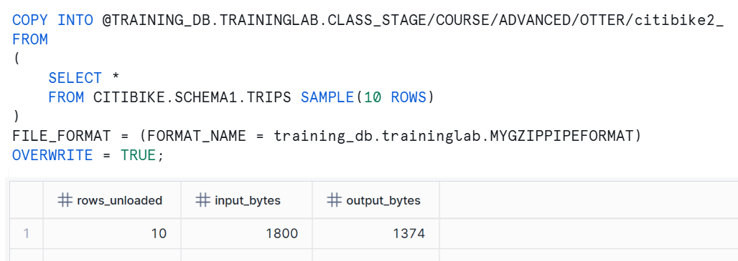

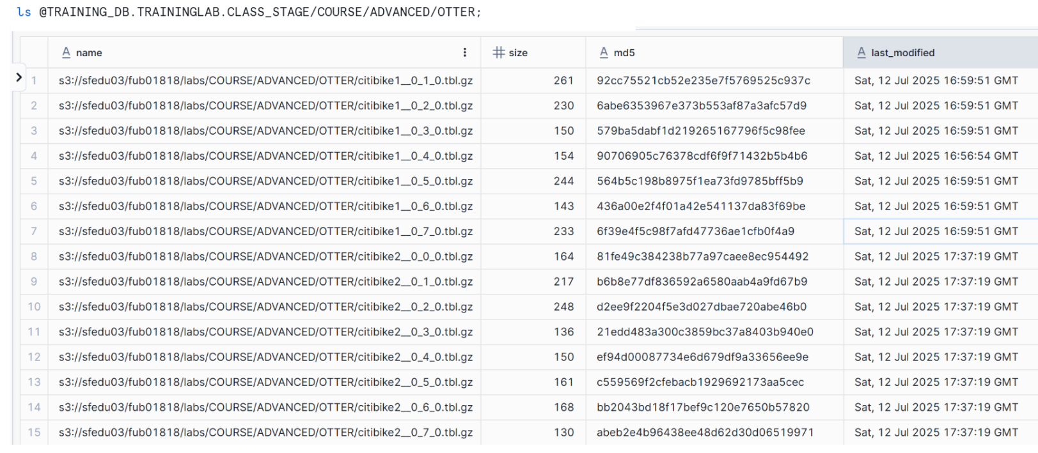

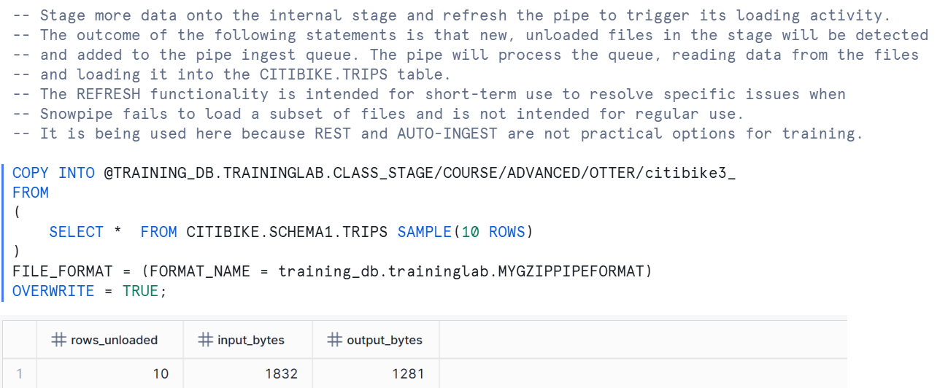

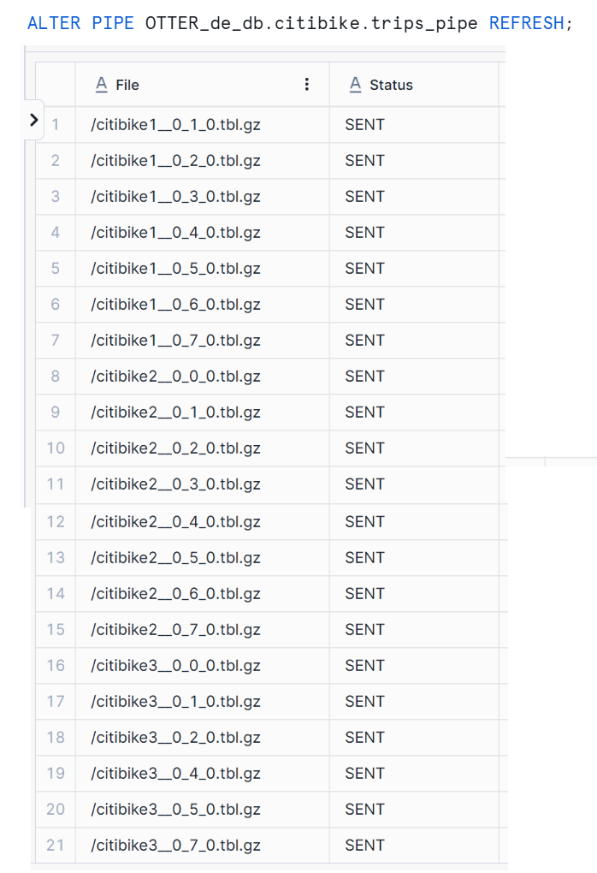

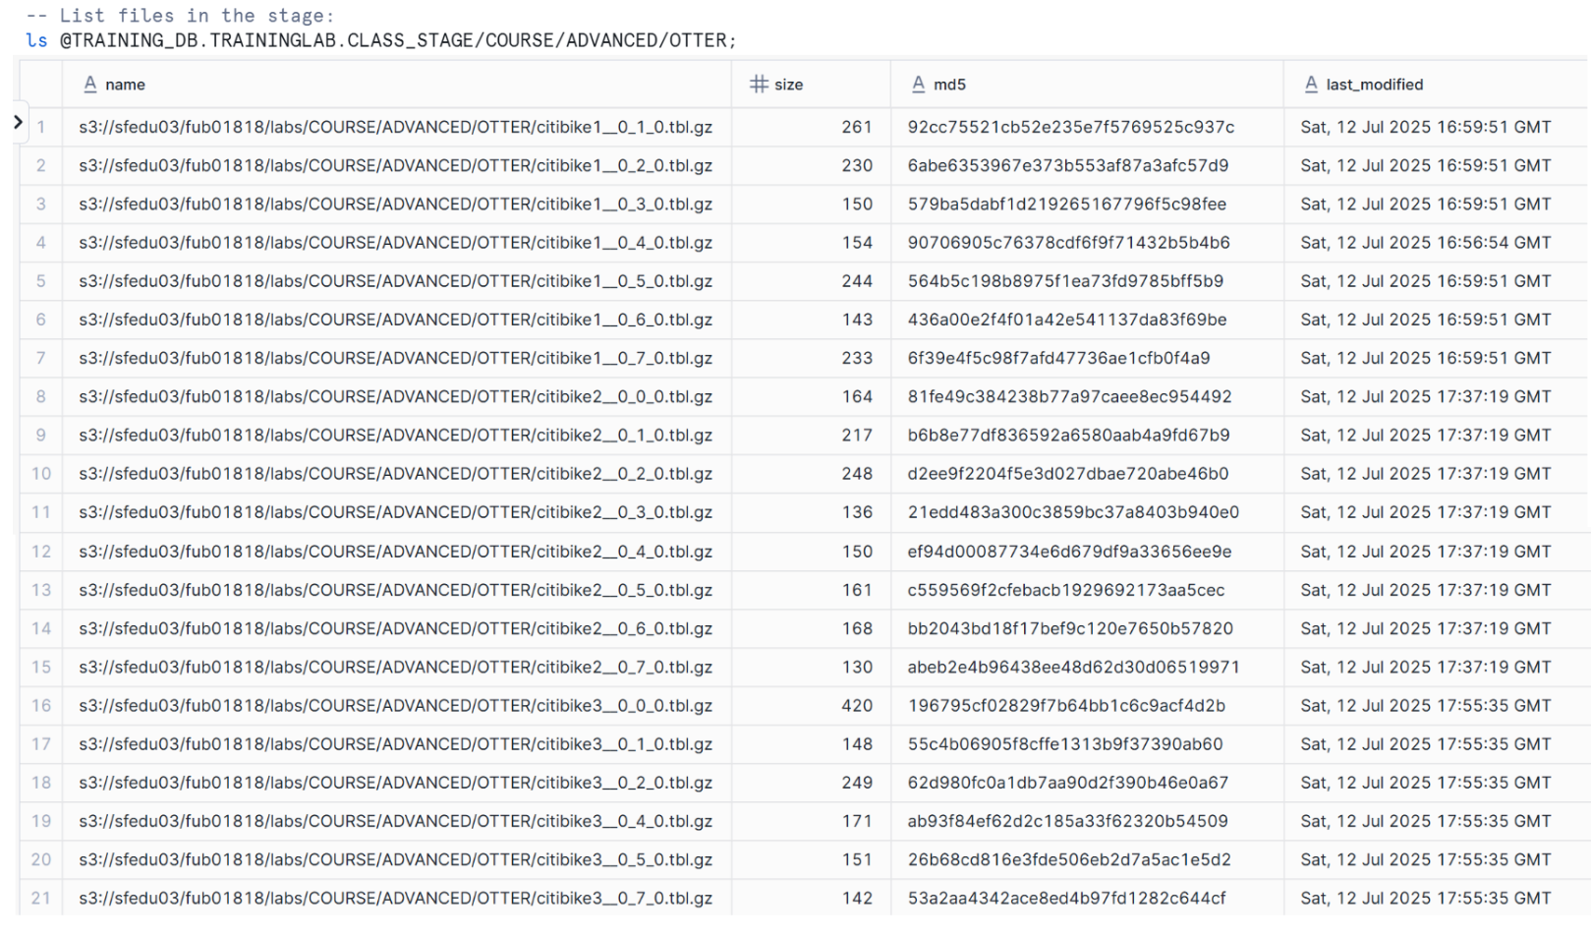

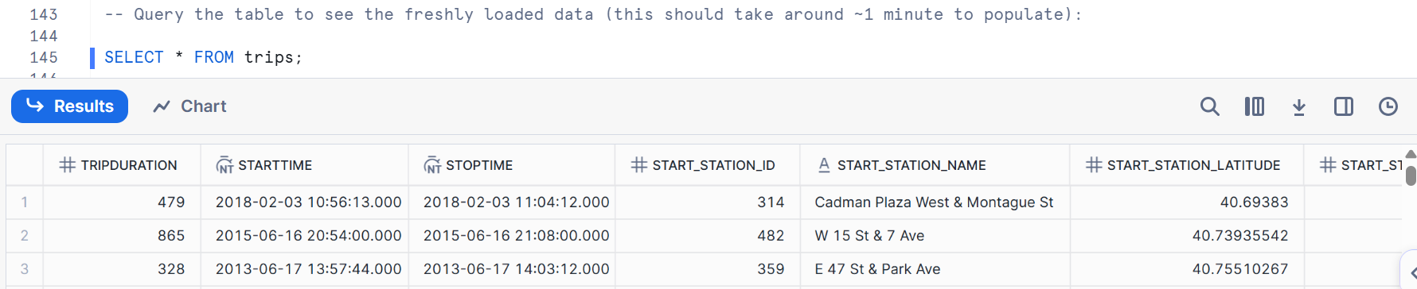

-- Check load history:

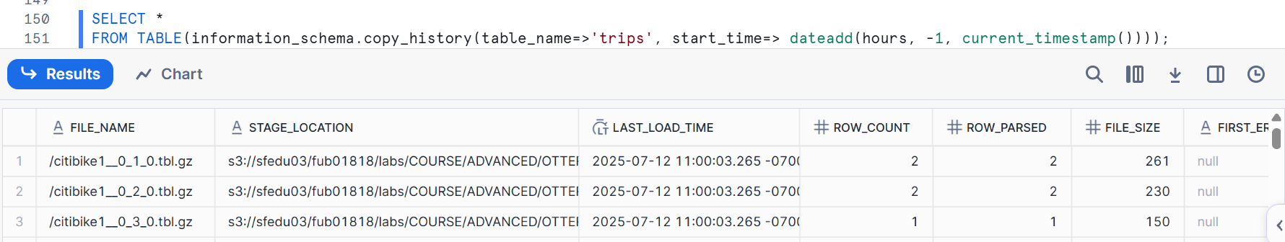



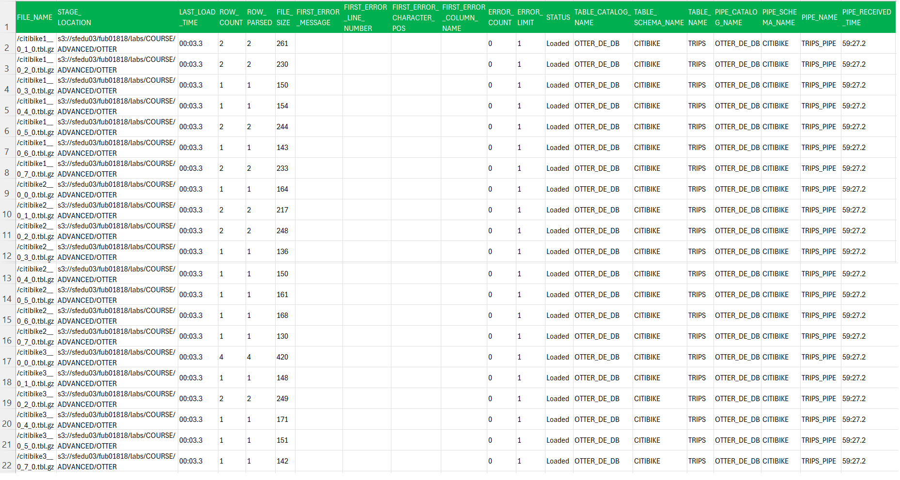

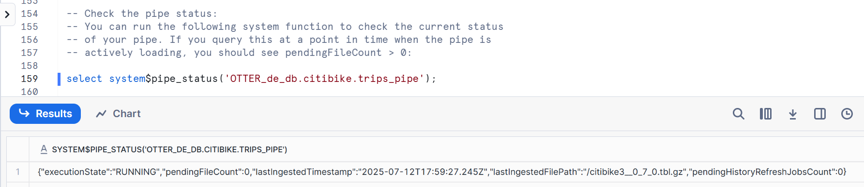

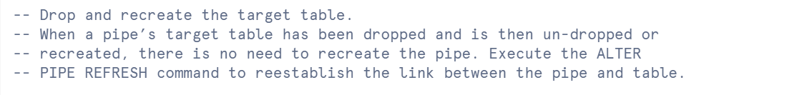

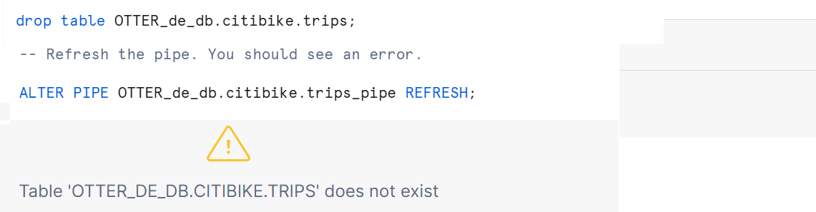

Recreate the target table and refresh the stage with a new file.

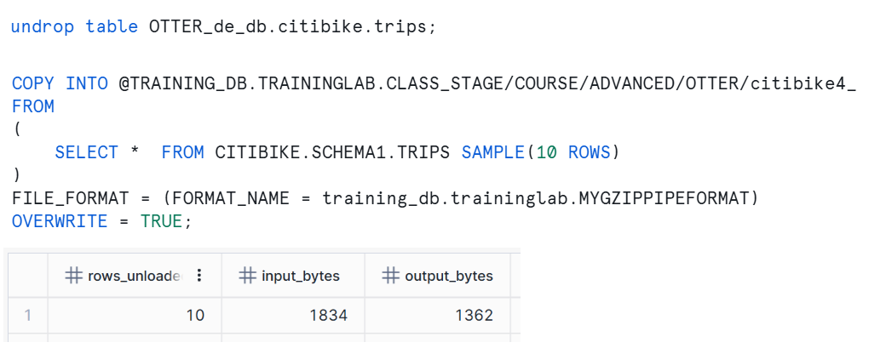

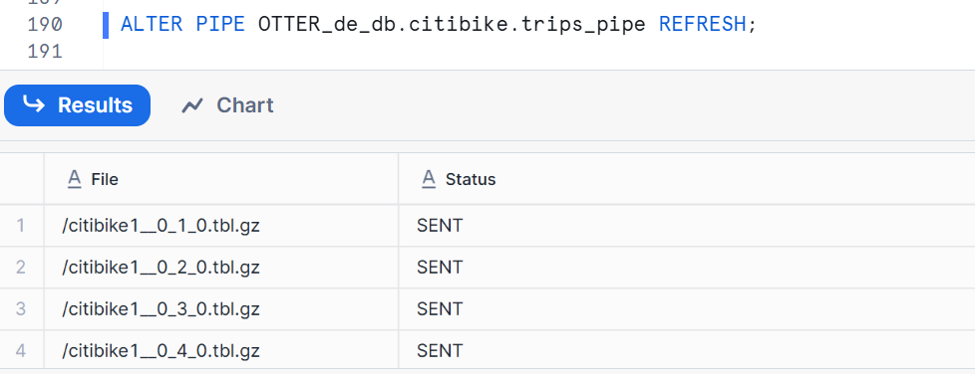

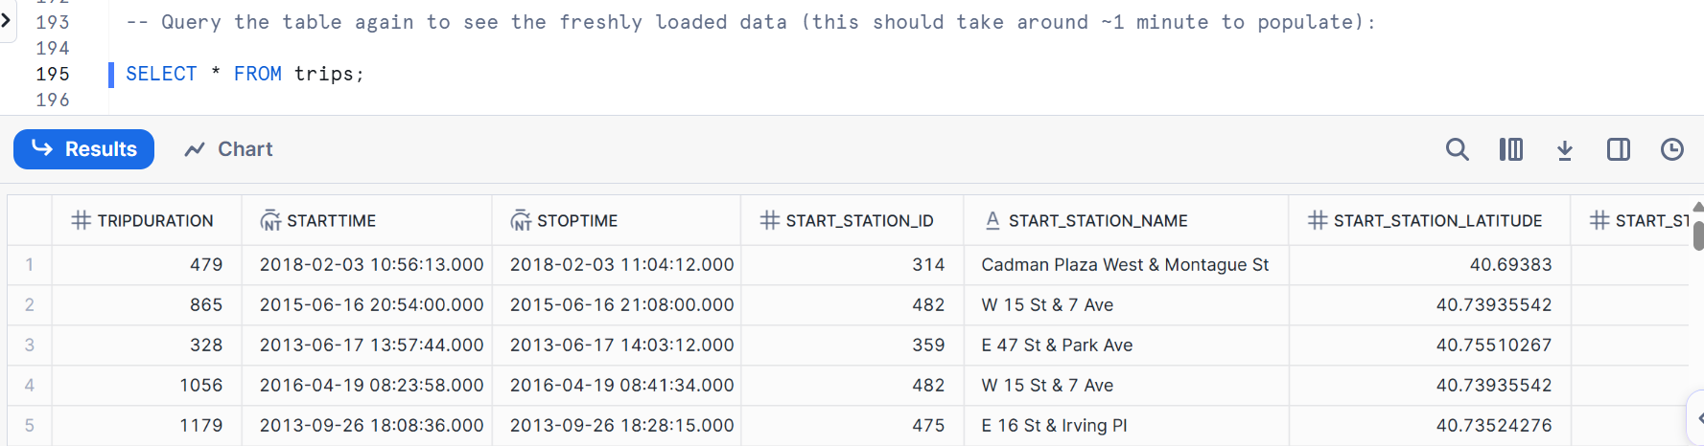

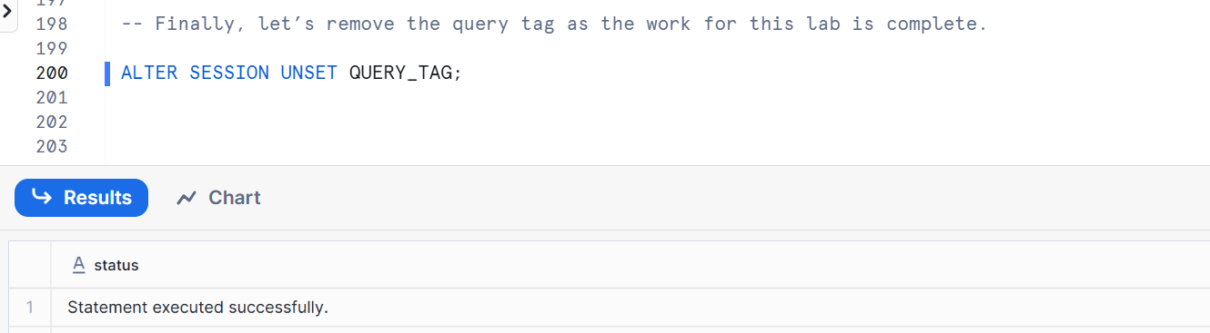

# Data Exchange

ALTER SESSION SET QUERY_TAG= '(OTTER) Lab: Data Exchange';

CREATE WAREHOUSE IF NOT EXISTS OTTER_de_QUERY_WH;

USE WAREHOUSE OTTER_de_QUERY_WH;

ALTER WAREHOUSE OTTER_de_QUERY_WH SET WAREHOUSE_SIZE = 'XSMALL';

**Exercise #1 – Lab A:** Explore the Snowflake Marketplace

* A Share can only be consumed once. The instructor will consume the Share. Students will query it.
* The Snowflake Marketplace uses Secure Data Sharing to connect data providers with consumers.
* In this exercise, use the Snowflake Marketplace to discover if any publicly available on-time flight performance data is available.
* Log in to the Snowsight web interface.
  + Click **Marketplace** in the left navigation menu.
  + Browse the Snowflake Marketplace categories. Select **Data products** tab in the Marketplace view.
  + Then select **Categories** to display the drop-down list and browse the selections in **Transportation** and **Travel**.
  + Explore the results. Notice that there are two types of listings:
    - Standard Data Listings: Noted by the Free tag. These provides instant access to a published data set.
    - Personalized Data Listings: Noted by the By Request tag. These listings allow customers to request specific data sets.
  + Do you see any on-time flight performance data for us to use?

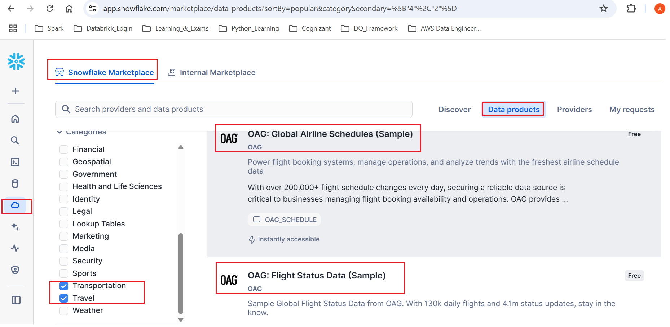

**Exercise #2 – Lab B:** Accessing Snowflake education’s **data exchange** as a consumer.

Data Exchange leverages the Snowsight web interface. Click on **Private Sharing** in the left navigation menu under the **Data** area, and then click the **“Shared With Me**” tab at the top

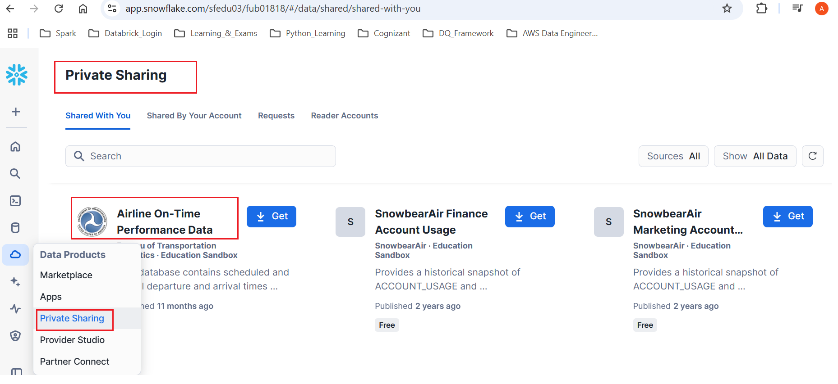

# Snowpark

Here we are doing transformations with Snowpark using Snowflake Notebooks. You will connect to your Snowflake account via a Snowpark session, create a Snowpark DataFrame, perform transformations on your data, and persist your transformed data as a new table in your Snowflake account.

-- set the context

USE ROLE de_role;

USE WAREHOUSE OTTER_de_wh;

ALTER WAREHOUSE OTTER_de_wh SET WAREHOUSE_SIZE = XSMALL;

CREATE DATABASE IF NOT EXISTS OTTER_de_db;

USE DATABASE OTTER_de_db;

CREATE SCHEMA IF NOT EXISTS OTTER_de_db.data;

USE SCHEMA OTTER_de_db.data;

|  |
| --- |
| -- Create the notebook  CREATE OR REPLACE NOTEBOOK OTTER_snowpark  FROM '@de_db.notebooks.notebook_files/de_snowpark'  MAIN_FILE = 'lab_snowpark.ipynb'  QUERY_WAREHOUSE = OTTER_de_wh; |

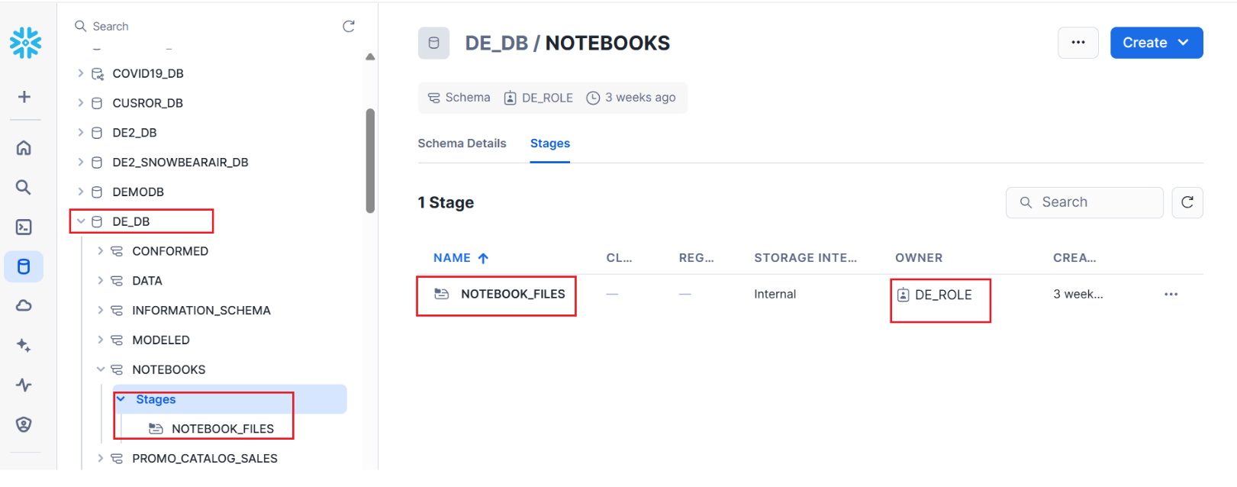

The Snowpark command you provided, CREATE OR REPLACE NOTEBOOK OTTER_snowpark FROM '@de_db.notebooks.notebook_files/de_snowpark' MAIN_FILE = 'lab_snowpark.ipynb' QUERY_WAREHOUSE = OTTER_de_wh;, is used to **create or replace a Snowflake Notebook** in your Snowpark environment.

Let's break down each part of the command:

* **CREATE OR REPLACE NOTEBOOK OTTER_snowpark**:
  + CREATE OR REPLACE NOTEBOOK: This is the core command that tells Snowflake you want to create a new notebook. The OR REPLACE clause means that if a notebook with the name OTTER_snowpark already exists, it will be overwritten with the new definition. If it doesn't exist, a new one will be created.
  + OTTER_snowpark: This is the **name** you are giving to your Snowflake Notebook. This is how you will refer to it in Snowflake.
* **FROM '@de_db.notebooks.notebook_files/de_snowpark'**:
  + FROM: This keyword indicates the source from which the notebook content will be loaded.
  + '@de_db.notebooks.notebook_files/de_snowpark': This is a **stage path** in Snowflake. It specifies the location where your notebook's files (including the main “.ipynb” file and any other supporting files) are stored.
    - @: Denotes a stage in Snowflake.
    - de_db.notebooks.notebook_files: This is likely a fully qualified path to a schema within a database where your stage is located.
    - de_snowpark: This is probably a named stage or a subdirectory within a stage that contains the notebook's project files.

Based on the path de_db.notebooks.notebook_files:

* **de_db is the Database Name.**
* **notebooks is the Schema Name.**
* **notebook_files** is likely a **stage name** within that schema, or it could be a sub-directory within a stage. In the context of the FROM '@de_db.notebooks.notebook_files/de_snowpark' part of the command, it signifies the location where your notebook files are stored on a Snowflake stage.
* **MAIN_FILE = 'lab_snowpark.ipynb'**:
  + MAIN_FILE: This parameter specifies the **primary notebook file** within the staged location that should be considered the main entry point for the Snowflake Notebook.
  + 'lab_snowpark.ipynb': This is the actual Jupyter Notebook file (with a .ipynb extension) that will be loaded and run as the Snowflake Notebook.
* **QUERY_WAREHOUSE = OTTER_de_wh**:
  + QUERY_WAREHOUSE: This parameter designates the **virtual warehouse** that will be used to execute the queries and computations within this Snowflake Notebook.
  + OTTER_de_wh: This is the name of the Snowflake virtual warehouse that will provide the compute resources for your notebook's operations.

**In essence, this command is performing the following actions:**

1. **Defining a new Snowflake Notebook**: It registers a new notebook object named OTTER_snowpark within your Snowflake account.
2. **Specifying the source code**: It tells Snowflake where to find the actual notebook content, which is an .ipynb file and potentially other related files, located in a Snowflake stage.
3. **Identifying the main notebook file**: It explicitly points to lab_snowpark.ipynb as the primary notebook file to be used.
4. **Assigning a compute resource**: It associates the OTTER_de_wh virtual warehouse with this notebook, meaning that any queries or code execution within OTTER_snowpark will utilize the resources of OTTER_de_wh.

This allows us to manage and execute your Snowpark (Python or SQL) code, typically developed in a Jupyter-like environment, directly within Snowflake's platform, leveraging Snowflake's scalable compute and data governance.

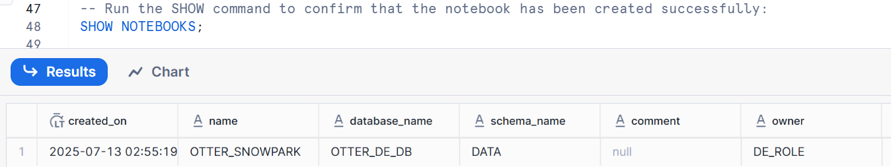



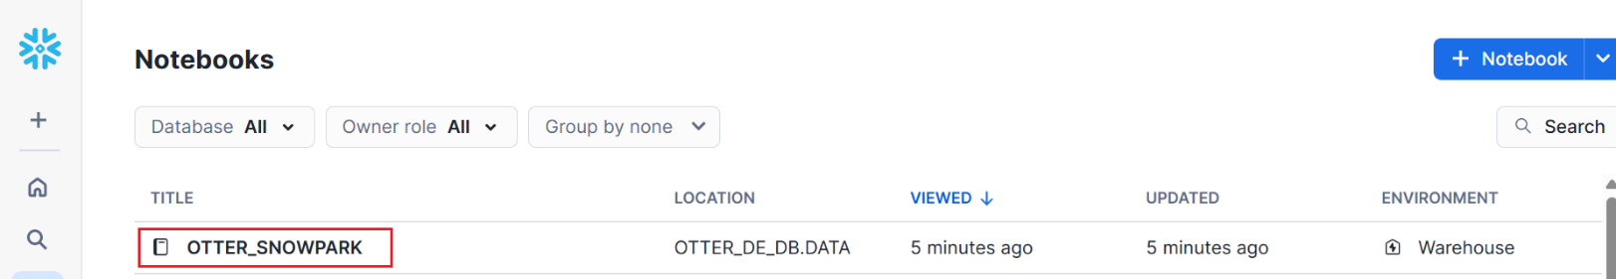

Under Projects, navigate to Notebooks in the main Snowsight navigation menu, and you should see the notebook you just created.

Select the name of your new notebook, **OTTER_snowpark**, to launch it, and follow the instructions provided to complete the lab.

You do not need to do anything else in this Snowsight worksheet, which can now be closed.

**Notebook Link**

<https://app.snowflake.com/sfedu03/fub01818/#/notebooks/OTTER_DE_DB.DATA.OTTER_SNOWPARK>



# Dynamic Table

USE ROLE de_role;

ALTER SESSION SET QUERY_TAG= '(OTTER) Lab: Dynamic Tables';

USE WAREHOUSE OTTER_de_wh;

ALTER WAREHOUSE OTTER_de_wh SET WAREHOUSE_SIZE = small;

-- ensure the following "zones" are created in OTTER_de_db to hold raw, transformed, and presentation data, respectively.

CREATE SCHEMA IF NOT EXISTS OTTER_de_db.RAW CLONE de_db.raw;

CREATE SCHEMA IF NOT EXISTS OTTER_de_db.CONFORMED CLONE de_db.conformed;

CREATE SCHEMA IF NOT EXISTS OTTER_de_db.MODELED CLONE de_db.modeled;

USE SCHEMA OTTER_de_db.raw;

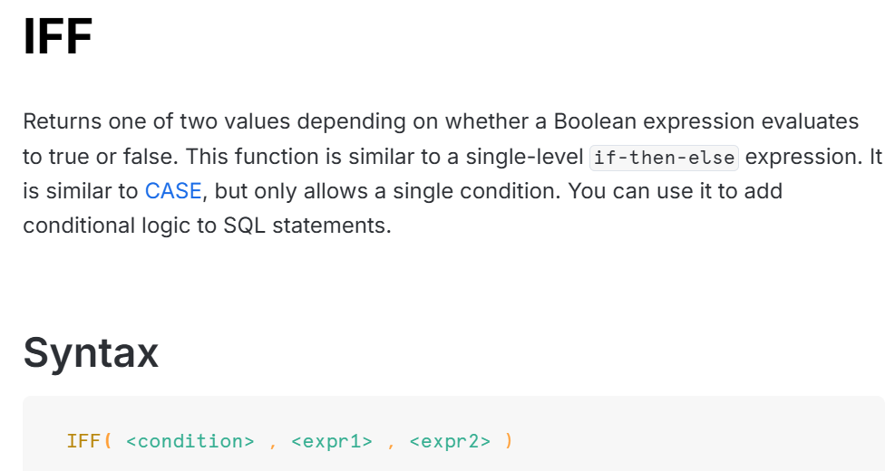

**Requisite objects - PRODUCT_DETAIL table.**

The following code block checks for the existence of the PRODUCT_DETAIL table in the OTTER_de_db.RAW schema.

If the check returns FAILED, it will recreate the table, including data, by cloning from a read-only reference table

under the TRAINING_DB.DATA schema. Run this code block to create/replace the PRODUCT_DETAIL table.

|  |
| --- |
| --anonymous block  DECLARE  status STRING default '';  msg STRING default 'PRODUCT_DETAIL table exists and contains data';  BEGIN  status :=  (SELECT IFF(  exists(select *  from information_schema.tables  where table_catalog = UPPER('OTTER_de_db')  and table_schema = 'RAW'  and table_name = 'PRODUCT_DETAIL'  and row_count > 0),  'PASSED',  'FAILED') as table_data_check);    IF (status = 'FAILED') THEN  CREATE OR REPLACE TABLE OTTER_de_db.raw.product_detail CLONE training_db.data.product_detail_seed;  msg := 'PRODUCT_DETAIL table (re)created and populated';  END IF;  return msg;  END; |

Review the data in the PRODUCT_DETAIL table, which should contain 20 product records.

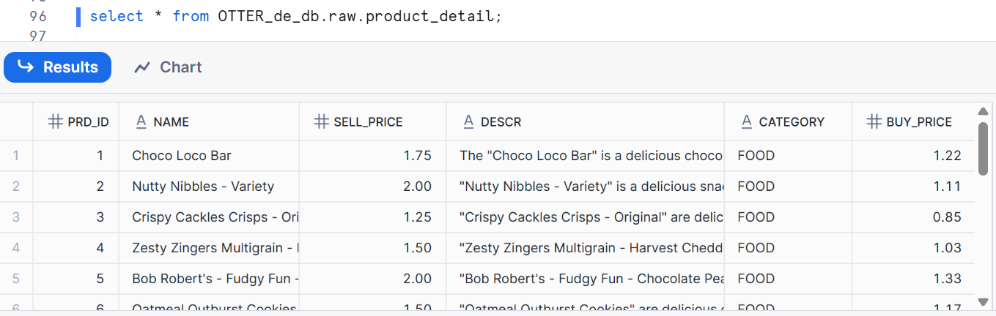

|  |
| --- |
| DECLARE  status STRING default '';  msg STRING default 'VENDING_MACHINE table exists and contains data';  BEGIN  status :=  (SELECT IFF(  exists(select *  from information_schema.tables  where table_catalog = UPPER('OTTER_de_db')  and table_schema = 'RAW'  and table_name = 'VENDING_MACHINE'  and row_count > 0),  'PASSED',  'FAILED') as table_data_check);    IF (status = 'FAILED') THEN  CREATE OR REPLACE TABLE OTTER_de_db.raw.vending_machine CLONE training_db.data.vending_machine_seed;  msg := 'VENDING_MACHINE table (re)created and populated';  END IF;  return msg;  END; |

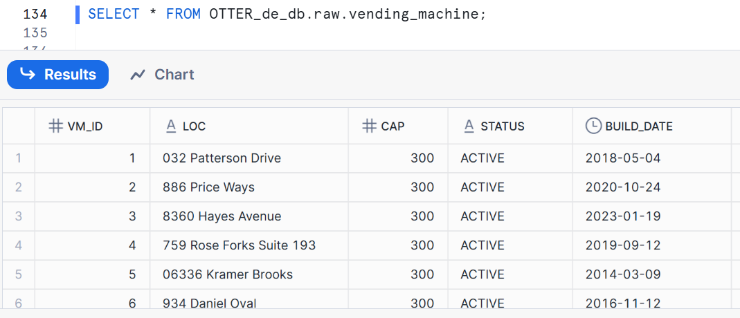

|  |
| --- |
| DECLARE  status STRING default '';  msg STRING default 'VENDING_TRANSACTIONS_NEW table exists';  BEGIN  status :=  (SELECT IFF(  exists(select *  from information_schema.tables  where table_catalog = UPPER('OTTER_de_db')  and table_schema = 'RAW'  and table_name = 'VENDING_TRANSACTIONS_NEW'),  'PASSED',  'FAILED') as table_check);    IF (status = 'FAILED') THEN  CREATE OR REPLACE TABLE raw.vending_transactions_new LIKE training_db.data.vending_transactions_seed;  msg := 'VENDING_TRANSACTIONS_NEW table created';  END IF;  return msg;  END; |

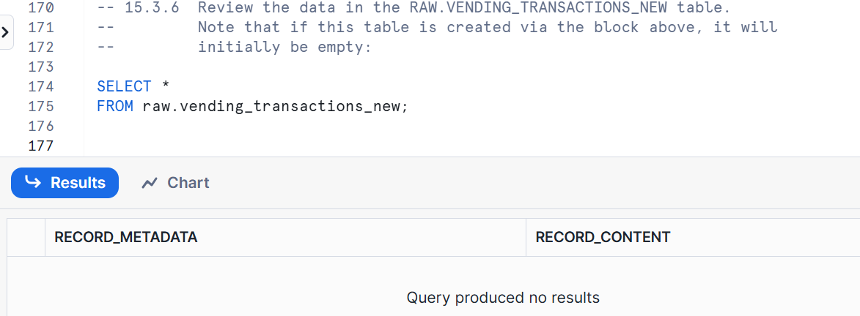

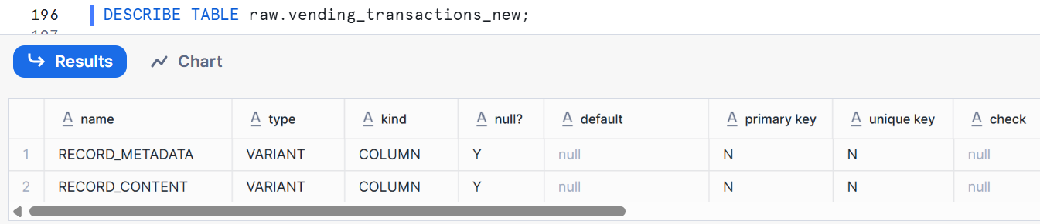

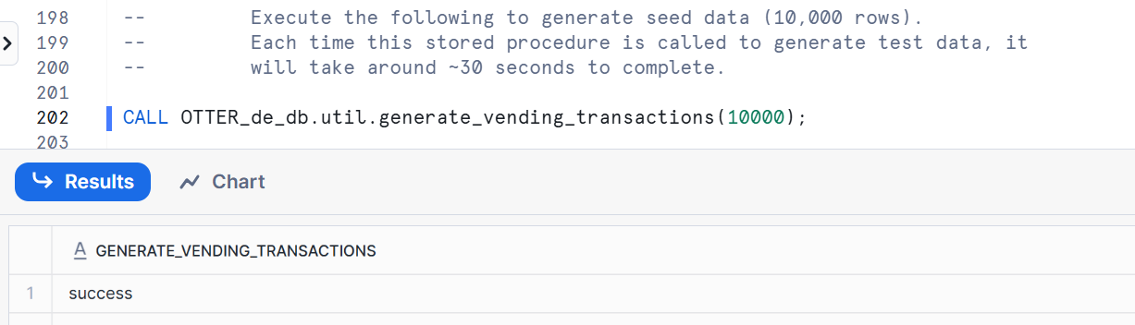

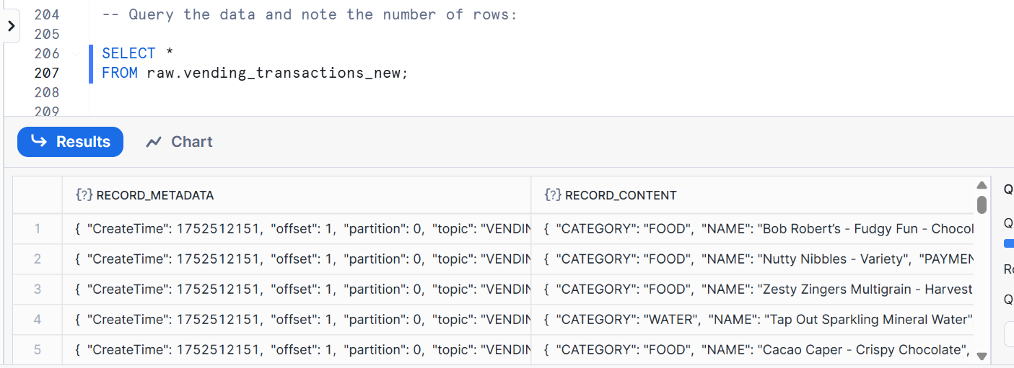

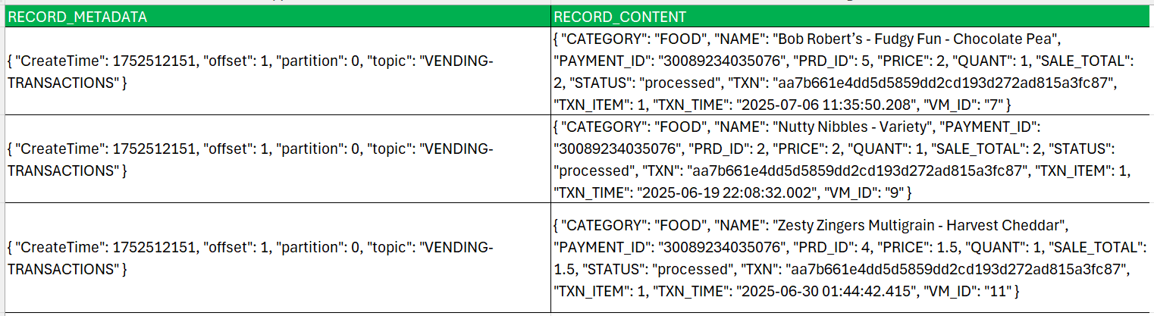

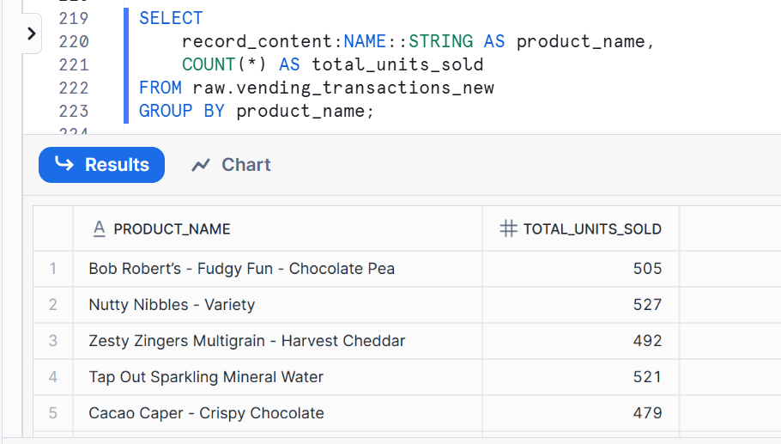

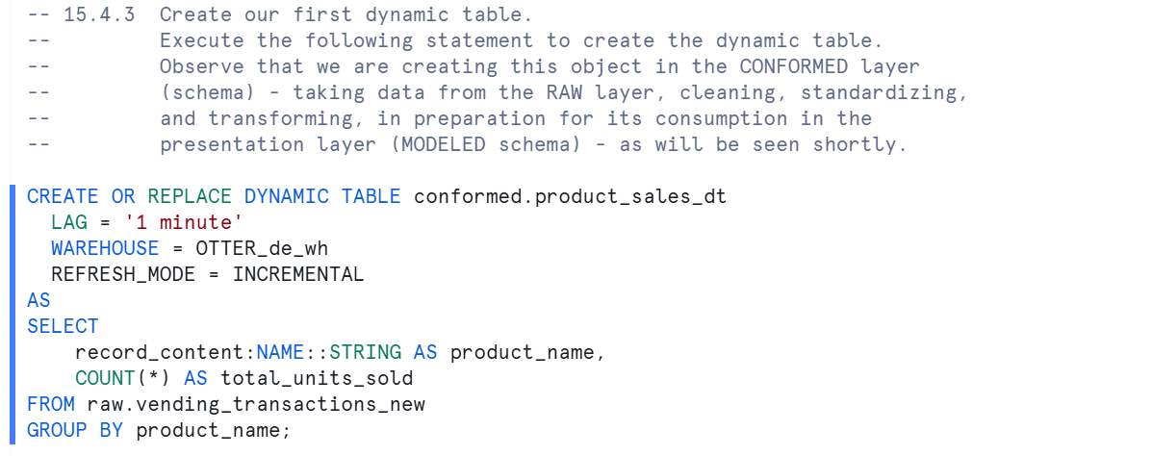

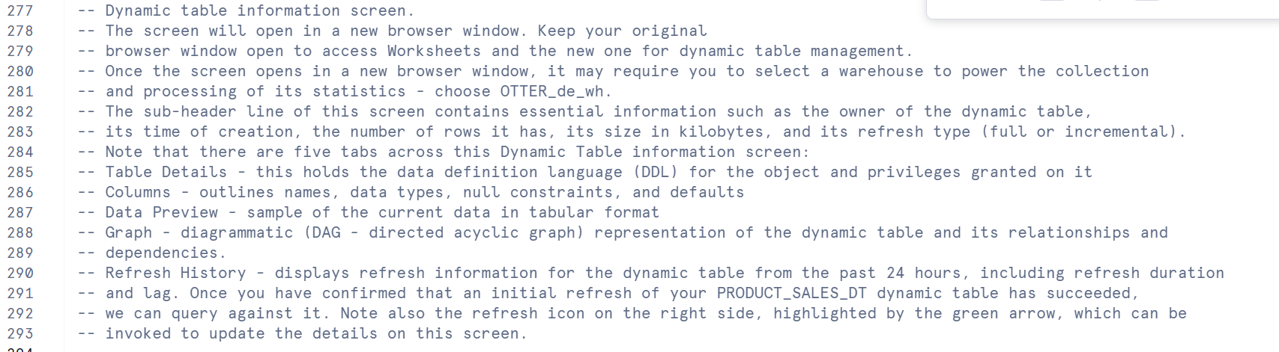

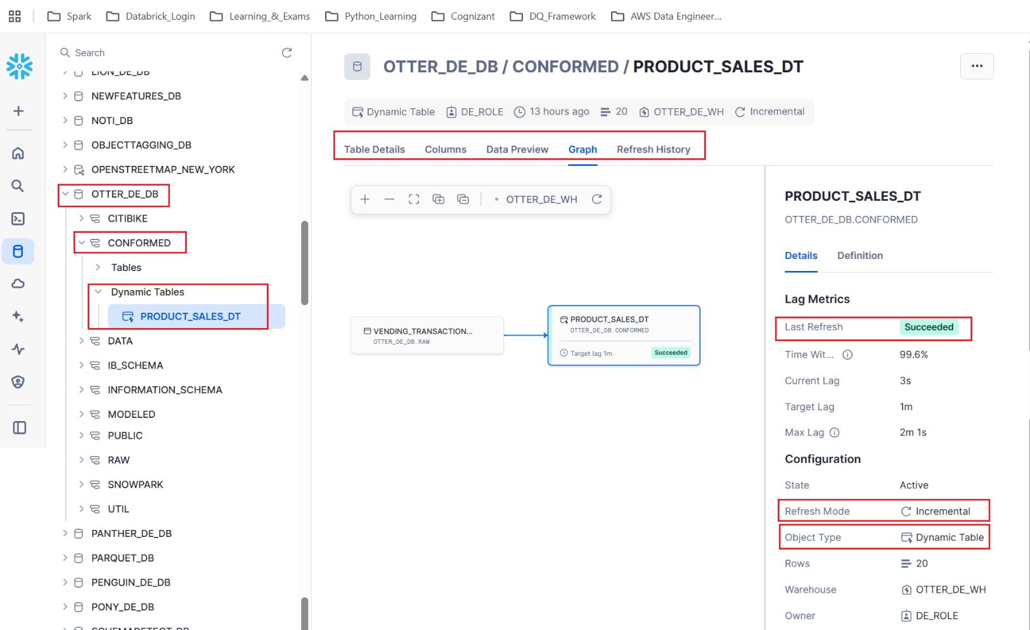

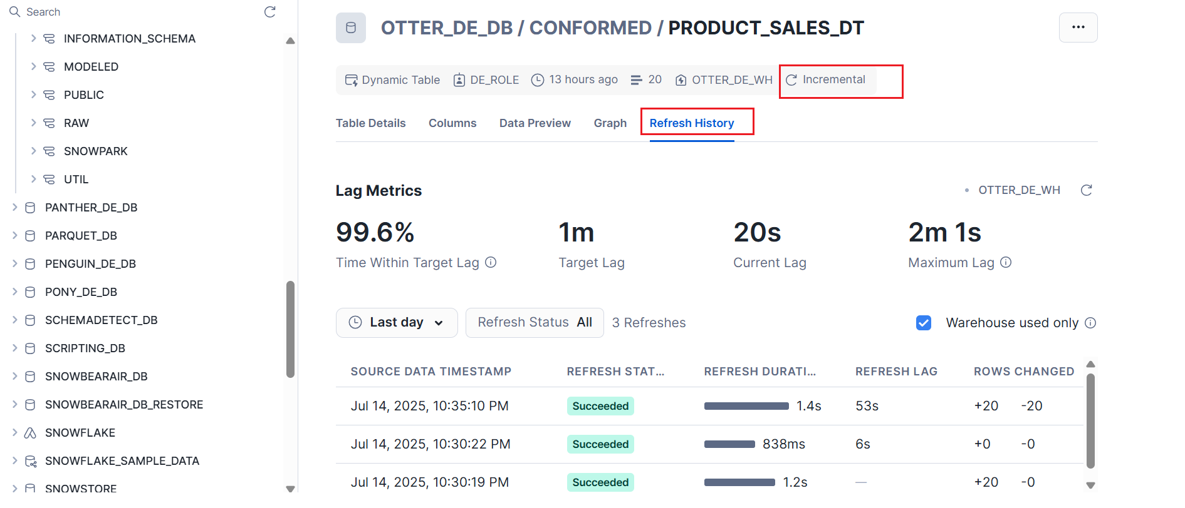

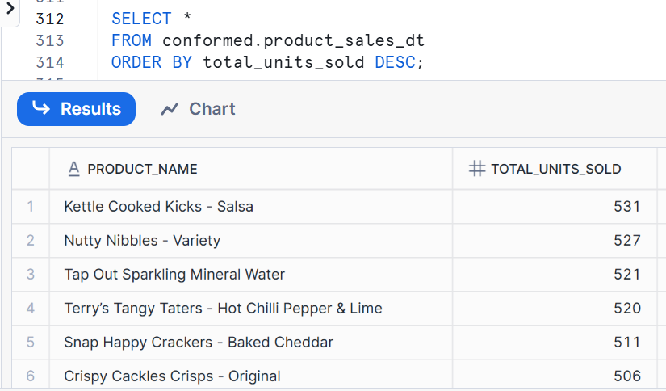

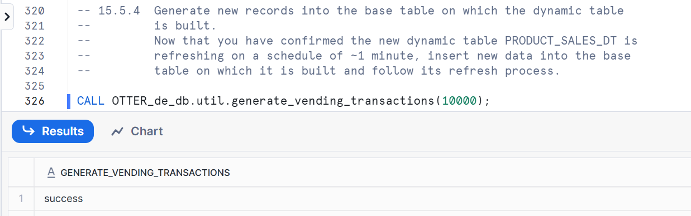

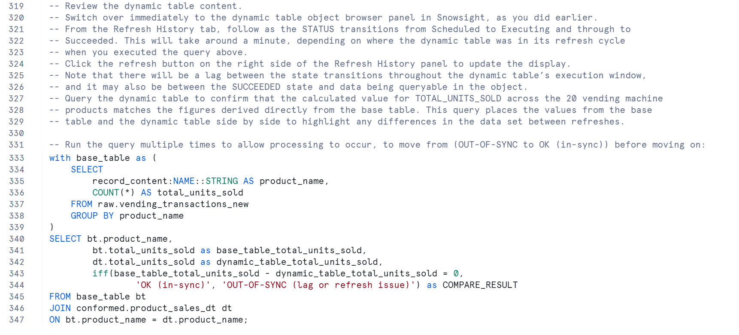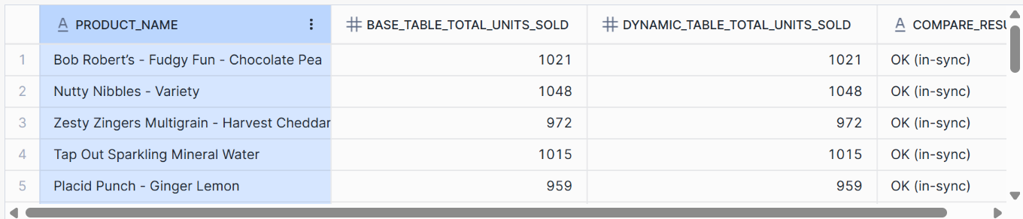

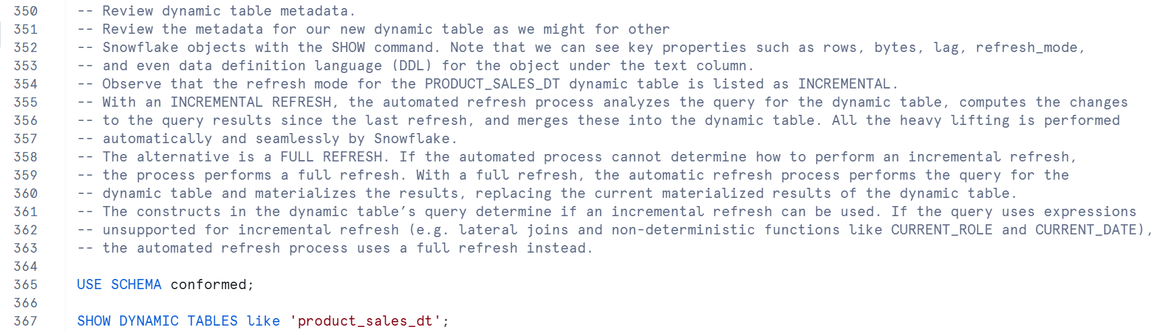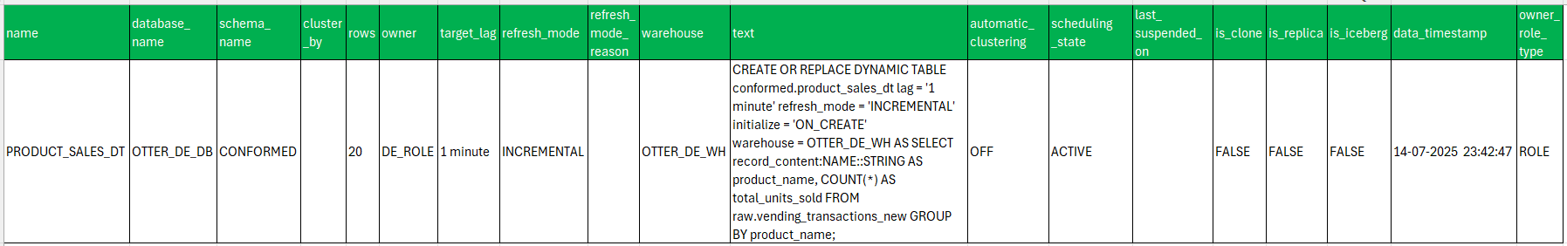

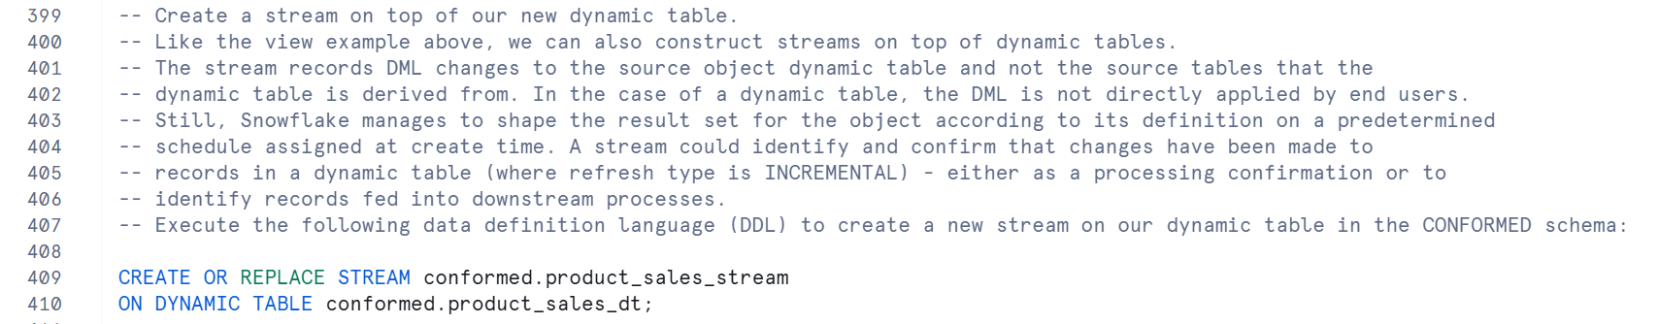

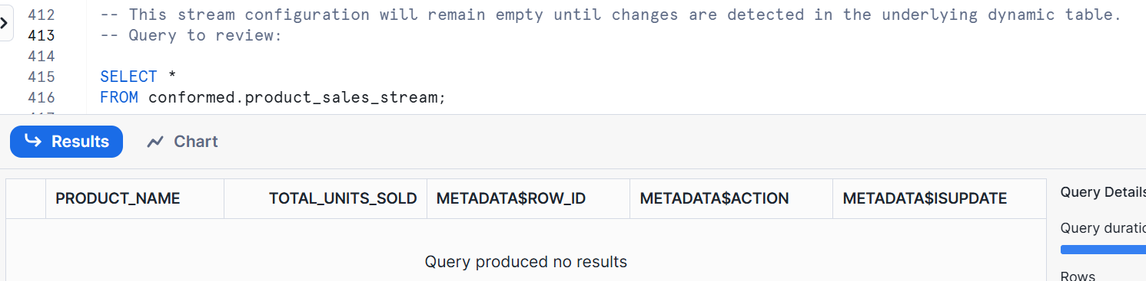

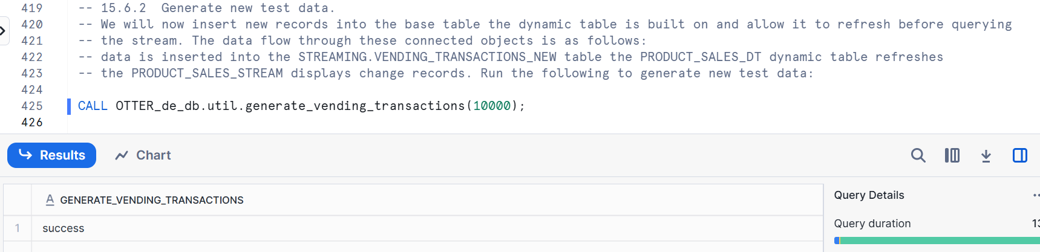

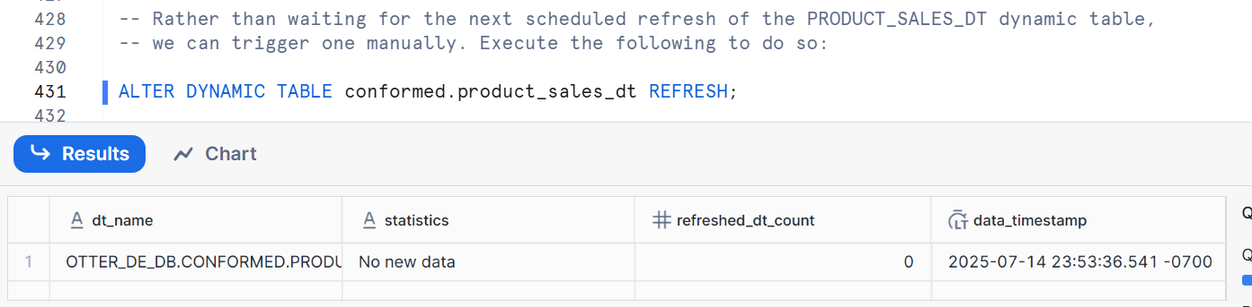

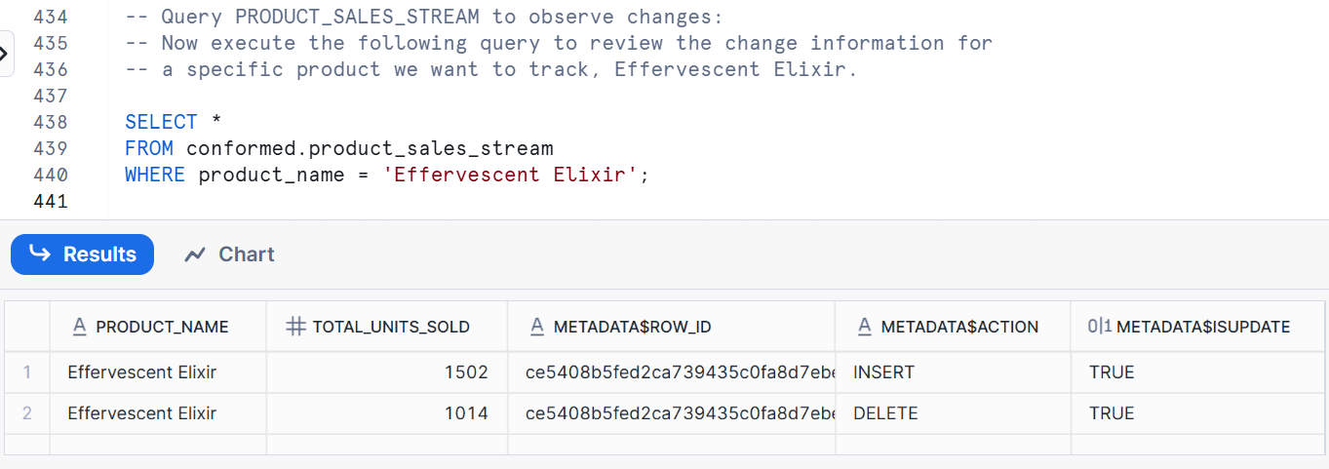

**Note** that the stream shows two rows that together form the functional equivalent of an UPDATE to the previous value for the product record (that is, the old value is deleted, and the new value is inserted).

Your results may differ from those shown in the screenshot above but should contain two rows.

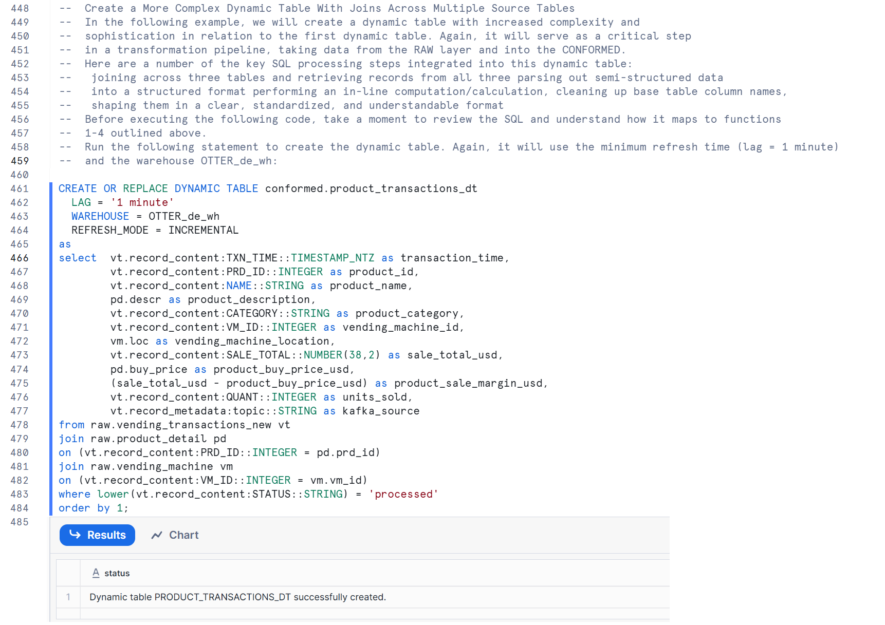

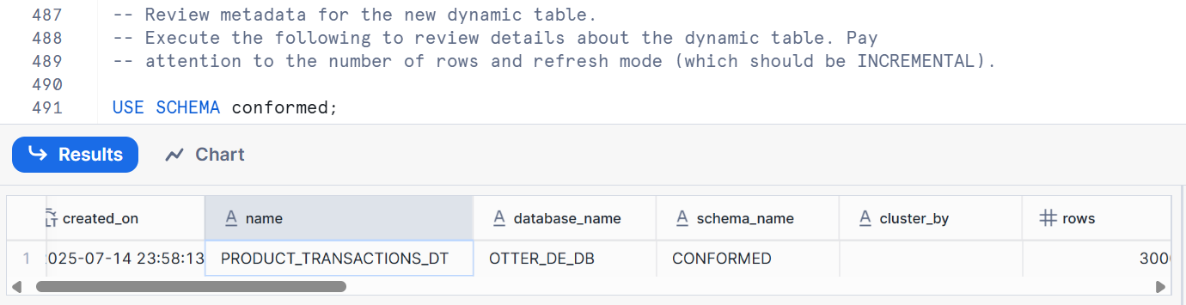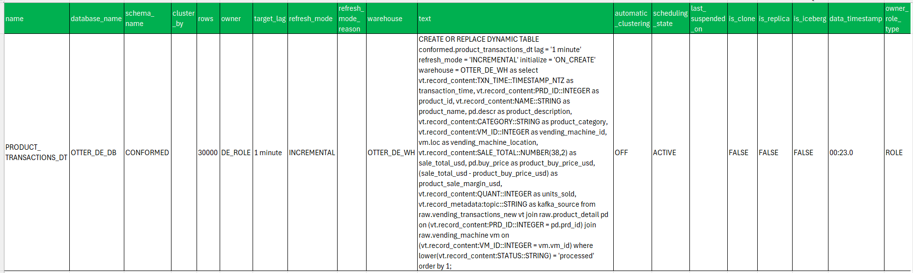

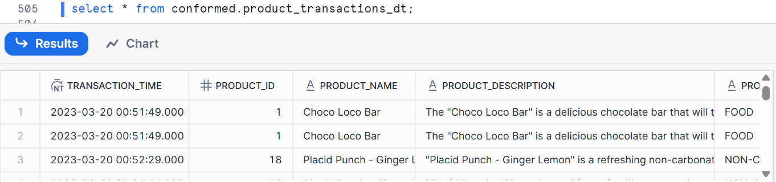

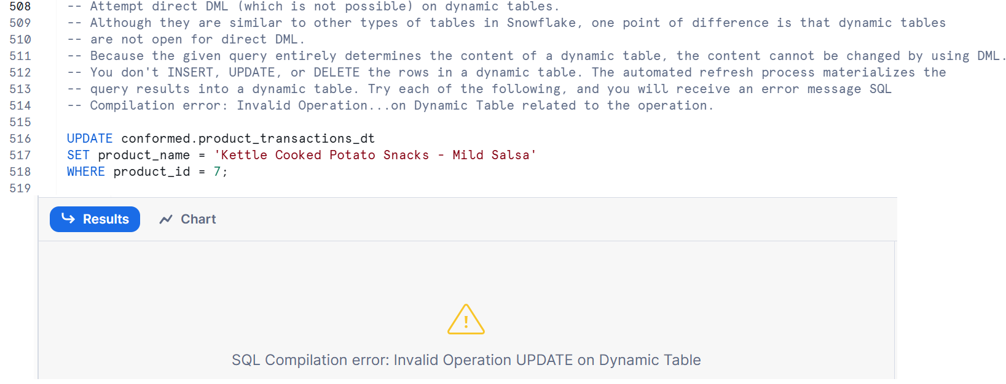

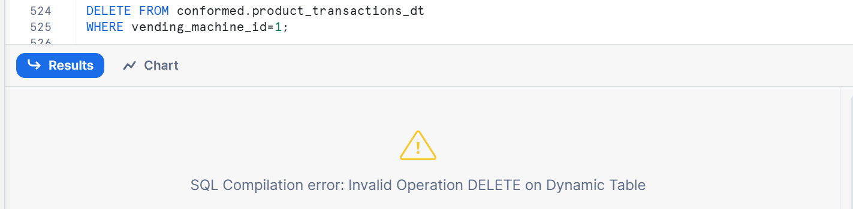

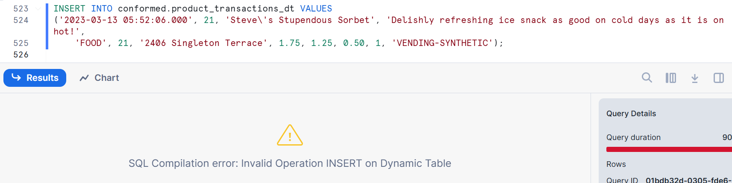

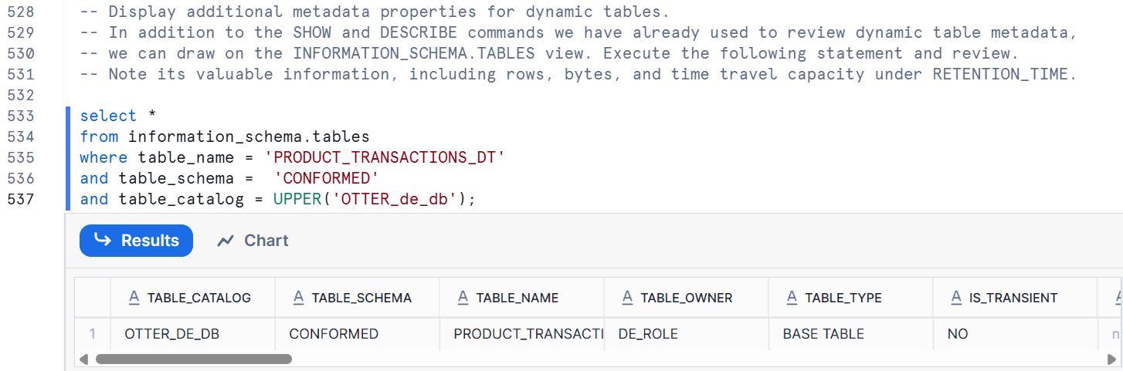

**Use Time Travel with dynamic tables.**

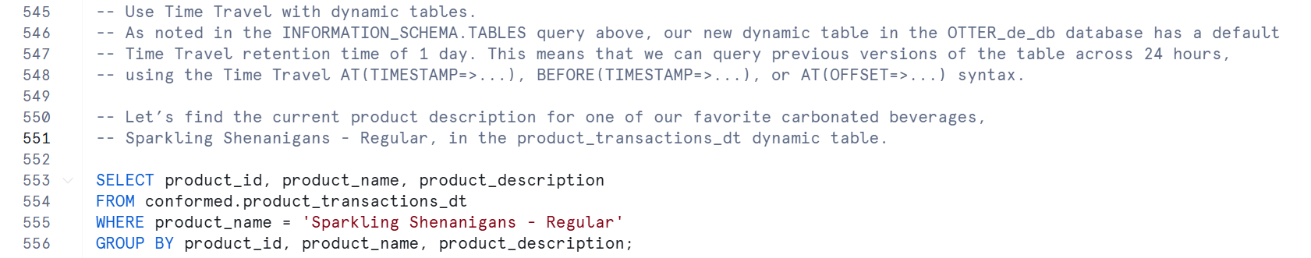

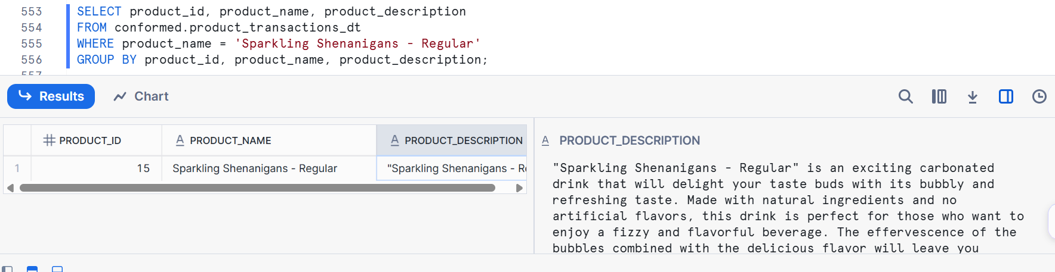

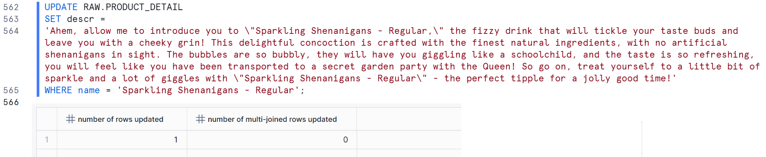

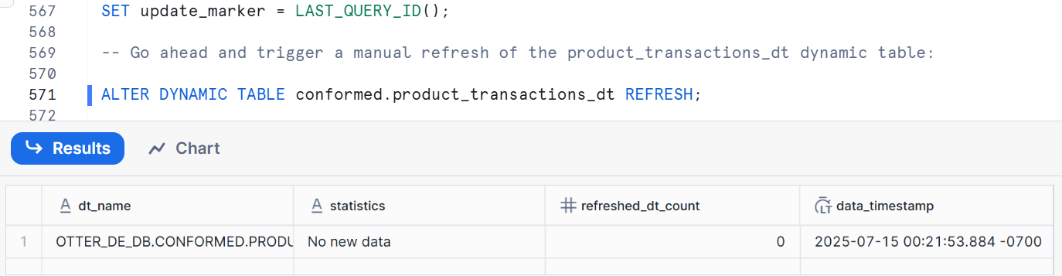

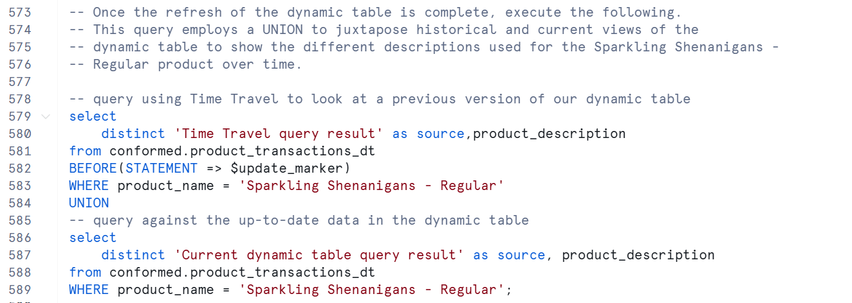

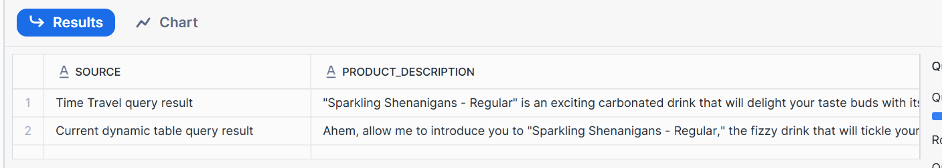

**Chain Together Dynamic Tables in a Pipeline**

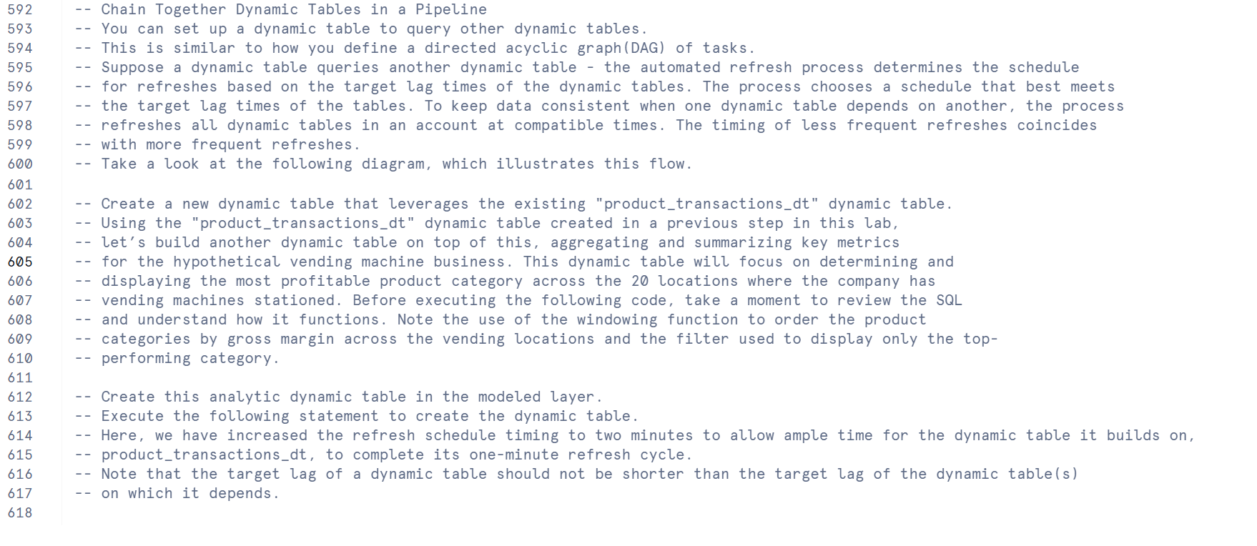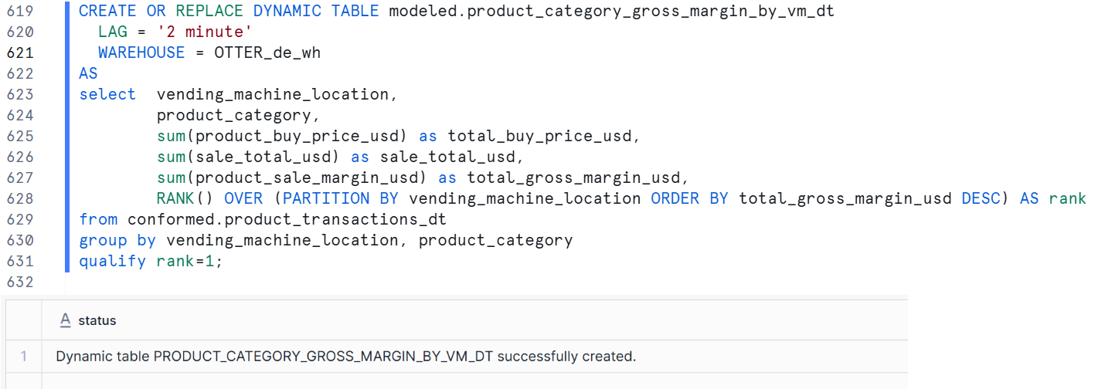

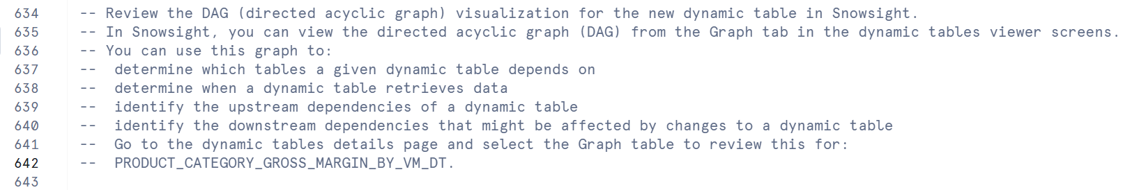

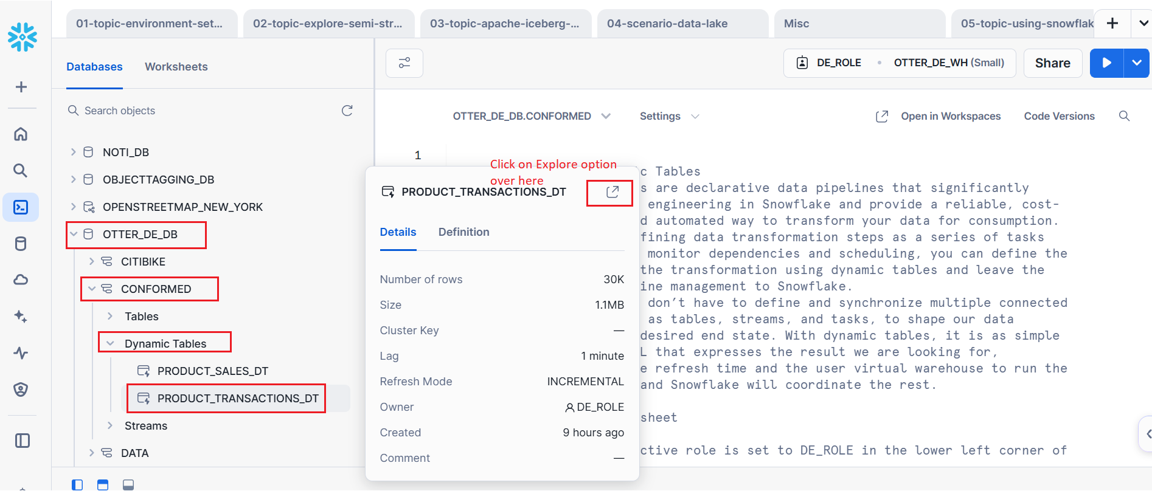

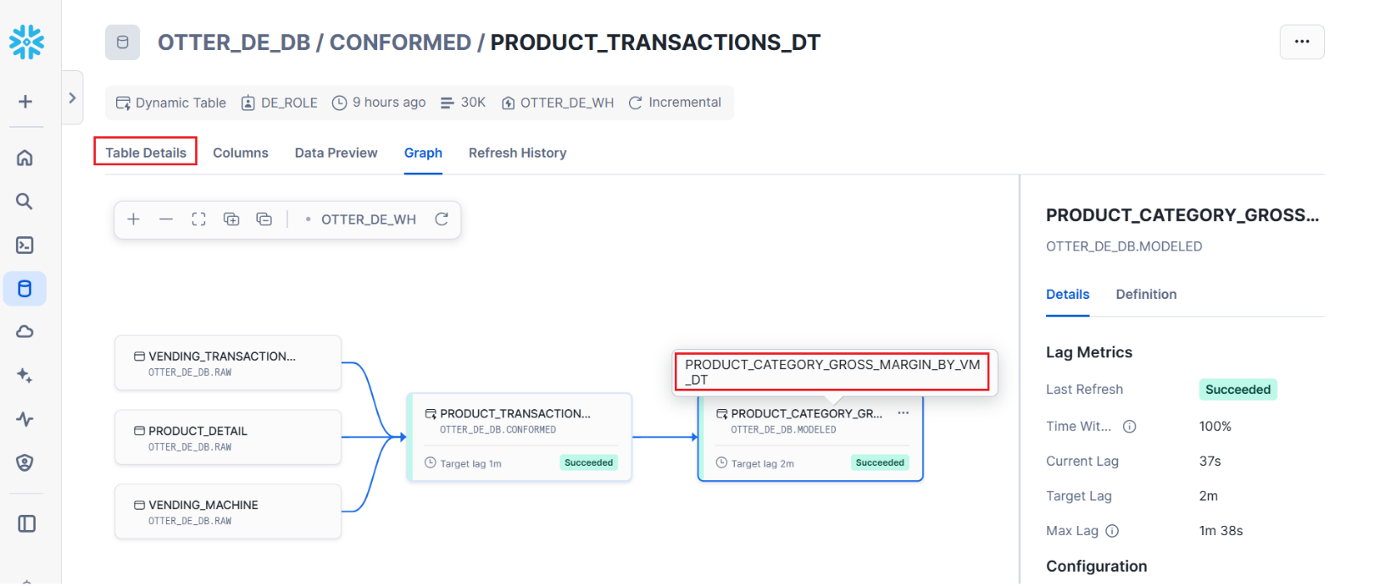

select * from table(information_schema.DYNAMIC_TABLE_GRAPH_HISTORY());

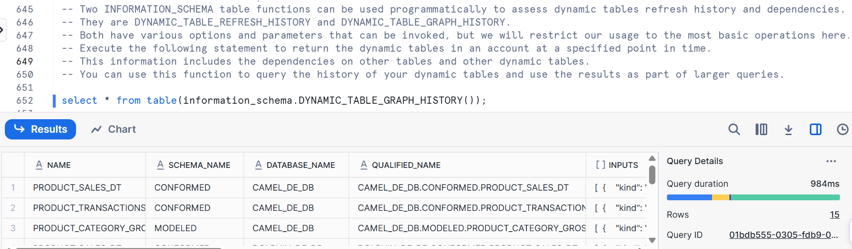

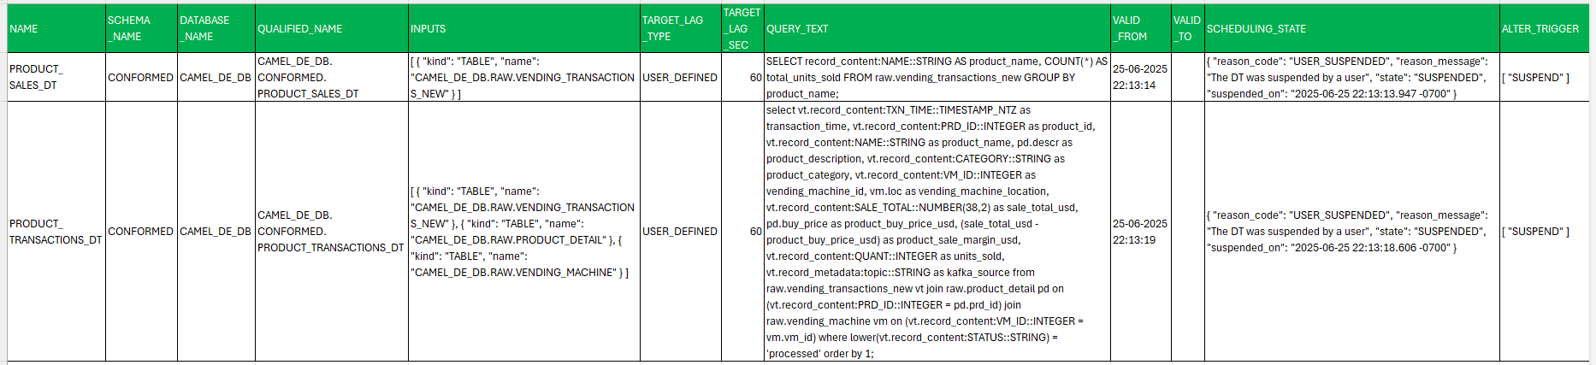

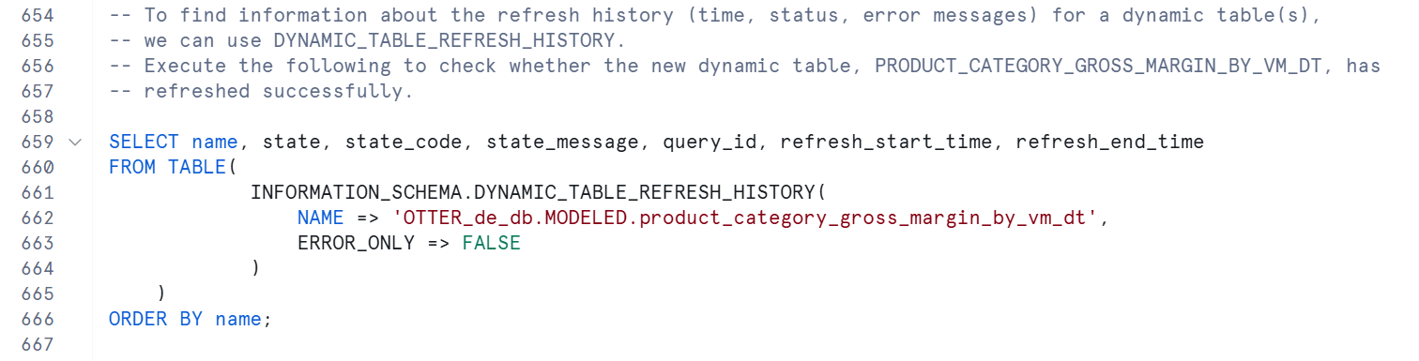

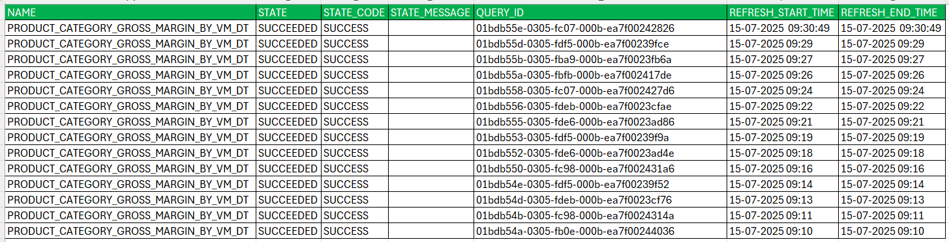

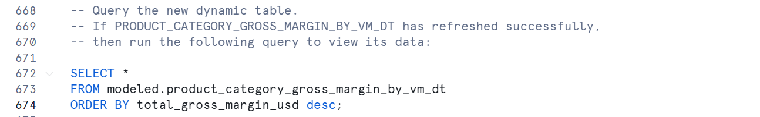

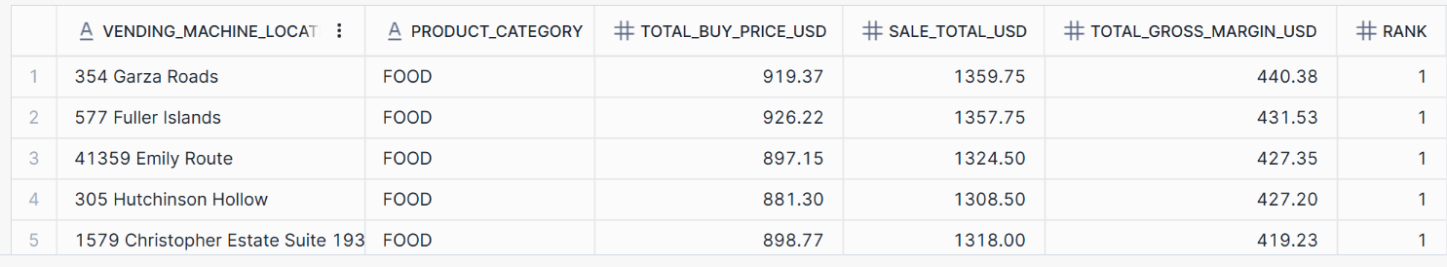

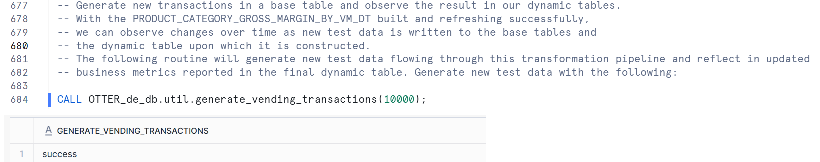

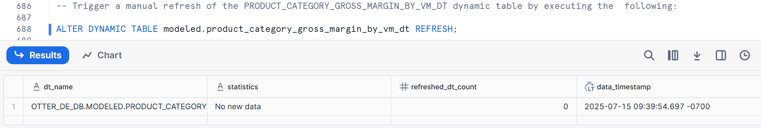

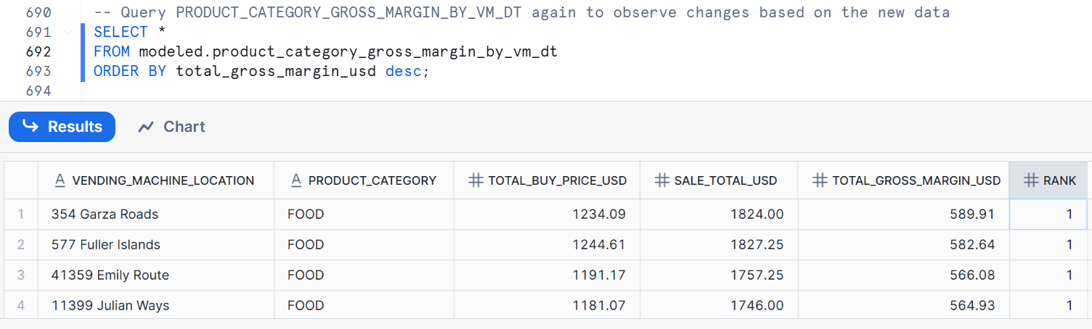

**Lab Cleanup**

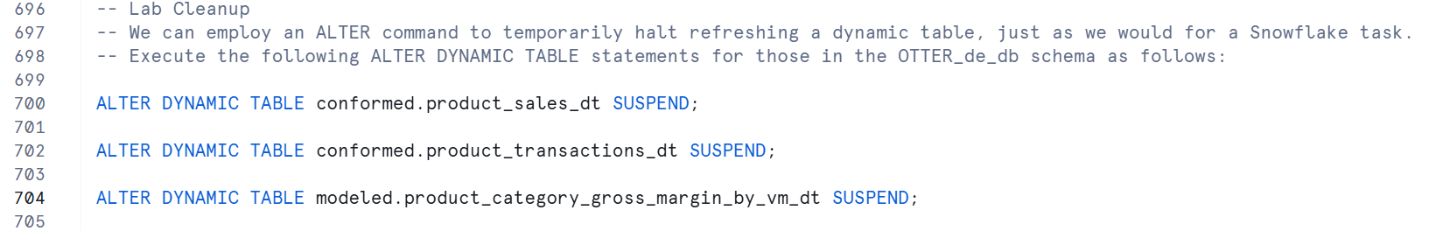

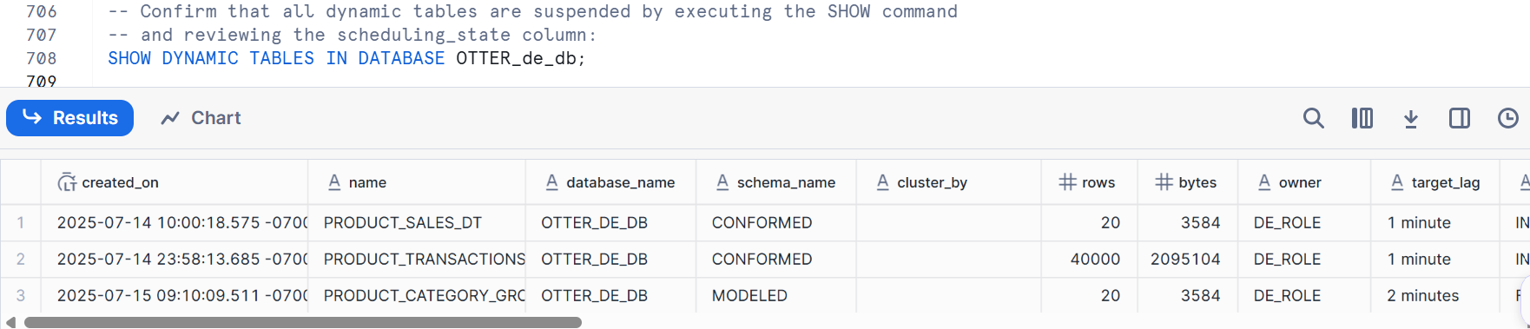

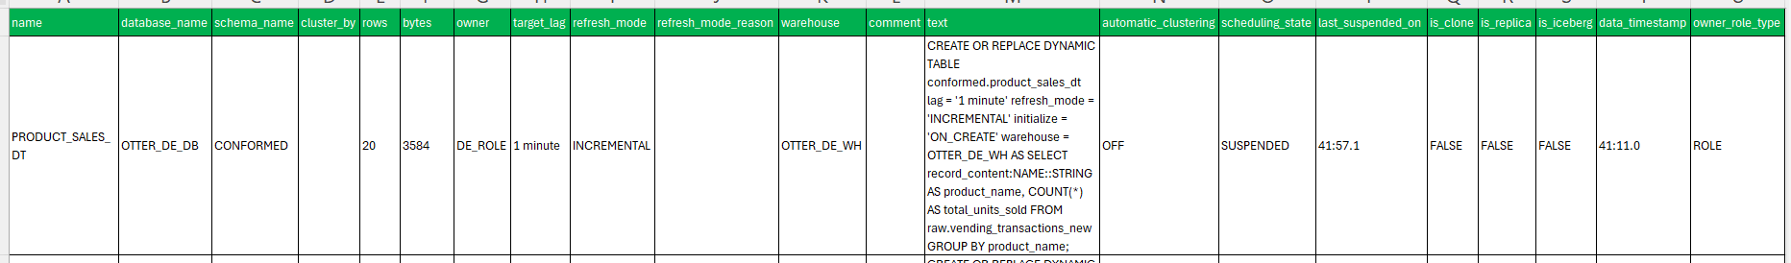



# MISCELLANEOUS

